
SOR-RL Residential Licensing User Guide for Applicants and Licensees
Version 2 – September 2024


Summary of Changes
Version 2 – September 2024
- Incorporated Quality Standards Framework regulation amendment user guide from June 2023
- Incorporated Staff Model Home licence type
- Updated style per Ontario’s Visual Identity system
- Added Tier 1 User support contact info with a link to webpage
- Replaced the use of the term “page” with “module” where appropriate to reflect accurate system terminology
- Re-organized the sequence of sections in the guide to reflect the licence management process
- Corrected information relating to role access
- Updated language, tips, examples, and screenshots to provide more detail to some functions
- Updated address field screenshots and functionality
- Replaced Appendix B with a link to a more comprehensive document relating to user roles

Table of Contents
Table of Contents 3
Introduction 7
Introduction to SOR-RL 7
Using this guide 7
Information not included 7
Getting assistance 8
Performing basic SOR-RL functions 9
Logging in to SOR-RL 9
Logging out of SOR-RL 11
System time-out 11
Navigating 11
Saving your entries 13
Understanding the SOR-RL home page 13
Changing the page language 15
Message Center 15
Banners 16
Identifying mandatory information 17
Entering a date 17
Updating your user profile 17
Administration – Viewing SOR-RL users 21
SOR-RL functionality common to all modules 24
Working in a dashboard 24
Working with a table 25
Searching 26
Assign to Me 27
Viewing/replying to a ministry comment 28
Creating/editing an applicant profile 31
Creating a profile 31
Editing a profile 41
Working with licence applications 43
Before you start 43
Submitting a Children’s Residence licence application 43
Submitting a Staff Model Home licence application 59
Submitting a Foster Care Agency Licence Application 79
Continuing to work on a draft application 93
Viewing a submitted application 94
Revising/editing a submitted application 96
Withdrawing a draft or submitted application 97
Decision notification 98
Working with supporting documents 100
Uploading a document from a list 100
Uploading a document to multiple sites under one licence (Staff Model Homes only) 106
Uploading a document that is not in the supporting document list 109
Viewing the contents of an uploaded document 110
Removing a draft document 111
Working with a submitted document 112
Working with Monthly Reporting 118
Monthly Report User 118
Timelines 120
Autogenerated Report Functionality 120
Submitting Monthly Reports 121
Serious Complaint Monthly Reports 123
Mechanical Restraint Monthly Reports 129
Multiple Incidents (Categories) in a Single SOR 133
Nil Report 134
Submitting the Monthly Report on the Summary Page 135
Working with a Director’s Approval 138
Requesting a Director’s Approval 139
Viewing the ministry decision 145
Viewing inspection reports and findings 148
Opening an inspection report 148
Examples of inspection sections 150
Working with non-compliances 153
Viewing non-compliances for a licence 153
Responding to a non-compliance that require action 156
Working with conditions 160
Viewing all conditions on a licence 160
Viewing your condition occurrence workload 161
Complying with a condition 163
Viewing completed condition occurrences 166
Licence management 168
Viewing a list of your licences 168
Viewing the licence summary 169
Updating licence details from the licence summary 215
Viewing/uploading supporting documents from the licence summary 219
Viewing the licence history 223
Viewing inspection reports from the license history 226
Viewing the Licence Management dashboard 230
Requesting a change to a licence 233
Filing a change request 233
Filing a change request for a licence closure 238
Filing a Change request to add or deactivate a site (Staff Model Homes only) 240
Withdrawing a Change Request 246
Renewing a licence 247
Start the renewal 247
Step 1: Review/update the licence information 249
Step 2: Review/update the applicant profile 251
Step 3: Review/update the Children’s Residence/Staff Model Homes/Foster Care Agency information 253
Step 4: Review the operation information 258
Step 5: Upload supporting documents 261
Step 6: Review director’s approvals 262
Step 7: Submit the renewal 264
If you renewed a director’s approval 266
Viewing a draft licence renewal 267
Withdrawing a licence renewal 268
Viewing serious occurrences 269
Appendix A: Terms and acronyms 271
Appendix B: System/functional roles 272
Appendix C: Statuses 273
Application statuses 273
Condition/occurrence statuses 273
Appendix D: Symbols and icons quick reference 275

Introduction

Introduction to SOR-RL
The Serious Occurrence and Residential Licensing system (SOR-RL) is a secure online tool available to licensees and Ministry staff that automates and harmonizes the end-to-end licensing process for children’s licensed out of home care and the reporting of Serious Occurrence Reports.
System users are assigned roles that determine what functions can be performed. A list of functional roles can be found in Appendix B: System/Functional roles.

Using this guide
This guide provides step-by-step instructions for service providers who already have a profile in SOR-RL to use and navigate SOR-RL for the purpose of Children’s Residential Licensing. Specifically, this guide is to be used by users within Service Providers who are involved in the Residential Licensing process in SOR-RL, those being users with the Service Provider Administrator role, the Site Designate role, and the Monthly Reporting User role.
This guide will be updated as functionality is added to SOR-RL.
A description of SOR-RL icons can be found in Appendix D: Symbols and icons quick reference. See Appendix A: Terms and acronyms for a list of terms and acronyms.

Information not included
Please note that this guide does not provide information or instructions for registering for SOR-RL. It is to be used for users who have been registered and have SOR-RL access. For information on how to register for SOR-RL or how to create a new service provider profile, please reference the SOR-RL registration guides from the SOR-RL Training Portal.
This document is a reference for using the SOR-RL online tool only; no business functions outside the system are included.
Instructions for performing Serious Occurrence reporting-related functions are not included. A separate guide entitled SOR-RL Serious Occurrence Reporting Guide for SOR Initiators is available on the SOR-RL Training Portal.

Getting assistance
If you have questions regarding the processes described in this document, contact your designated regional licensing specialist or SOR-RL Tier 1 User Support Representative, listed here.

Performing basic SOR-RL functions

Logging in to SOR-RL
- Open your browser such as Microsoft Edge or Google Chrome.
- Enter the following address in your browser: https://www.sorrl.mcss.gov.on.ca/SORRL/public/login.xhtml
Tip: Save the link to SOR-RL as a favourite in your browser for easy access.
- The Log in page appears.
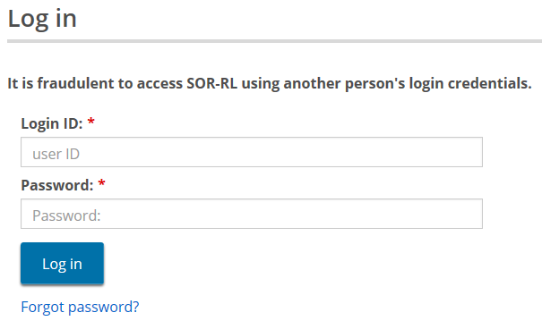
- Enter your Login ID (your email).
- Enter your Password.
- If you have forgotten your password:
- Click Forgot password?. The Forgot password? page appears.
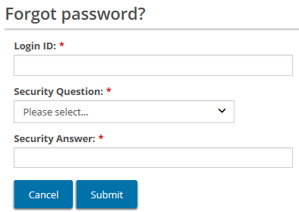
- Enter your Login ID.
- Select the Security Question from the dropdown list.
- Enter the Security Answer.
- Click 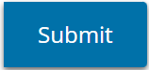.
- Click 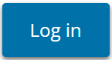. The Enter Verification Code page appears.
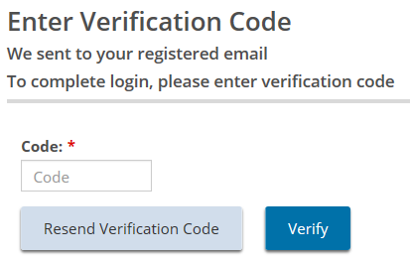
- You will be emailed a verification code. Enter the verification Code from the email.
Tip: Copy and paste the code from the email.
- Click 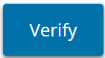. The SOR-RL home page appears.
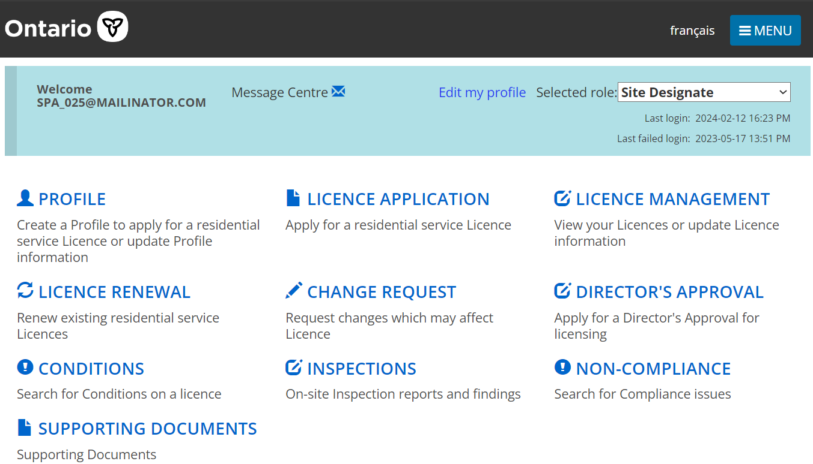
- SOR-RL home page options vary depending on the role selected.

Logging out of SOR-RL
- Click .
- Select . The Log in page appears.

System time-out
In order to protect the privacy of information in SOR-RL, the system times out after approximately 25 minutes of inactivity. Users can save their work regularly with the ‘Save’ button or refresh the page to re-start the session.
Note: SOR-RL does not allow the same user to simultaneously log in to the system through more than one tab or window of SOR-RL. In these instances, the system will time-out, log out, or fail.
Note: SOR-RL can time-out or fail if the user clicks a button more than once. Click a button once. The system may be slow to load but will eventually load. If not, refresh the page rather than clicking the button again.

Navigating
- Click 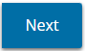 or 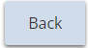 to navigate between main pages in the same module.
- Click 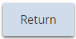 to go back to the previous.
- Click 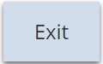 to return to the home page.
- The menu can be accessed from the top of any page by clicking 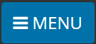. The menu contains links to the sections you have access to as well as the logout function.
- To access the SOR-RL home page from any page, click then select the link, or click the SOR-RL link from the breadcrumbs at the top of the page.
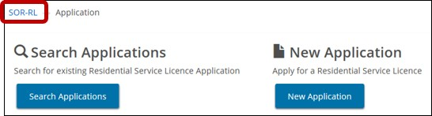
- The top of many pages is a line of links called breadcrumbs. Click the previous section in the breadcrumb to go back to the previous page For example, in the following page, you would click the Application link in the breadcrumb to go to back to the Application page from the Residence information page. It is recommended that you navigate back in SOR-RL by using the breadcrumbs rather than using the back button in your browser, as the latter can cause issues.
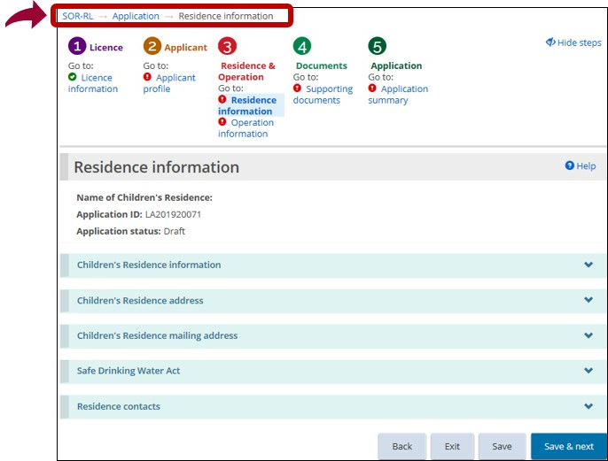

Saving your entries
- Click 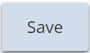 to save your entries and remain on the current page.
- Click 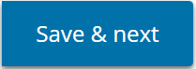 to save your entries and go to the next page.

Understanding the SOR-RL home page
After you log in, the first page to appear is the SOR-RL home page. The items that appear on the home page, known as modules, will vary depending on your system access rights (role). For more information about roles see Appendix B: System / functional roles.

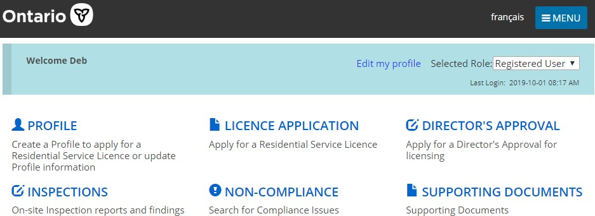
Example of a home page for a Registered User
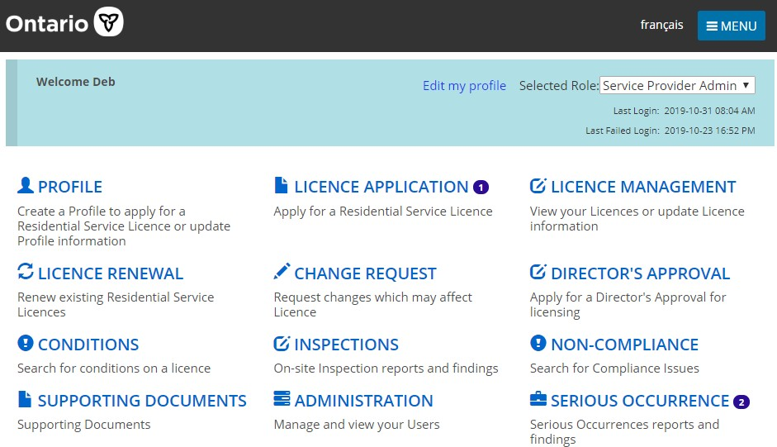
Example of a home page for a Service Provider Administrator

Changing the role displayed
If you have been assigned more than one role, you can change the selected role from the home page.
- Click the Selected Role dropdown on the home page.
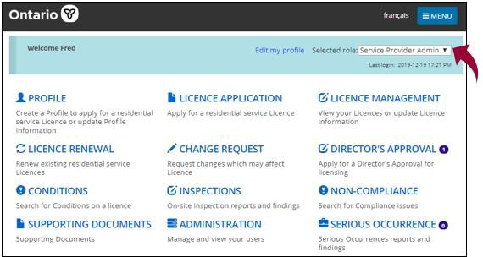
- Select the role from the list.

Changing the page language
To change the page language, from the top of any page, click the language button. 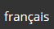

Message Center
This new functionality has been added to allow the SOR-RL Corporate Team to easily communicate important SOR-RL information directly to users, through memos or emails. A memo or email may be targeted based on user roles or sent to all users, for example to notify of an upcoming SOR-RL outage.
All users now have access to the "Message Centre" module that is available in the top blue bar of their SOR-RL homepage. When a new memo or email has been received, a red dot will appear beside the mail icon.
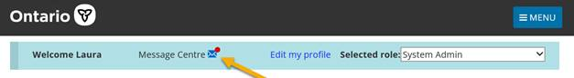
Click on the mail icon, and you will be brought to the Message Centre module. Here you will see memos and/or emails that have been sent to you. Click the "Select" button of a specific memo or email to open it and read its contents. Once you have opened all “unread” memos and emails, the red dot beside the mail icon on your SOR-RL homepage will disappear.
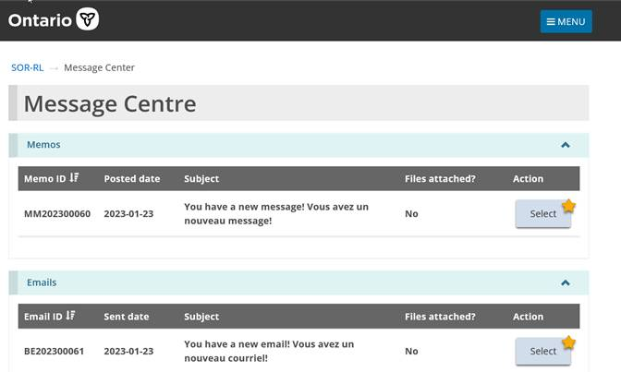
Memos will appear in your message centre for only as long as they are posted. Records of the emails will continue to show in this module for 6 months. Please do not respond to emails or memos from the SOR-RL message centre.

Banners
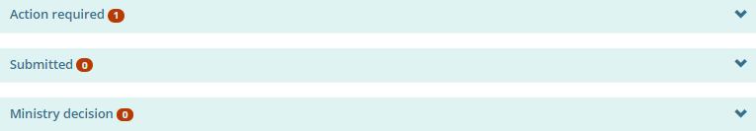
The number in the banner indicates the number of items in the list. Click the banner arrow to expand/collapse the section.

Identifying mandatory information
A red asterisk *indicates that a field is mandatory and must be completed.
If mandatory information is not completed, a red “Required” message appears next to the field when you attempt to save the information or go to the next page.
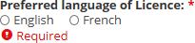

Entering a date
Dates can be entered manually or by clicking the date on a calendar. To enter a date manually, type the date in yyyy/mm/dd format. To enter a date using the calendar, click . A calendar appears.
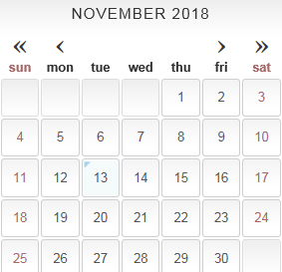
Scroll to the month using the arrow buttons. To change the year, click the chevron << >> arrow. Select the date.

Updating your user profile
Your user profile includes your email address, phone number, password and security questions. Your name and email address cannot be edited; if they need to be changed, please contact the ministry.

Changing your phone number
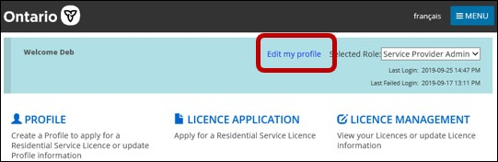
- From the SOR-RL home page, click Edit my profile. The Edit my profile page appears.
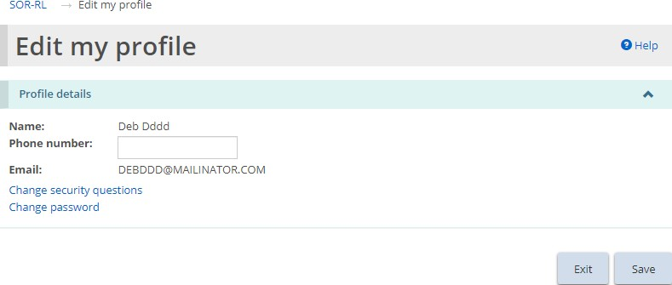
- Update your phone number as required.
- Click .

Changing your password
- From the SOR-RL home page, click Edit my profile. The Edit my profile page appears.
- Click Change password. The Change password page appears.
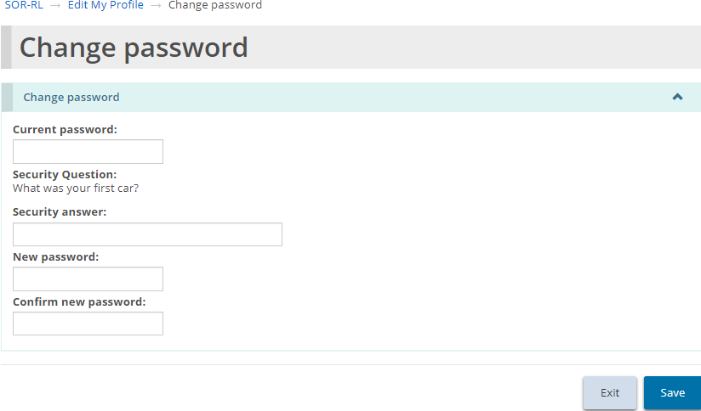
- Enter your Current password.
- Enter the Security answer.
- Enter the New password.
Note: The password must be at 8 to 20 characters in length and contain: At least one UPPERCASE letter, AND at least one lowercase letter, AND at least one number, AND at least one special character. ( ) ! _ @ # $ % ^ &* +.
- Type the new password again in the Confirm new password field.
- Click 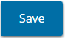.

Changing your security questions
- From the SOR-RL home page, click Edit my profile. The Edit my profile page appears.
- Click Change security questions. The Security questions page appears.
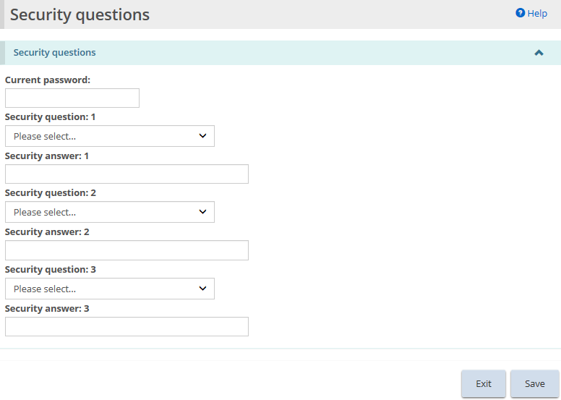
- Enter your Current password.
- Select the Security question.
- Enter the Security answer.
- Repeats steps 4 and 5 for all three questions.
- Click .

Administration – Viewing SOR-RL users
The Administration module is used for SOR-RL user management. Only users with the Service Provider Administrator role have access to the Administration module. Additionally, Service Provider Administrators without a Local Registration Authority (LRA) designation have read-only access to the Administration module, meaning they can only view user profiles but cannot make changes or register new users. Only Service Providers with an LRA designation can perform user management functions. An LRA designation is obtained through an application submitted to the ministry. This guide does not provide information on user management functions of a Service Provider Administrator with an LRA designation. For more information, access the SOR-RL Training Portal and the SOR-RL Registration and User Guide for Service Provider Administrators with Local Registration Authority Designations.
- Click . The Administration menu appears.
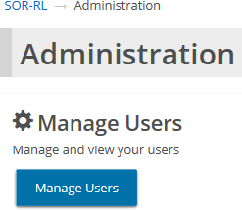
- Click 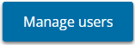. The Manage Users page appears.
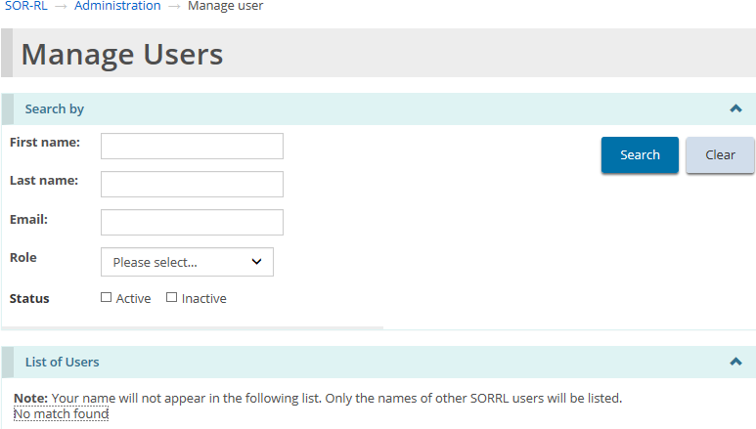
- Enter the search criteria for the user, then click 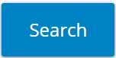. The List of Users section appears at the bottom of the page.
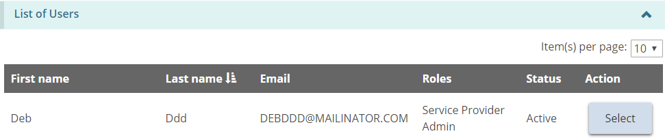
- Click 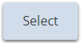. The User details page appears.
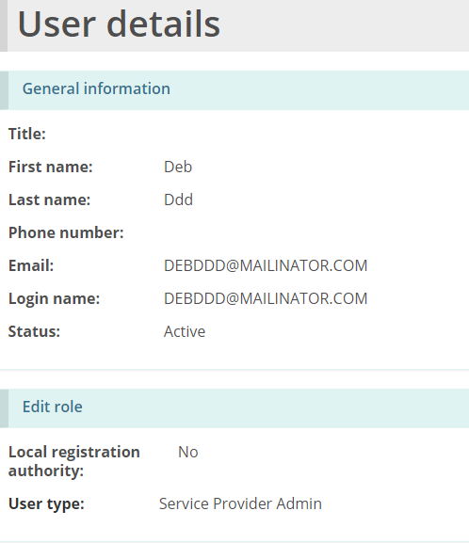

SOR-RL functionality common to all modules

Working in a dashboard
A dashboard is a list of items grouped by function.
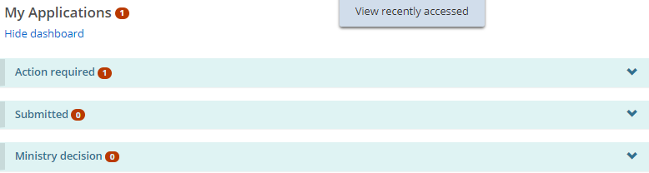
Example of a dashboard
There is a different dashboard for each of the Residential Licensing modules used to perform functions in the Licensing process.

Opening a dashboard
- From the SOR-RL home page, open a module, such as .
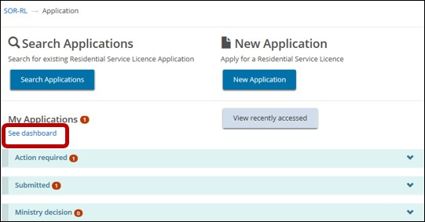
- Press See dashboard. (The link changes to Hide dashboard.)

Working in a dashboard
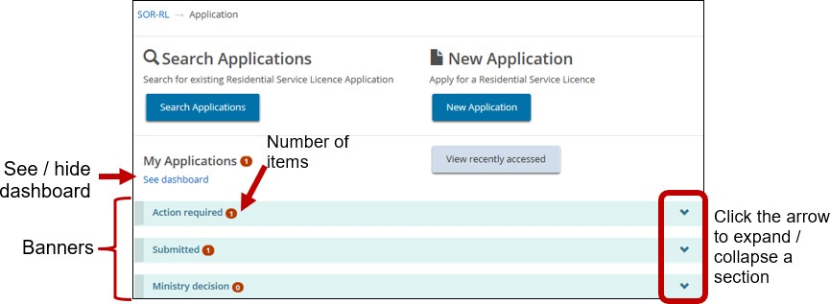
A dashboard is divided into sections indicated by banners. The number in the banner indicates the number of items in the section. To expand a section, click the arrow in the banner.
Below is a list of common sections.
Note: Not all dashboards have the same sections.
- Action required: This section displays applications that are draft or require an action from the user. This section lets you update an item.
- Submitted: This section lists all items you have submitted.
- Ministry decision: This section displays items where a ministry decision has been reached.
To show / hide the dashboard, click Show dashboard/Hide dashboard.

Working with a table
Search results and other information are displayed in a table.
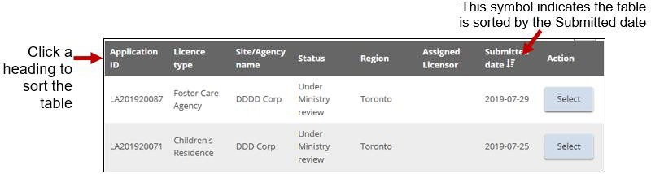
After you expand a section, 10 items appear. Click the Per Page arrow to change the number of items per page. If there is more than one page of results, a page indicator appears at the bottom of the page . Click the page number you want or choose.
To sort a column, click the column heading. To sort in the opposite direction, click the heading again. A symbol appears indicating that the list is sorted in ascending order 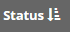 or descending order .
In some tables you will see a delete or edit icon.

Searching
Searching can be completed once having accessed a module.
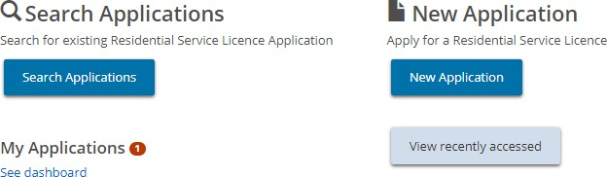
Tip: If you are looking for an item that you worked on recently, click 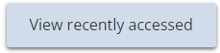.
- To complete a search, click the search button such as 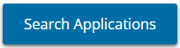. The Search By page appears.
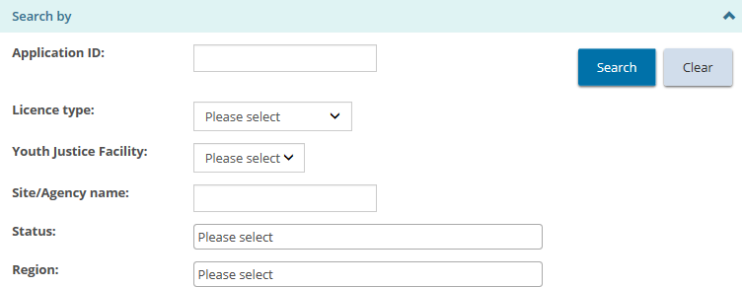
Options in the search by page vary depending on the module.
- Select/enter the search criteria.
Tips: To find all items, leave the search criteria blank. To narrow down the search results, enter more search criteria. Search criteria are not case-sensitive. You can enter criteria in UPPER or lower case. You can enter part of the entry. For example, if you are looking for ABC agency, you could type in “bc”. To erase the search criteria, click .
- Click . The search results appear in a table below the search criteria.
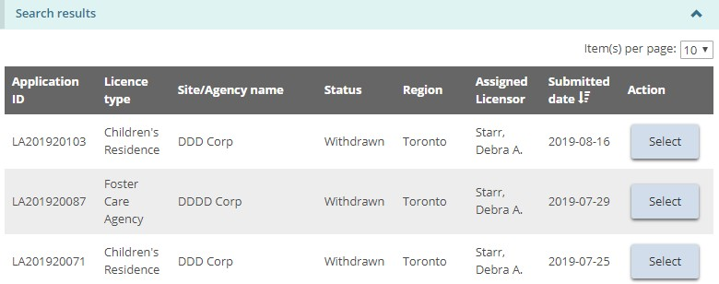
- To view an item, click .
Note: See the Working in a Table section for tips on working with a search result table.

Assign to Me
Licensing items in SOR-RL can only be assigned to one user at a time. Where a licensed site has more than one Service Provider Admin or Site Designate assigned to it, a user may first need to “assign to me” to be able to take any action on an item in SOR-RL.
To do this, the user must access the licensing item through the appropriate module on the SOR-RL homepage. After selecting the appropriate licensing item, the user must the scroll to the bottom of the summary page and select the “assign to me” button.
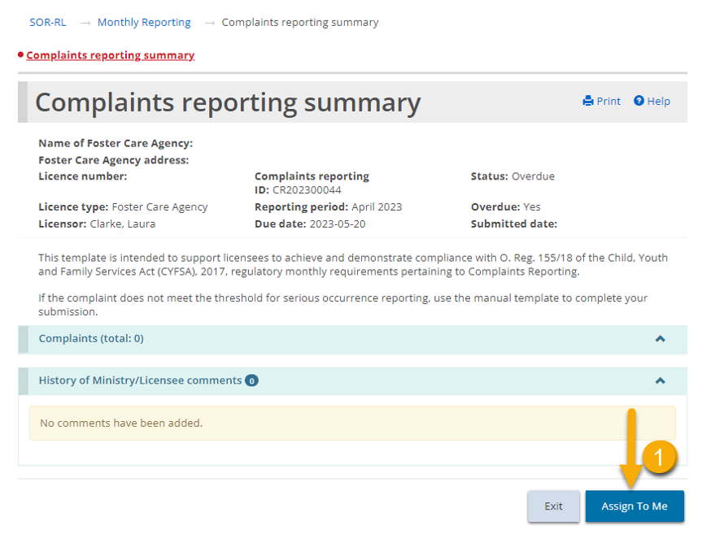

Viewing/replying to a ministry comment
A user can view or add comments to the ministry on the summary page prior to submitting an action in SOR-RL. This functionality is available in all modules in SOR-RL where a licensing action is underway, for example an application for a Director’s Approval, a licensing renewal or in response to a non-compliance.
- Open an item, either through a search, the recently accessed function, or through your dashboard.
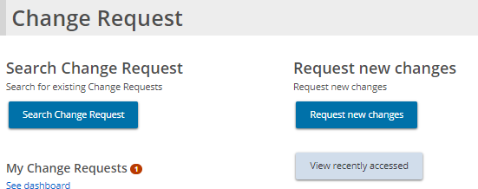
- The commented item is in the Action required section.
- Click to open the item. The Summary page appears.
- Scroll down to the comments section.
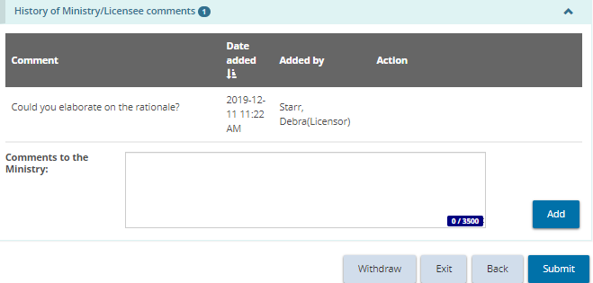
- To reply to the ministry’s comment, enter your comments back to the Ministry in the comment box and press 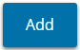.
- The comment appears in the list.
- In order for the comment to be sent and be visible to the ministry, the action in SOR-RL must be submitted to the ministry. In order to complete the licensing action and submit to the ministry, please follow the remaining steps outlined in the appropriate module section in this manual.
Note: Where a licensing action has been returned by the ministry to a licensee, the licensee is required to add a comment on the summary page prior to resubmitting. Additionally, a comment is required to be added when submitting a Monthly Report in overdue status.

Creating/editing an applicant profile
In SOR-RL there are two profiles; one for the user (to use SOR-RL) and one for the applicant (individual or corporation). The applicant profile includes information about the individual or corporation such as the address, phone number, owners, directors, officers, etc. This section refers to the applicant profile. For information about your user profile, see the Updating your user profile section.
Note: The profile must be completed before a licence application can be started. Supporting documentation must be uploaded before an individual/corporation can be licensed.

Creating a profile

Individual profile
- From the SOR-RL home page, click . The Profile module appears.
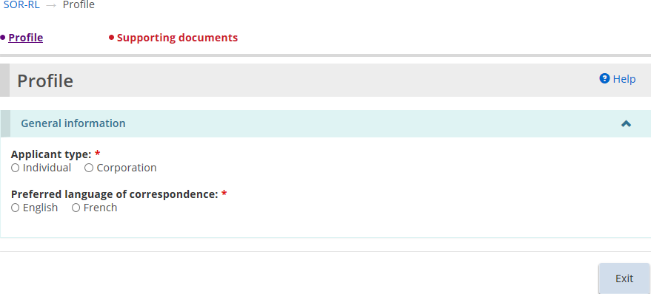
- Select “Individual” as the Applicant Type.
- Select the Preferred language of correspondence. (This is the language you wish to receive correspondence in from the Ministry.) The Individual details section appears.
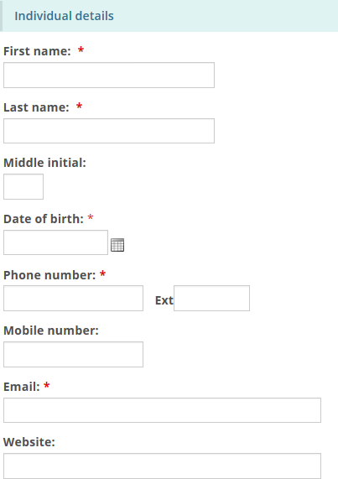
- Enter the individual information.
- Scroll down to the Address section and enter the address information.
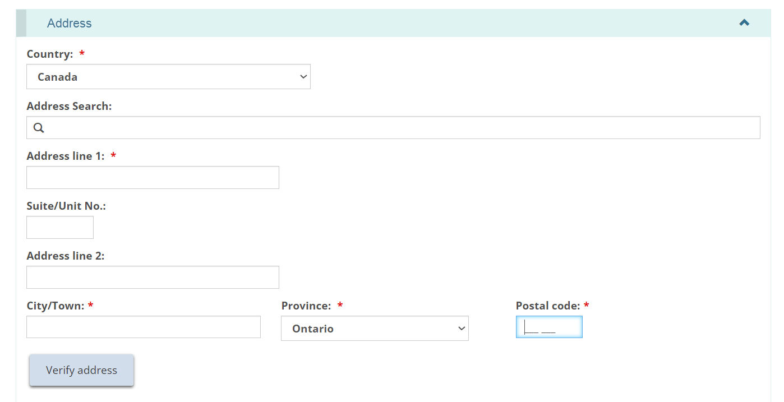
Users may manually populate the address fields or utilize the predictive address search field. An address verification mechanism is available.
Note: An address is not required to be verified for it to be saved in the system.
- Scroll down to the Operating name section and answer the question.
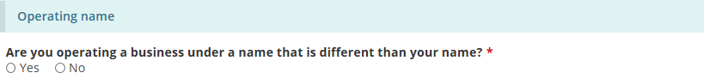
- If you selected “Yes” the section expands.
- Click 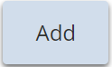. The Operating name page appears.
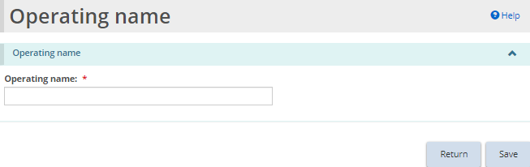
- Enter the operating name and click .
- Click . The name appears in the operating name list.
- Click . The Supporting Documents page appears.
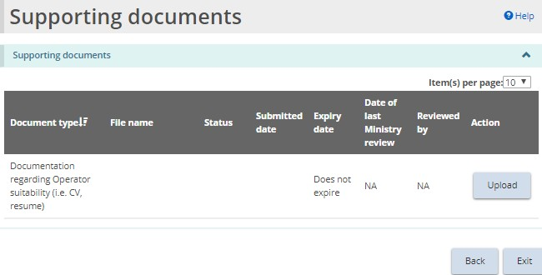
- Upload the supporting documents. See the Working with supporting documents section of the guide for more information.

Corporation profile
Note: Either one Director or Officer must be authorized to receive ministry communications on behalf of the licensee before you can submit an application.
Note: There must be at least two signing authorities and two active Directors, Officers, or Owners with a submitted “supporting document regarding operator suitability” before you can submit an application.
- From the SOR-RL home page, click . The Profile module appears.
- Select “Corporation” as the Applicant type.
- Select the Preferred language of correspondence. The Corporation details section opens.
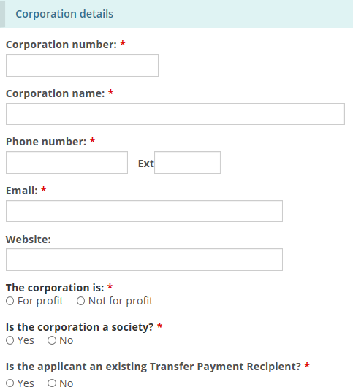
- Enter the corporation details.
- Scroll down and enter the head office address.
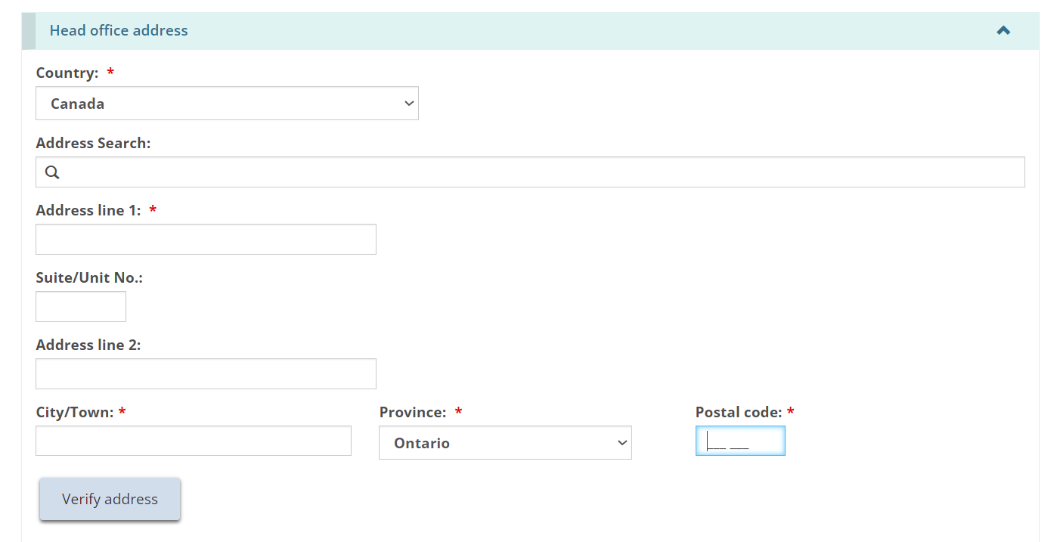
Users may manually populate the address fields or utilize the predictive address search field. An address verification mechanism is available.
Note: An address is not required to be verified for it to be saved in the system.
- Scroll down and indicate if the mailing address is the same as the head office address. If it is different, enter the mailing address.
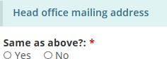
- Scroll down to the Operating Name section.
- Indicate if the corporation is operating under a different name.
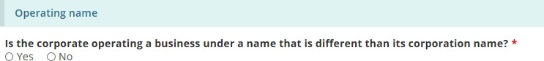
- If you select “Yes”, the section expands.
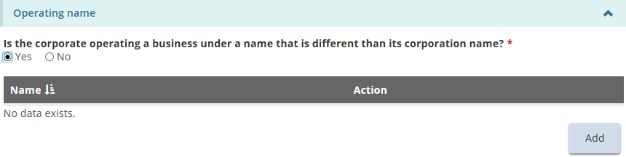
- Click . The Operating name page appears.
- Enter the operating name and click .
- Click . The operating name appears in the table.
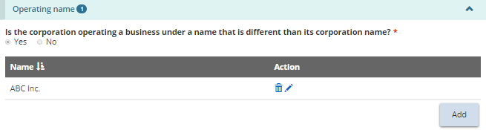
Note: You can have more than one operating name. Repeat the steps for each name.
- Scroll down to the Owners of the corporation section.
- Click . The Owner details page appears.
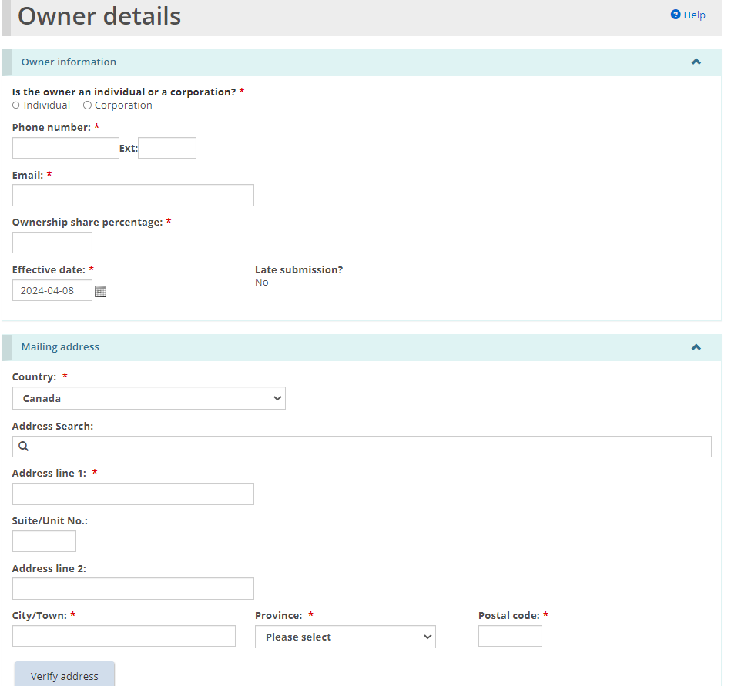
- Enter the owner information and click .
- Click . The owner appears in the table.
- Scroll down to the Directors of the corporation section.
- Click . The Director details page appears.
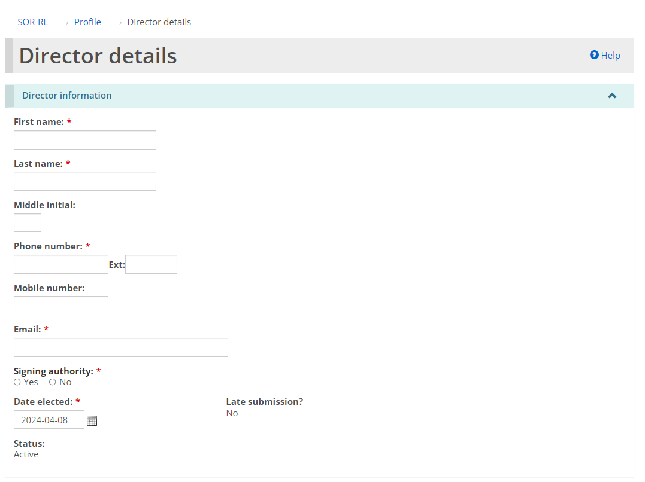
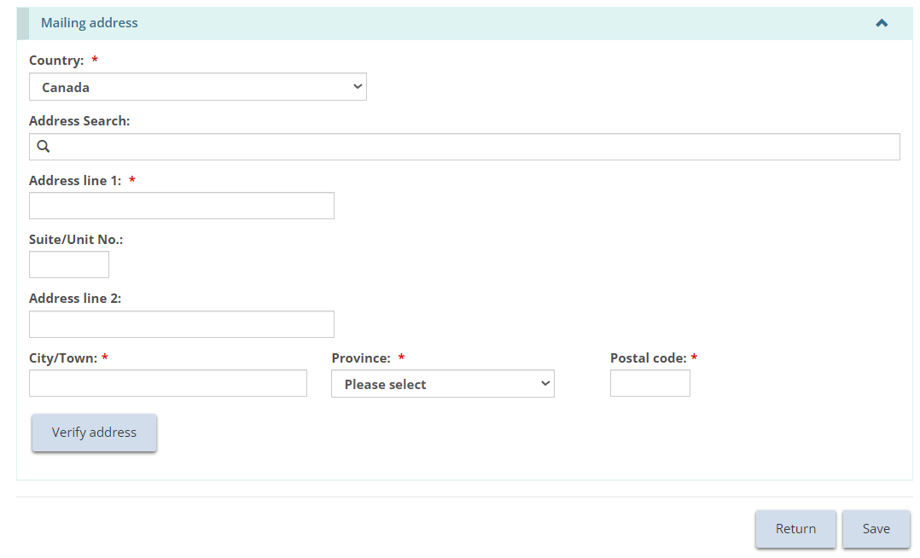
- Enter the Director information and click .
Note: If the Date elected is in the past and more than 15 business days from the current date, the Late Submission indicator will display “Yes”.
- Click . The Director appears in the table.
- Indicate if the person is authorized to receive ministry communications on behalf of the licensee. (Click the radio button.)
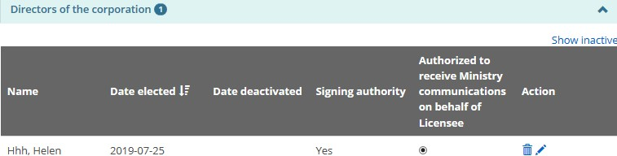
Note: At least one individual must be authorized to receive ministry communications before a licence can be submitted.
- Scroll down to the Officers of the corporation section.
- Click . The Officer details page appears.
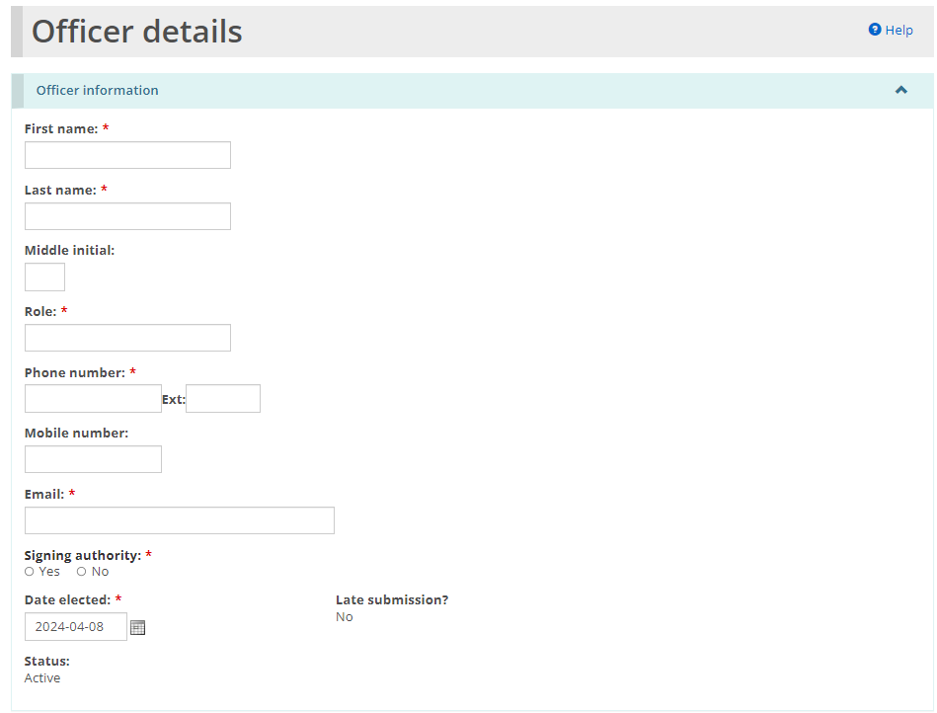
- Enter the Officer information and click .
Note: If the Date elected is in the past and more than 15 business days from the current date, the Late Submission indicator will show “Yes”.
- Click . The officer appears in the table.
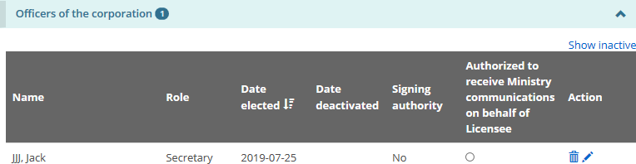
- Indicate if the person is authorized to receive Ministry communications on behalf of the licensee. (Click the radio button.)
- Click . The Supporting documents page appears.
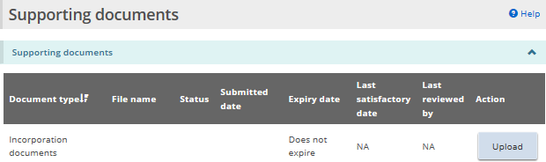
The documentation list will vary depending on your selections when creating your profile.
- Upload the supporting documents. For details, see the Working with Supporting Documents section.
Note: Once you submit an application, the applicant type cannot be changed.
Note: If there is a change to the officers or directors of the corporation, you must notify the ministry of the change within 15 days.

Editing a profile
- From the SOR-RL home page, click . The Profile module appears.
- Make the changes required. A Director/officer cannot be deleted but can be deactivated.
- Open the director’s/officer’s page. Click 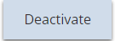 then enter the date and deactivation reasons.
- Click . The Supporting Documents page appears.
- Edit/change the supporting documents if required.
- If you changed a supporting document, click otherwise click .

Working with licence applications

Before you start
An application can be submitted to operate a Children’s Residence, Foster Care Agency, or Staff Model Homes. The step-by-step instructions are documented separately in this section. Be sure you follow the correct instructions.
Applications can be submitted by a corporation or an individual. The application process is slightly different depending on whether you are applying as a corporation or an individual. Only the corporation application process is documented in this guide.

Submitting a Children’s Residence licence application
Note: This section outlines the process for applying for a Children’s Residence licence. Please see the process for applying for a Foster Care Agency, or Staff Model Homes. licence in the sections below.
An application can be submitted/updated by a user with the Registered User or Service Provider Admin role in SOR-RL.

Step 1: Start the application and enter basic information
As you work on your application, click  to save your entries.
Tip: You can open your draft application at any time and continue working on it. See the Continuing to work on a draft application section for details.
- From the SOR-RL home page, click the module.
- The Application module appears.
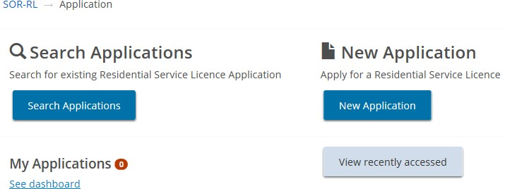
- Click 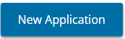. The Notice of collection of personal information page appears.
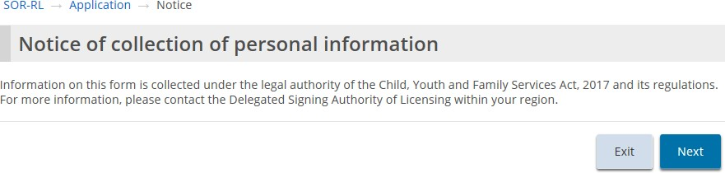
- Read the notice then click . The Licence information page appears.
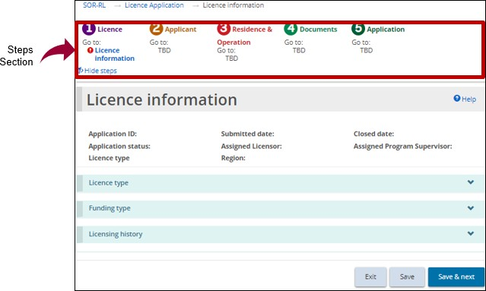
Tips: Look at the steps section to monitor your progress.
Symbols indicate the status of each section. A green checkmark appears after you go to the next page. It indicates that the information on that page is complete. A red exclamation mark appears after you go to the next page. It indicates that information is missing from that page and must be completed before you can submit the application. The red exclamation mark does not indicate if the information is correct.
To quickly go to a step, click the step from the steps section.
To hide the list of steps, click . To show the list of steps, click .
- Scroll down to the Licence type section.
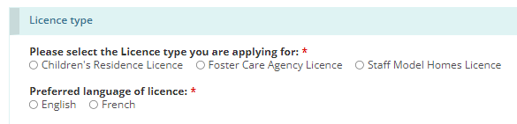
- Select “Children’s Residence”.
- Select the Preferred language of the licence.
- Scroll down to the Funding type information section and select the funding type.
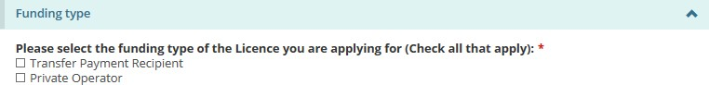
Note: If you are applying as an individual, there is only one option.
- Scroll down to the Licensing history section and answer the licensing history questions.
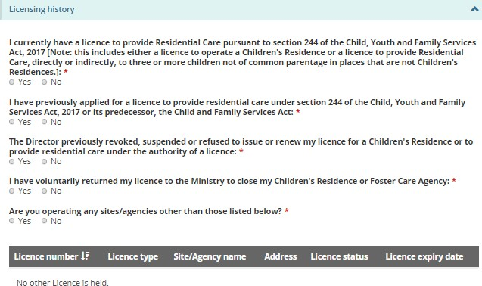
- More questions may appear depending on your answers. Be sure to answer all the questions.
- Click . The Applicant profile section appears.

Step 2: Review the applicant profile
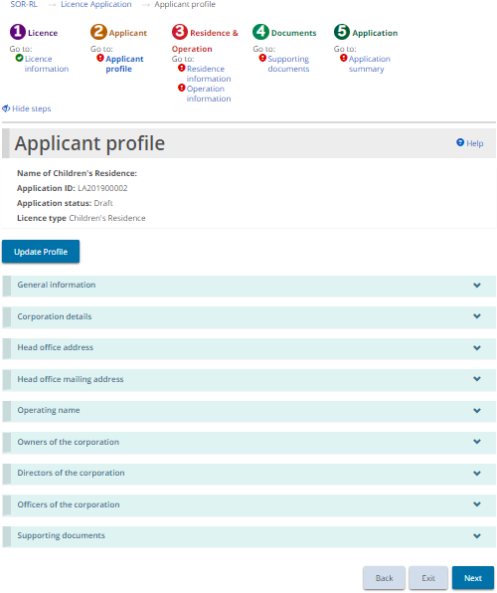
- If the Applicant profile page is not on your screen, click the Applicant profile link from the steps section.
- Expand and review all the sections of your profile.
- If changes are required:
- Click 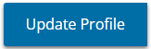. This brings you to the Profile module.
- Make the changes as required and save the changes.
- Click . The SOR-RL home page appears.
- To return to your application, click the module then select the draft application from your dashboard. The Application summary screen appears.
- To proceed to the next section, click Residence Information.
- If changes are not required, click . The Residence Information section appears.

Step 3: Enter the residence information
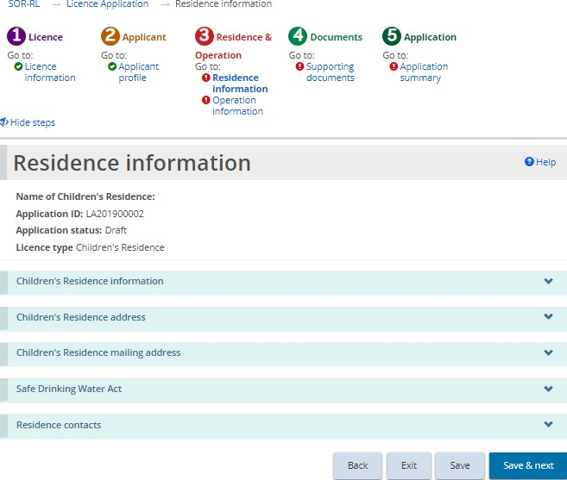
- If the Residence information page is not on your screen, click the Residence information link from the steps section.
- Enter the Children’s residence information.
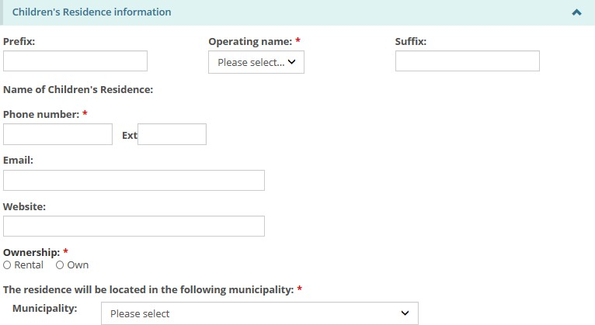
- Enter the Children’s Residence address information.
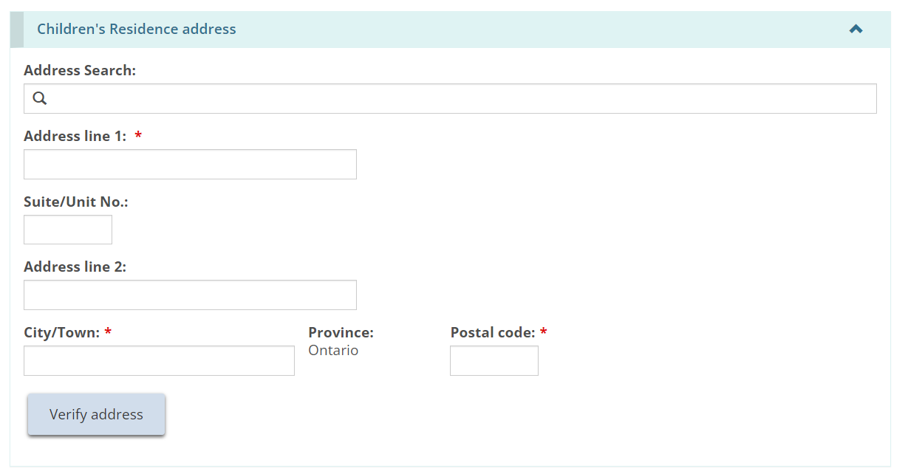
- Users may manually populate the address fields or utilize the predictive address search field. An address verification mechanism is available.
Note: An address is not required to be verified for it to be saved in the system.
- Enter the Children’s residence mailing address.
- Enter the Safe Drinking Water Act information.
- Add the Residence contacts.
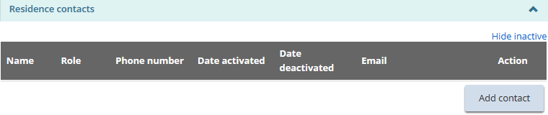
Note: Enter the onsite residence contact for the licensee.
- Click 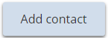. The Residence contact details page appears.
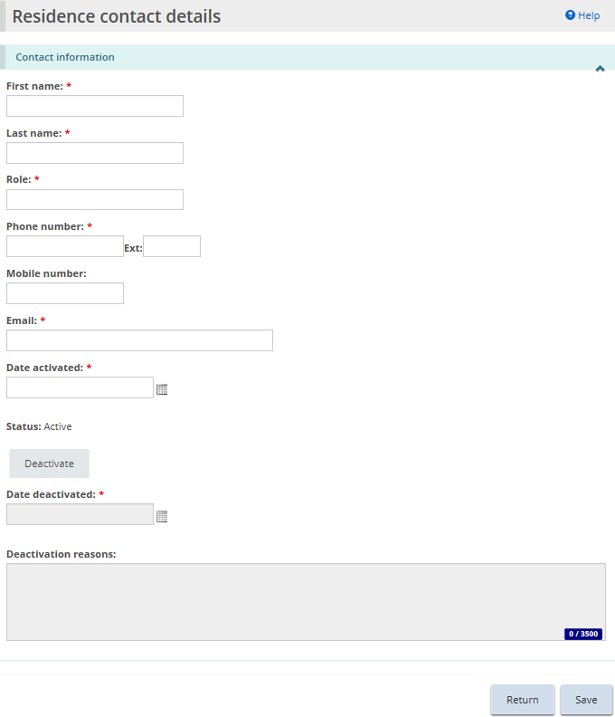
- Enter the contact information and click .
- Click . The contact name appears in the table.
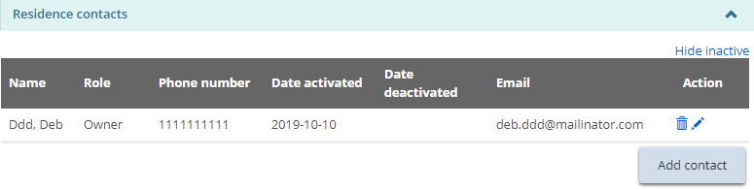
- Repeat step 6 for all contacts.
- Click . The Operation information page appears.

Step 4: Enter the Operation Information
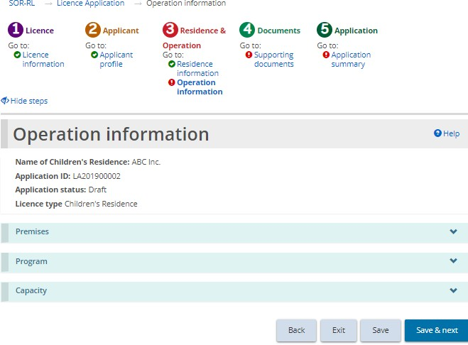
- If the Operation information page is not on your screen, click the Operation information link from the steps section.
- Enter the Premises information.
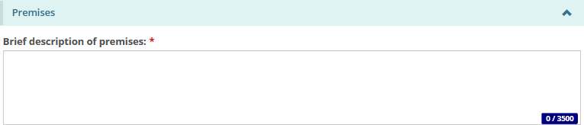
- Enter the Program information.
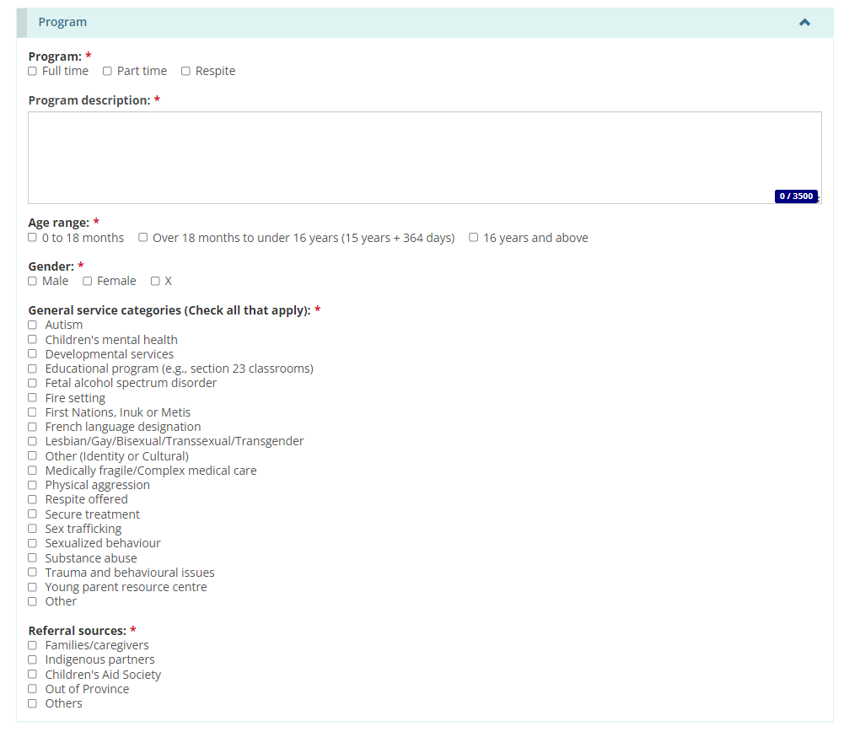
- Scroll down to the Capacity section:
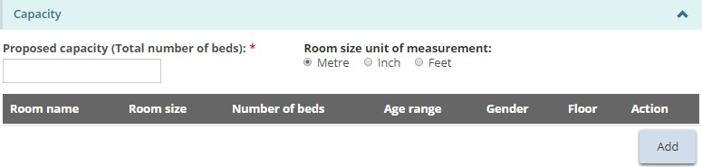
- Click . The Room information page appears.
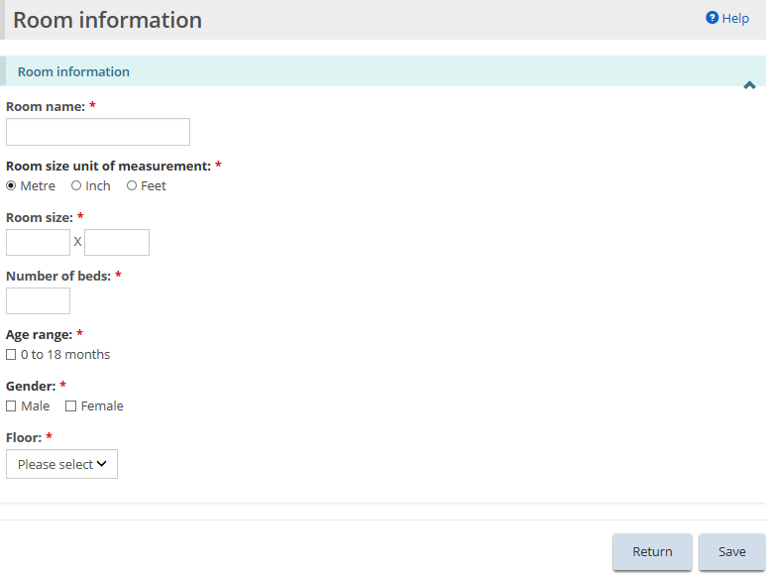
- The required room information varies depending on the program information selected.
- Enter the room information and click .
- Click .
- The room appears in the table.
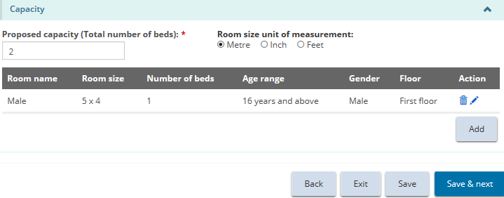
Note: The room size is converted to metres. To view the room size in a different unit of measure, select the unit of measure from the top of the table.
- Repeat step 5 for each room.
- Click . The Supporting documents page appears.

Step 5: Upload supporting documents
Note: You must upload the mandatory supporting documents with your application. Other documents can be added after submission but will be required before your licence is issued.
- If the Supporting Documents page is not on your screen, click the Supporting Documents link from the steps section.
- Upload the documents. For details, see the Working with Supporting Documents section.
- Click . The Application summary page appears.

Step 6: Review and submit
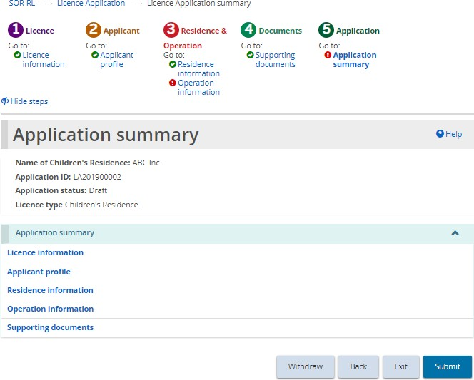
- If the Application summary page is not on your screen, click the Application summary link from the steps section.
- Review the information in the summary.
Tip: To see information under a blue heading, click the sub-heading. To edit the information, click the heading in the steps section.
- To withdraw the application:
- Click 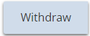.
- A confirmation window appears.
- To continue click . To cancel the withdrawal, click 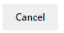.
- Click . The system reviews your entries and verifies that the mandatory information/documents are completed.
- If there is an error, a description of the error/omission appears at the top of the page.
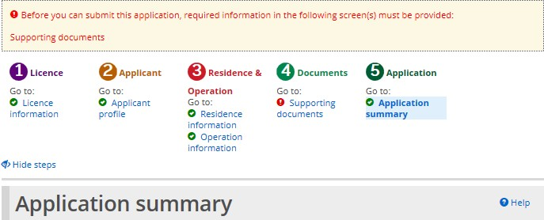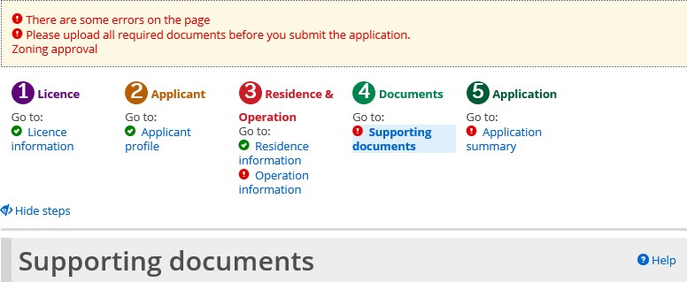
- The error message displays the names of the pages that contain errors. When you go to that page you will see a detailed list of errors or missing information on that page that need to be addressed.
- If the information is complete, a confirmation message appears. Click .
- The Declaration & consent page appears.
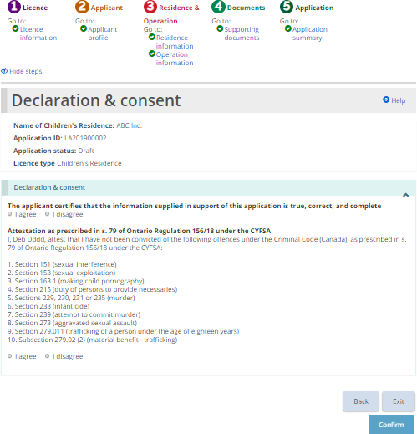
- Read the Declaration and consent, then answer the questions.
Note: An executive officer of the corporation who has authority to bind the corporation must complete the attestation. The declaration and consent must be signed by an officer of the agency that has the authority to legally bind the corporation, for example an executive director, The application can be completed by another individual with appropriate access in the system, however for the required individual to complete the consent and declaration they must first access the application and select the “assign to me” button at the bottom of the summary page. Please see the “Assign to Me” section for further details.
- Click 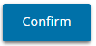. A Confirmation message appears.
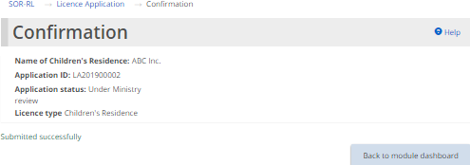
- Click
- The application appears in the submitted section of your dashboard with a status of “Under Ministry review”.
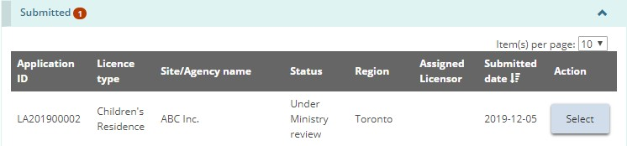

Submitting a Staff Model Home licence application
Note: This section outlines the process for applying for a Staff Model Home licence. The process for applying for a Staff Model Homes licence is identical to the licence application for a Children’s Residence with the exception of adding individual sites. The process for applying for a Children’s Residence can be found in the section above, and the process for applying for a Foster Care Agency licence can be found in the section below.

Step 1: Start the application and enter basic information
Tip: As you work on your application, click to save your entries. You can open your draft application at any time and continue working on it. See the “continuing to work on a draft application” section for details.
- From the SOR-RL home page, click the module.
- The Application module appears.
- Click . The Notice of collection of personal information page appears.
- Read the notice then click . The Licence information pe appears.
Tips: Look at the steps section to monitor your progress.
Symbols indicate the status of each section. A green checkmark appears after you go to the next page. It indicates that the information on that page is complete. A red exclamation mark appears after you go to the next page. It indicates that information is missing from that page and must be completed before you can submit the application. The red exclamation mark does not indicate if the information is correct.
To quickly go to a step, click the step from the steps section.
To hide the list of steps, click . To show the list of steps, click .
- Scroll down to the Licence type section.
- Select “Staff Model Homes”.
- Select the Preferred language of the licence.
- Scroll down to the Funding type information section.
Note: If you are applying as an individual, there is only one option.
- Select the funding type information.
- Scroll down to the Licensing history section.
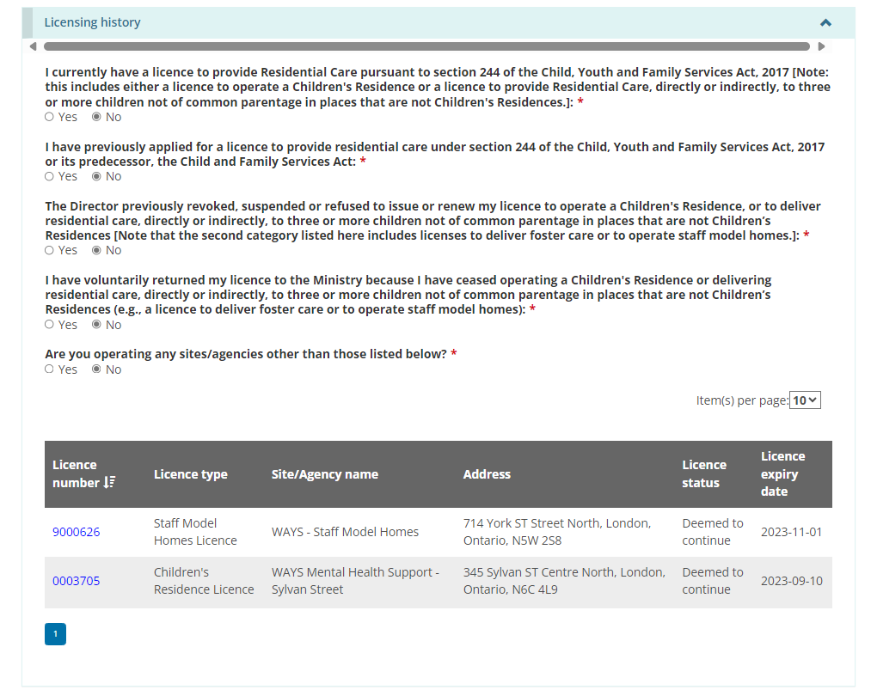
- Answer the licensing history questions.
- More questions may appear depending on your answers. All questions are mandatory and require answers to proceed.
- Click . The Applicant profile section appears.

Step 2: Review the applicant profile
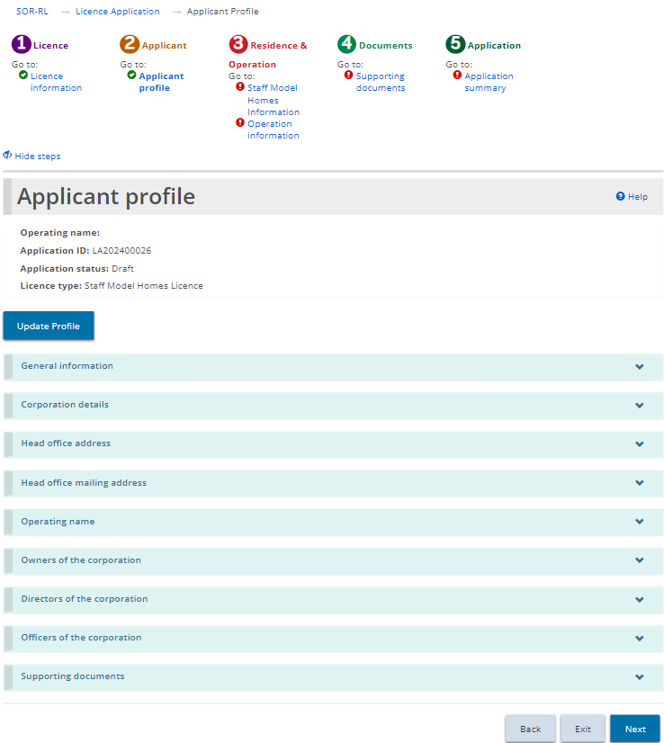
- If the Applicant profile page is not on your screen, click the Applicant profile link from the steps section.
- Expand and review all the sections of your profile.
- If changes are required:
- Click 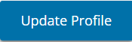. This brings you to the Profile module.
- Make the changes as required and save the changes.
- Click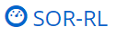. The SOR-RL home page appears.
- To return to your application, click the module, then select the draft application from your dashboard. The Application summary screen appears.
- To proceed to the next section, click Staff Model Homes Information.
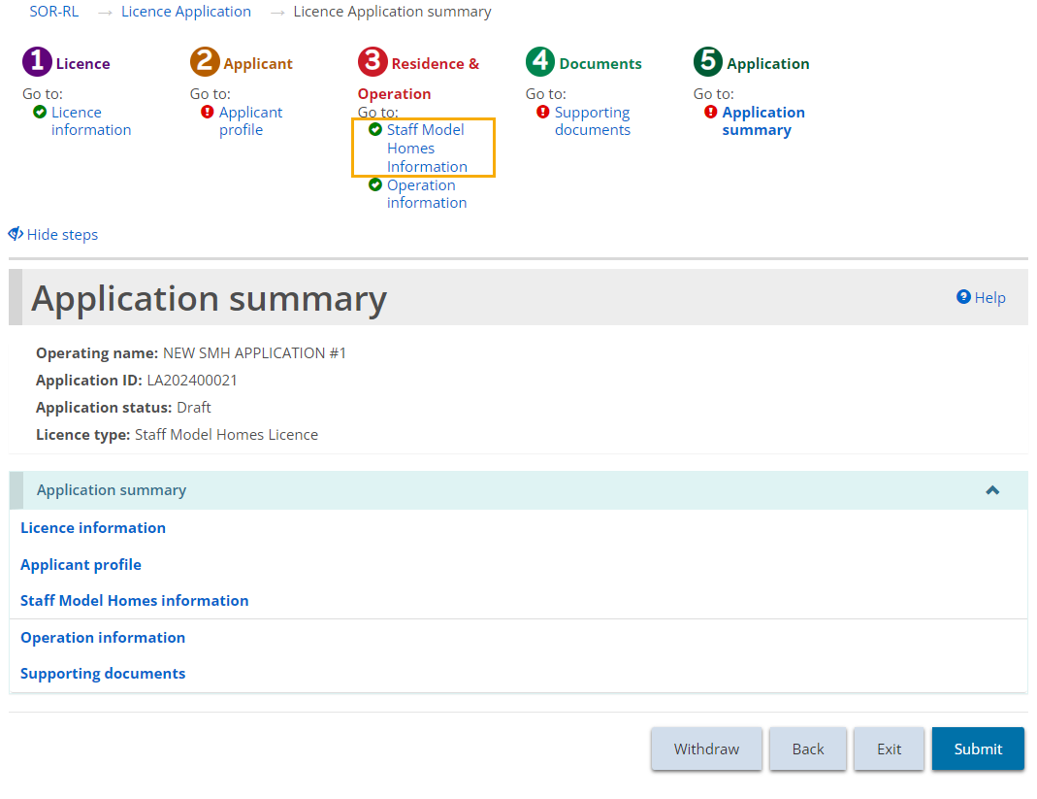
- If changes are not required, click . The Staff Model Homes Information section appears.

Step 3: Enter the Staff Model Homes Information
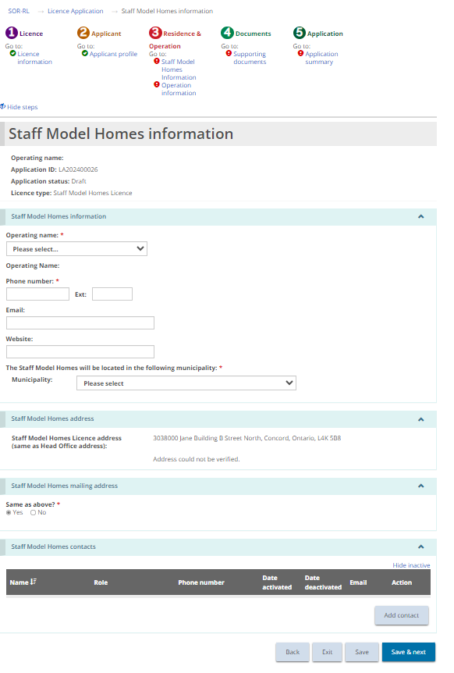
- Enter the Staff Model Homes information.
- Indicate whether the licence mailing address is the same as the licence address.
- Add Staff Model Homes contacts.
Note: Staff Model Homes contacts are individuals with oversight of all the Staff Model Homes sites. At least one contact needs to be added before the application can be submitted.
- Once done, press . The Operation information page appears.

Step 4: Enter the Operation Information
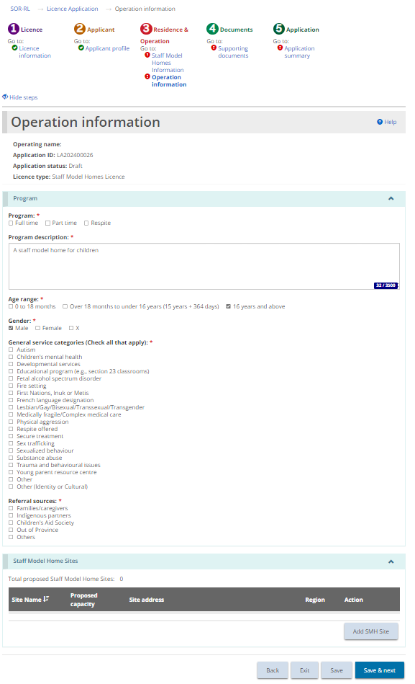
- Populate all fields on the Operation Information screen. Press Save.
- Click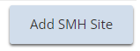. The Staff Model Home Site details page opens.
Note: At least two sites must be added to a Staff Model Home licence application. The following screen must be completed for each individual site to be added to the Staff Model Home licence. Once the licence is approved, additional sites can be applied for through the Change Request module.
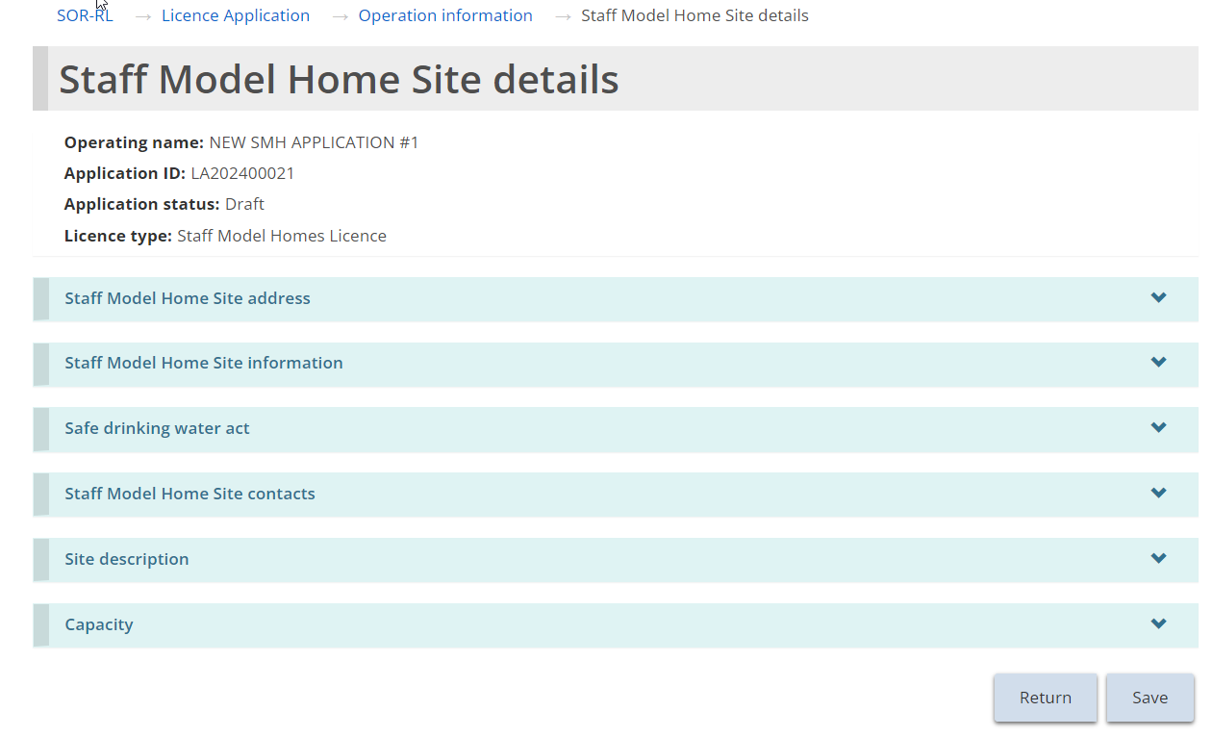
- Enter the Staff model Home Site address.
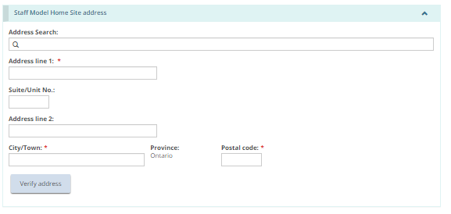
- Users may manually populate the address fields or utilize the predictive address search field. An address verification mechanism is available.
Note: An address is not required to be verified for it to be saved in the system.
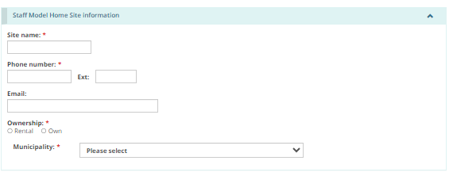
- Enter the site-specific mailing address.
- Enter the Safe Drinking Water Act information.
- Add the Staff Model Home site contacts by clicking .
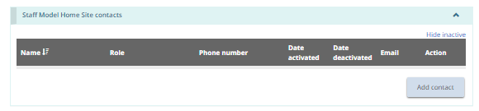
Note: Enter the onsite residence contact for the staff model home site.
- The Residence contact details page appears.
- Enter the contact information and click .
- Click . The contact name appears in the table.
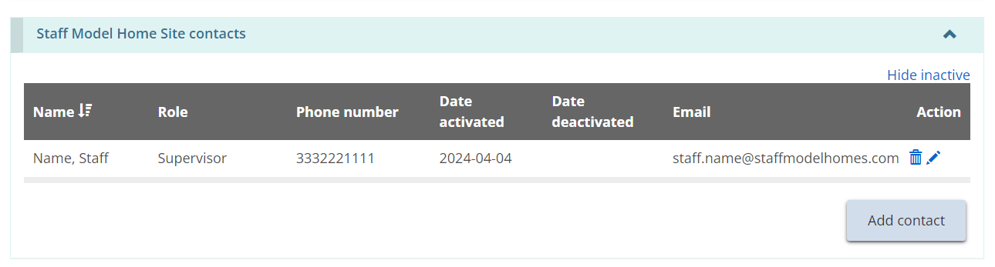
- Repeat steps for all site contacts.
- Enter the site description details, brief description of premises and brief description of clients served.
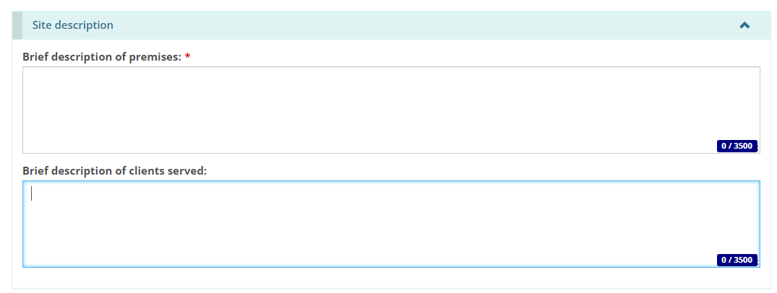
- Scroll down to the Capacity section. Add the proposed capacity of the licence.
Note: The capacity of any site applied for in a Staff Model Home licence cannot exceed two.
- Click . The Room information page appears.
- Enter the room information and click . Click . The room appears in the table.
Note: The room size is converted to metres. To view the room size in a different unit of measure, select the unit of measure from the top of the table.
- Repeat steps for each room.
- Click . The Supporting documents page appears.

Step 5: Upload supporting documents
Note: You must upload the mandatory supporting documents with your application. Other documents can be added after submission but will be required before your licence is issued.
- If the Supporting Documents page is not on your screen, click the Supporting Documents link from the steps section.
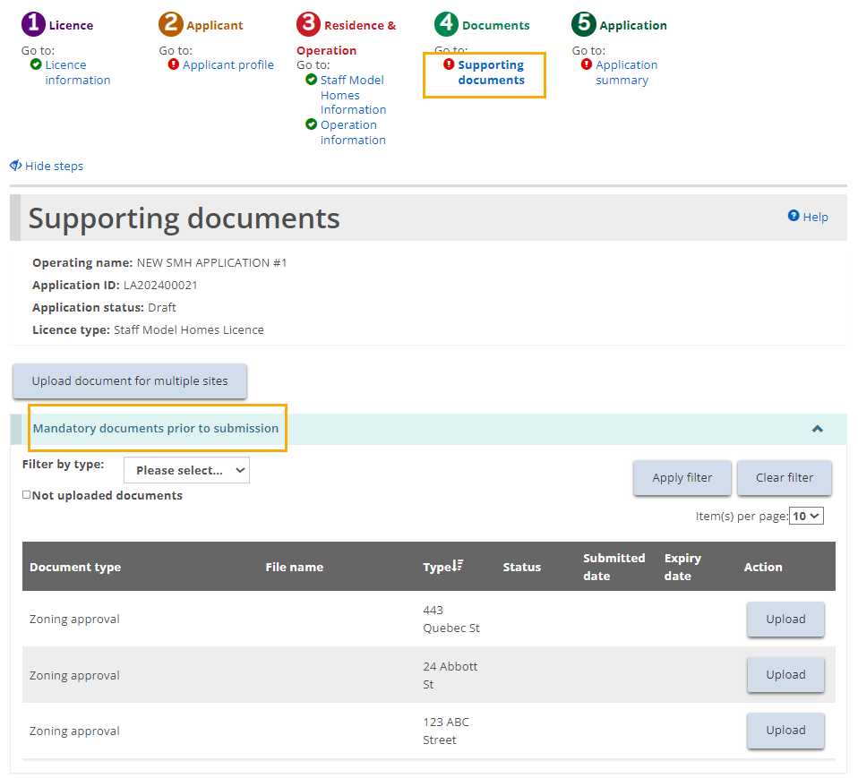
- Upload the documents. For details, see the Working with Supporting Documents section, including the Uploading a document to multiple sites under one licence section.
- Click . The Application summary page appears.

Step 6: Review and submit
- If the Application summary page is not on your screen, click the Application summary link from the steps section.
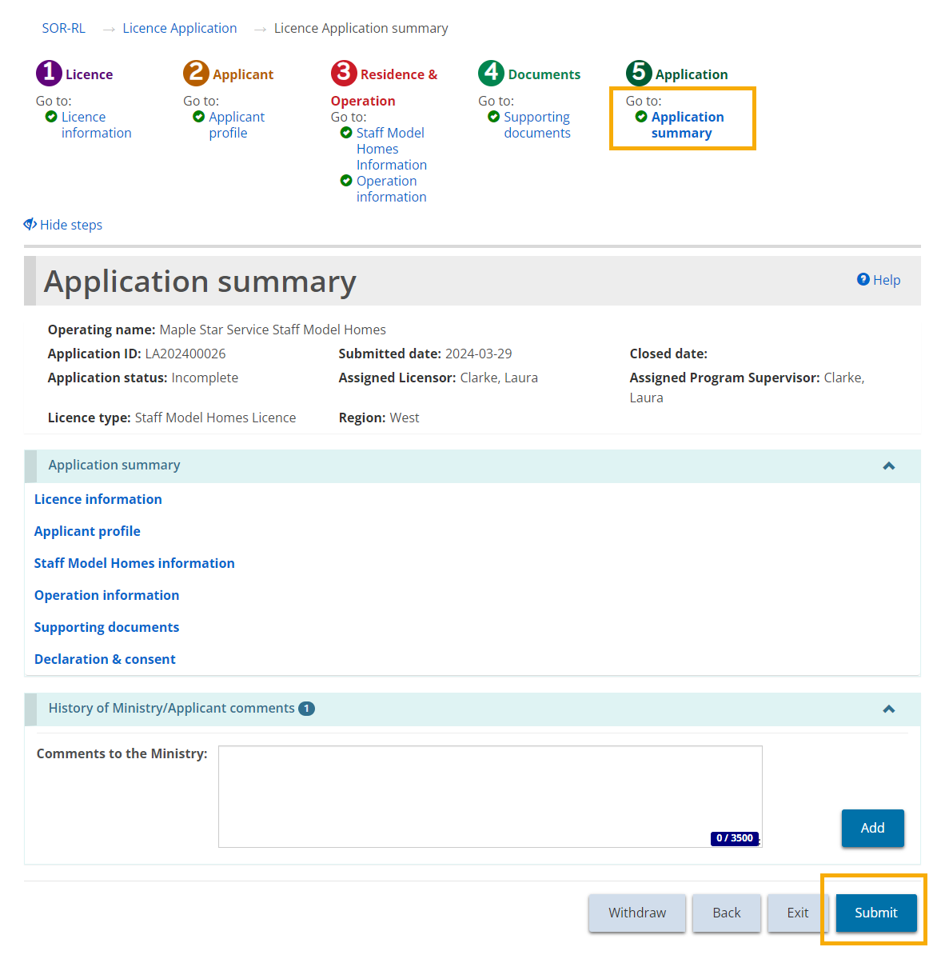
- Review the information in the summary.
Tip: To see information under a blue heading, click the sub-heading. To edit the information, click the heading in the steps section.
- To withdraw the application click . A confirmation window appears. To continue click . To cancel the withdrawal, click .
- Click . The system reviews your entries and verifies that the mandatory information/documents are completed.
- If there is an error, a description of the error/omission appears at the top of the page.
- The error message displays the names of the pages that contain errors. When you go to that page you will see a detailed list of errors or missing information on that page that need to be addressed.
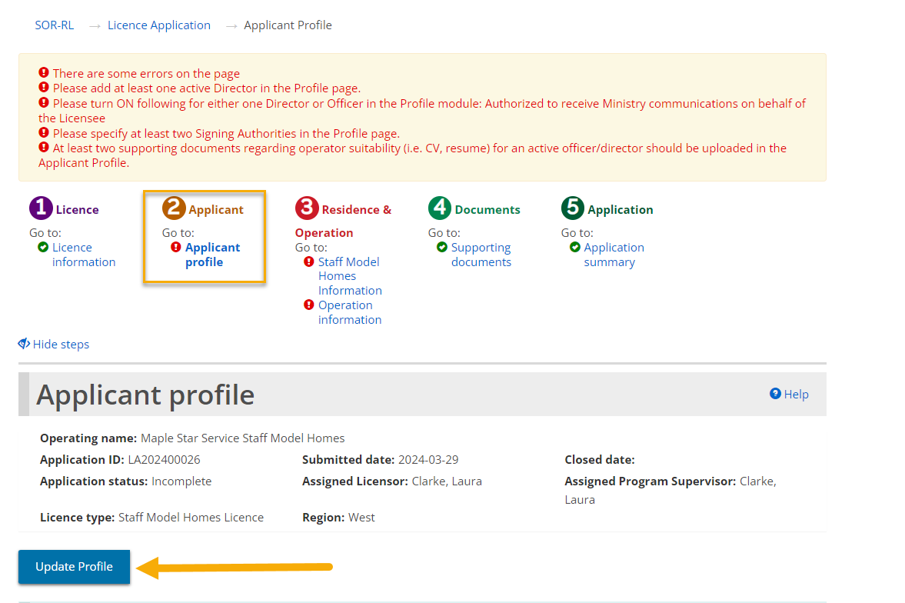
- If the information is complete, a confirmation message appears. Click .
- The Declaration & consent page appears.
- Read the Declaration and consent, then answer the questions.
Note: An executive officer of the corporation who has authority to bind the corporation must complete the attestation. The declaration and consent must be signed by an officer of the agency that has the authority to legally bind the applicant, for example an executive director, The application can be completed by another individual with appropriate access in the system, however for the required individual to complete the consent and declaration they must first access the application and select the “assign to me” button at the bottom of the summary page. Please see the “Assign to Me” section for further details.
- Click . A Confirmation message appears.
- Click .
- The application appears in the submitted section of your dashboard with a status of “Under Ministry review”.
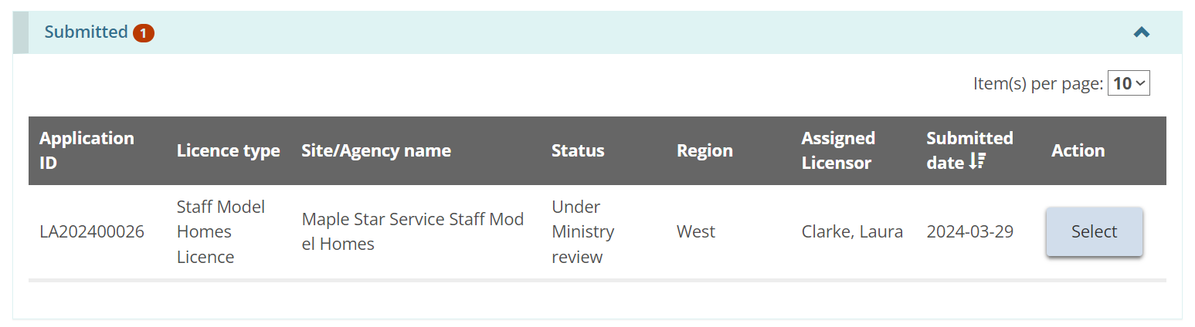

Submitting a Foster Care Agency Licence Application
The instructions in this section are for a Foster Care Agency application only. For instructions on submitting a Children’s Residence or Staff Model Home application, reference the previous two sections.

Step 1: Start the application and enter basic information
Tip: As you work on your application, click to save your entries. You can open your draft application at any time and continue working on it.
- From the SOR-RL home page, click the module. The Licence Application module appears.
- Click . The Notice of collection of personal information page appears.
- Read the notice then click . The Licence information pe appears.
Tips: Look at the steps section to monitor your progress.
Symbols indicate the status of each section. A green checkmark appears after you go to the next page. It indicates that the information on that page is complete. A red exclamation mark appears after you go to the next page. It indicates that information is missing from that page and must be completed before you can submit the application. The red exclamation mark does not indicate if the information is correct.
To quickly go to a step, click the step from the steps section.
To hide the list of steps, click . To show the list of steps, click .
- Scroll down to the Licence type section.
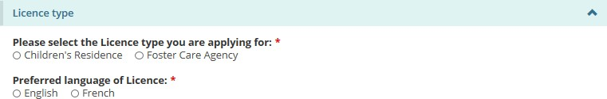
- Select “Foster Care Agency”.
- Select the Preferred language of the licence. The page expands.
- Scroll down to the Funding type information section.
Note: If you are applying as an individual, there is only one option.
- Select the funding type information.
- Scroll down to the Licensing history section.
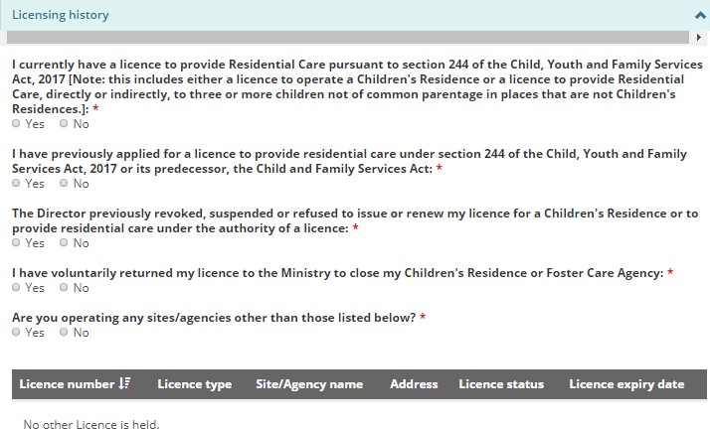
- Answer the licensing history questions.
- More questions may appear depending on your answers. Be sure to answer all the questions.
- Click . The Applicant profile page appears.

Step 2: Review the applicant profile
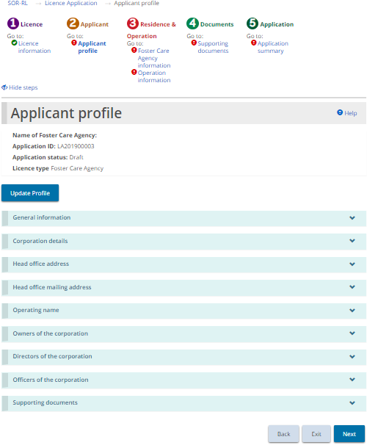
- If the Applicant profile page is not on your screen, click the Applicant profile link from the steps section.
- Expand and review all the sections of your profile.
- If changes are required:
- Click .The Profile page appears.
- Make the changes as required.
- Save the changes.
- Click . The SOR-RL home page appears.
- To return to your application: Click then select the draft application from your dashboard.
- Click . The Foster Care Agency information page appears.

Step 3: Enter the Foster Care Agency information
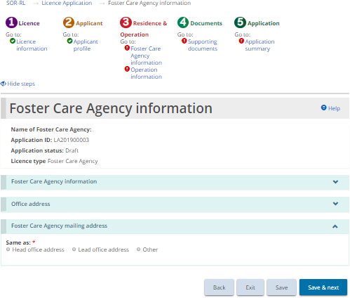
- If the Foster Care Agency information page is not on your screen, click the Foster Care Agency information link from the steps section.
- Scroll down to the Foster Care Agency information section.
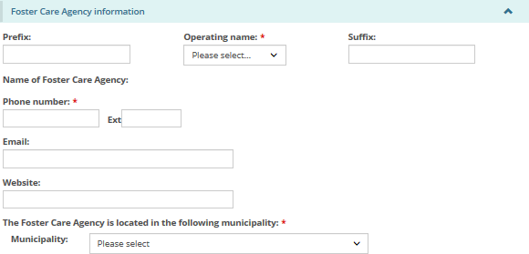
- Enter the Foster Care Agency information.
- Scroll down to the Office address section.
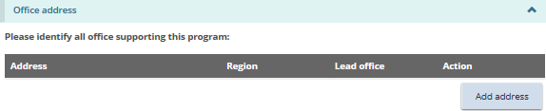
- Click 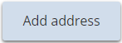. The office address page appears.
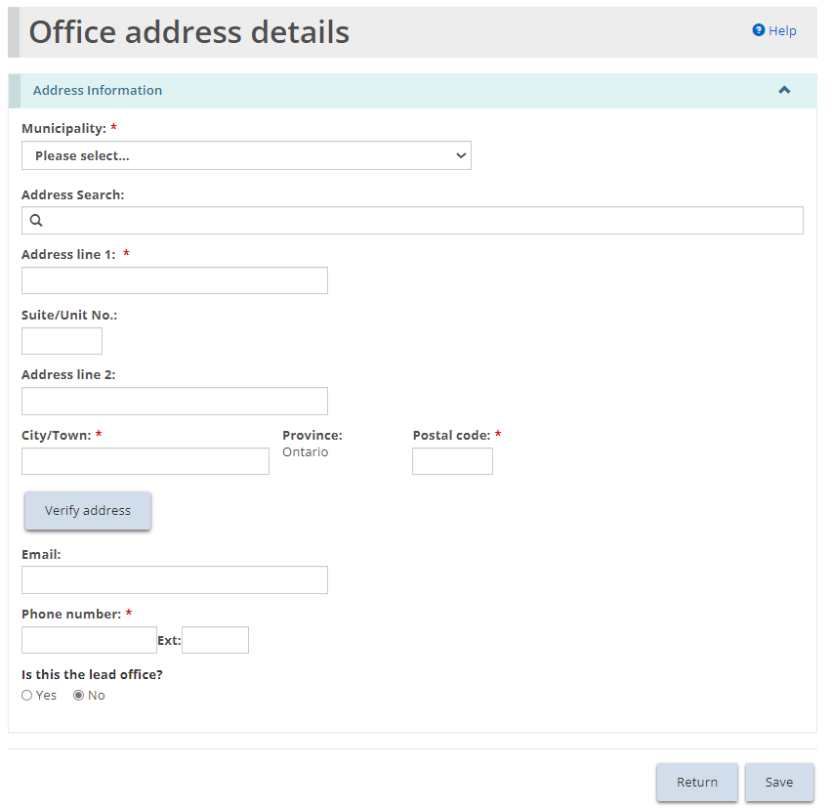
- Users may manually populate the address fields or utilize the predictive address search field. An address verification mechanism is available.
Note: An address is not required to be verified for it to be saved in the system.
- Enter the office address information. Click .
- Click . The office appears in the table.
- Be sure to list all office addresses that provide support/supervision to the foster care agency.
- Scroll down to the Foster Care Agency mailing address section.
- Select/enter the Foster Care Agency mailing address information.
- Click . The Operation information page appears.

Step 4: Enter the operation information
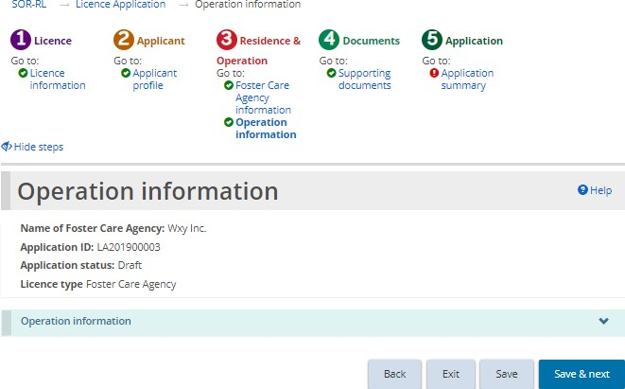
- If the Operation information page is not on your screen, click the Operation information link from the steps section.
- Enter the Operation Information.
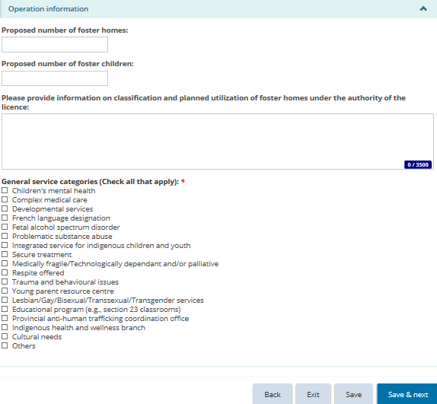
- Click . The Supporting documents page appears.

Step 5: Upload supporting documents
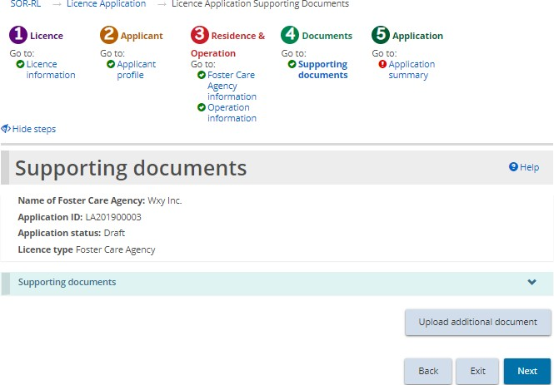
- If the Supporting Documents page is not on your screen, click the Supporting Documents link from the steps section.
- Upload the documents. For details see the Working with Supporting Documents section.
Note: There are no mandatory documents required with your application. Documents can be added after submission, but documents must be uploaded before your licence will be issued.
- Click . The Application summary page appears.

Step 6: Review and submit
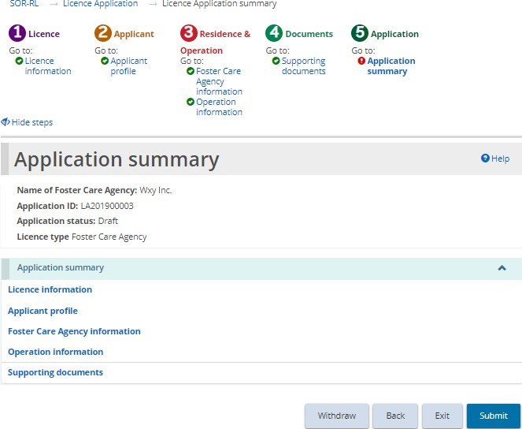
- If the Application summary page is not on your screen, click the Application summary link from the steps section.
- Review the information in the summary.
Tip: To see information under a blue section sub-heading, click the sub-heading. To edit the information, click the heading in the steps section.
- To withdraw the application:
- Click .
- A confirmation window appears.
- To continue click . To cancel the withdrawal, click .
- Click . The system will review your entries and verify that the mandatory information/documents are completed.
- If there is an error, a description of the error/omission appears at the top of the page.
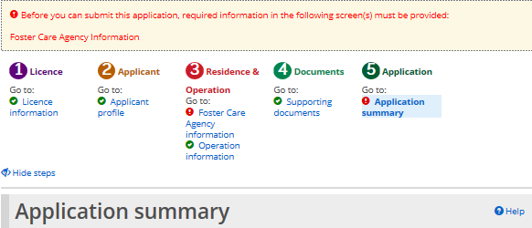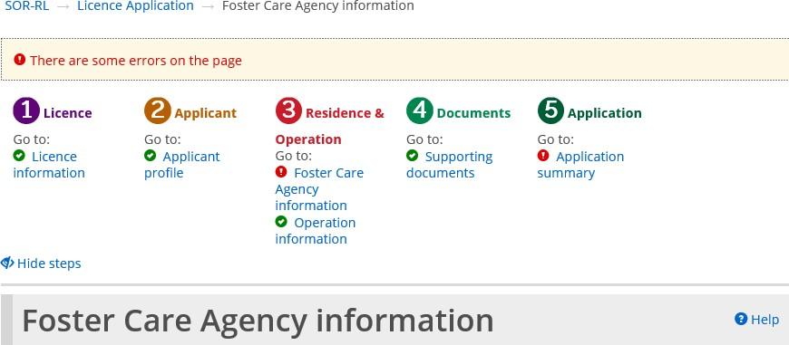
- The error message displays the names of the pages that contain errors. When you go to that page you will see a detailed list of errors or missing information on that page that need to be addressed.
- If the information is complete, a confirmation message appears.
- Click . The Declaration & consent page appears.
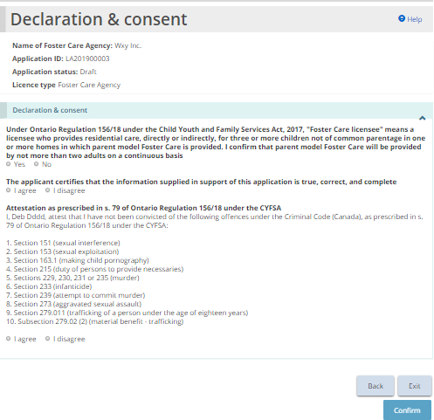
- Read the Declaration and consent, then answer the questions.
Note: An executive officer of the corporation who has authority to bind the corporation must complete the attestation. The declaration and consent must be signed by an officer of the agency that has the authority to legally bind the applicant, for example an executive director, The application can be completed by another individual with appropriate access in the system, however for the required individual to complete the consent and declaration they must first access the application and select the “assign to me” button at the bottom of the summary page. Please see the “Assign to Me” section for further details.
- Click . A confirmation message appears.
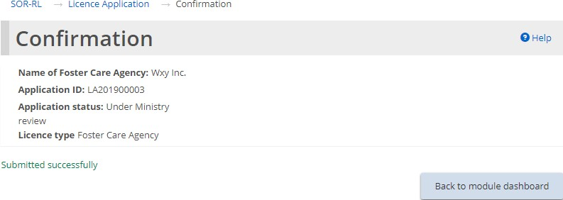
- Click 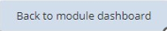. The application appears in the submitted section of your dashboard with a status of “Under Ministry review”.
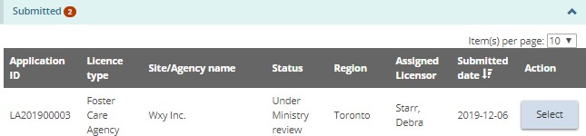

Continuing to work on a draft application
A draft application is an application that has not been submitted. The ministry cannot view a draft application.
- Click the module. The Applications module appears.
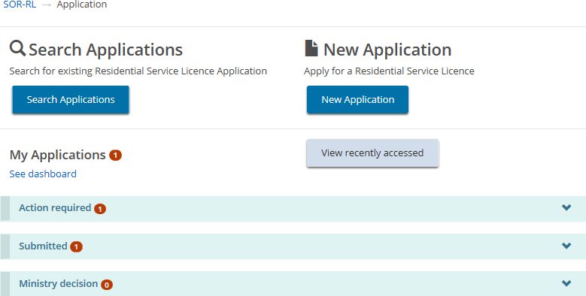
- Expand the Action required section. A table appears showing draft applications.
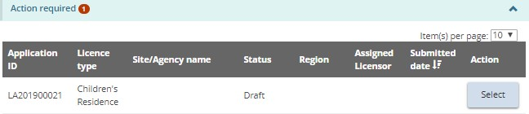
- Click . Continue updating the application.

Viewing a submitted application
Once an application has been submitted, the applicant is unable to edit the information submitted, unless additional information or revisions are requested by the ministry.
Although information cannot be edited unless requested by the ministry, at any time, you can:
- Upload supporting documents that have not been marked as “Not required” or “Satisfactory” by the ministry or documents that have been marked as “Pending Revision”.
- Update the Owner, Director, Officer information in the Profile module.
- Withdraw the application.
- Click themodule. The Application module appears.
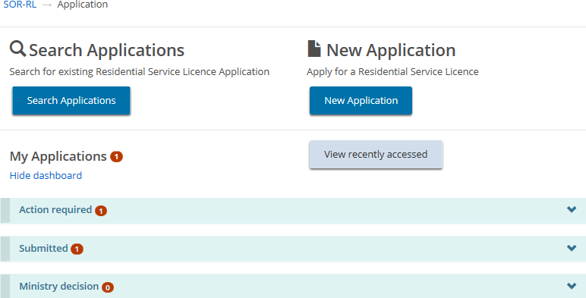
- Under the dashboard, expand the Submitted section.
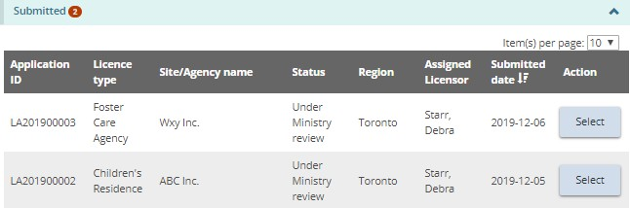
- Click . The Application summary page appears.
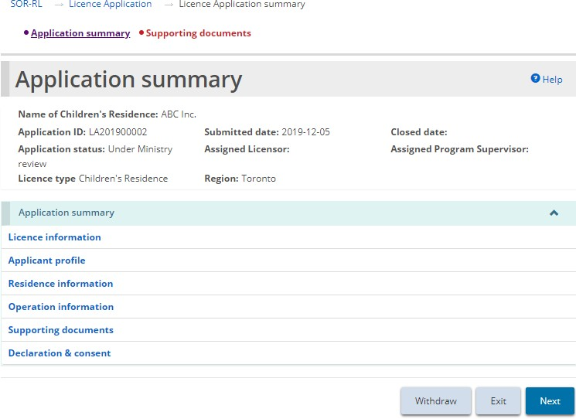
- To see the contents of a section, click the blue section heading.
- Click .

Revising/editing a submitted application
A submitted application cannot be revised or corrected unless the ministry changes the status of the application to “Incomplete”. Contact the ministry to change the status. Once the status changes, you will see it in the dashboard.
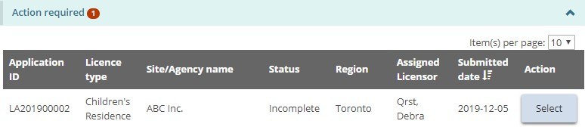
- Open the application with the status “Incomplete”.
- From the Application Summary page, scroll down to the History of Ministry/Applicant comments section and read the ministry comment.
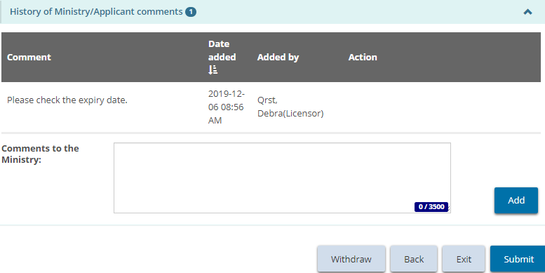
- Make the changes required. Save the changes.
- Click Application Summary. The Application Summary page appears.
- If required, add a note back to the ministry then click 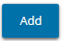.
- Click . The Declaration and Consent page appears.
- Read the declaration and consent, then answer the questions.
- Click. A Confirmation message appears.
- Click 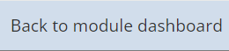.
- The application status changes back to “Under Ministry Review”.

Withdrawing a draft or submitted application
- Open the application. The Application summary page appears.
- Click . A confirmation message appears.
- Click to continue.
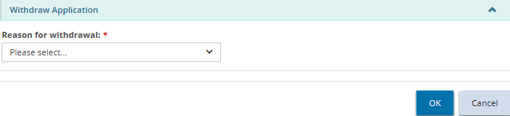
- Select the reason for the withdrawal.
- Click .

Decision notification
You will be notified by email when a decision is reached. You will also see the decision in the Ministry decision section.
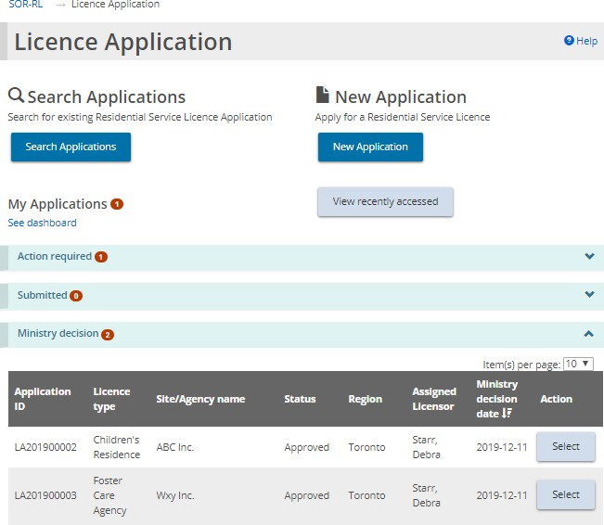

Working with supporting documents
There are several areas in SOR-RL where you can upload and edit documents. The process is documented here for reference.
Note: The following types of files can be uploaded: graphic (gif, jpeg, png, pdf), documents (pdf, rtf, doc, docx, plain text, ppt), and spreadsheets (xls, xlsx).
Note: If the document is larger than 10MB, it must be split it into smaller files and uploaded separately. Consult with the ministry if you have questions about large files.
Note: Do not email documents to the ministry. All communication with the Ministry regarding a licence must be done through SOR-RL. The system notifies recipients of all correspondence and action items. SOR-RL automatically saves communication.
You can upload documents itemized in a list, or, in some cases, you can upload an additional document.

Uploading a document from a list
The documents contained in the supporting documents list depend on the module (Licence Application, Director’s approval, etc.) and licence type. The list may be divided into mandatory documents, documents required prior to submission, and other mandatory documents.
Note: If the document status of a mandatory document is “Submitted”, no further updates can be made. For non-mandatory documents, revised documents may be submitted after the initial submission.
- Open the application/licence. The summary page appears.
- Click or . The Supporting documents page appears.
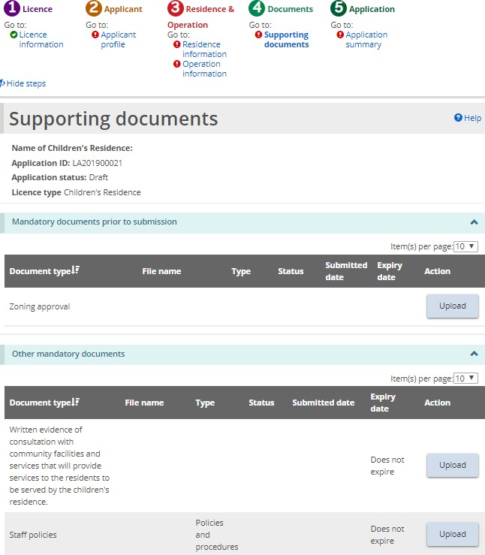
Partial page example of a Supporting Documents page from a Children’s Residence application
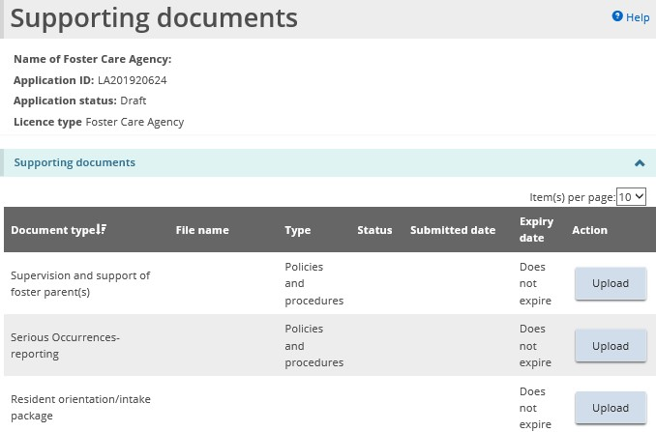
Partial page example of a Supporting Documents page from a Foster Care Agency application.
Tip: To quickly identify the documents that have not yet been uploaded, click on the Status column header to sort the list and move the documents that have not been uploaded to the top of the table.

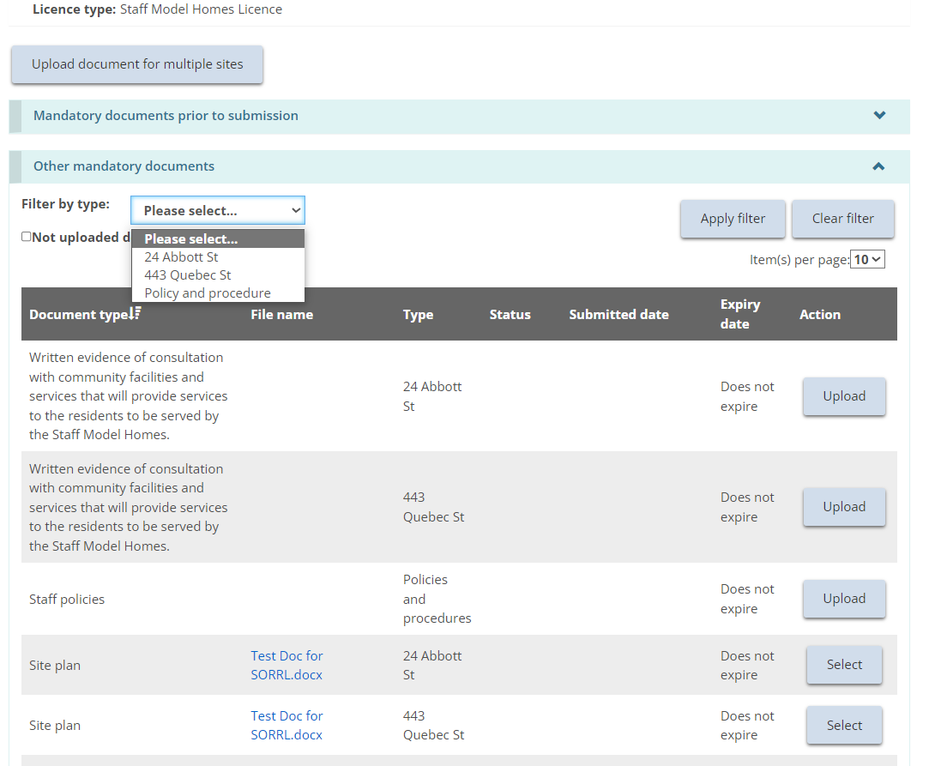
Partial page example of a Supporting Documents page from a Staff Model Home.
Tip: To quickly navigate the documents for a Staff Model Home licence, the user can filter by site/document type or documents that have not yet been uploaded. Additionally, columns can be filtered by clicking on the column header for example “Type” or “Status” or “Document Type”.
- Click 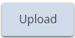 or .
Note: See the section below for how to upload one document to multiple sites (for Staff Model Homes only).
- The Upload supporting document page appears.
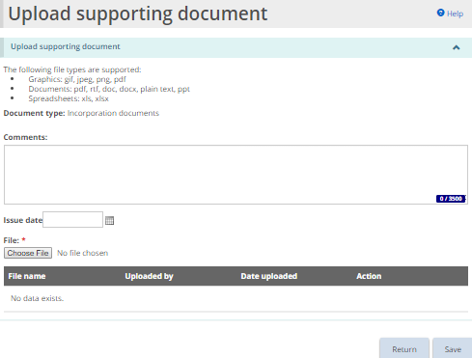
- The page may look different depending on the type of document being uploaded.
- You can enter a description of the document in the Comments field.
- Select the Issue Date of the document if applicable.
- Click 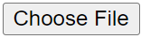. The Choose File to Upload page appears.
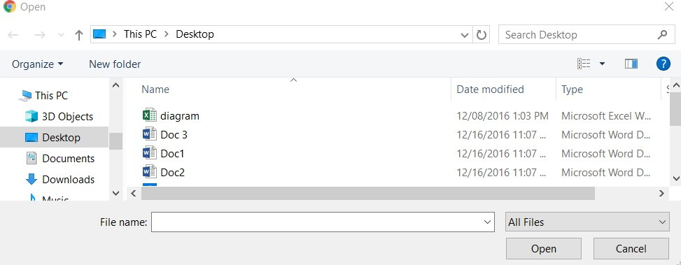
- Select the document and click .
- Click . The file name appears in the table.
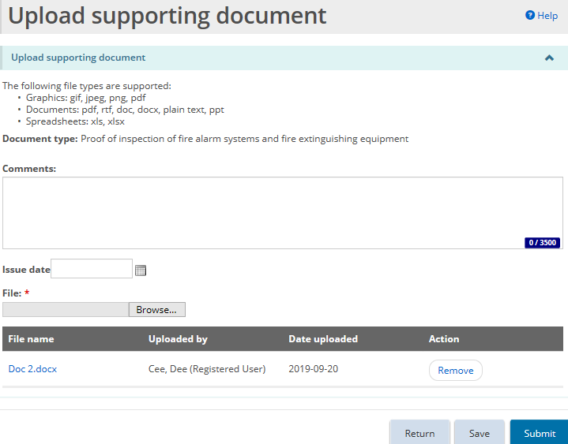
- Click . A confirmation message appears.
- Click . The document appears in the Supporting documents page with the status of “Submitted”.
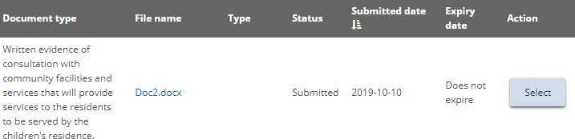
Note: Once a mandatory document has been uploaded and submitted to the ministry for review, further updates cannot be made.

Uploading a document to multiple sites under one licence (Staff Model Homes only)
For staff model homes licensees, supporting documents can be uploaded at either the licence level (e.g. policies and procedures), to an individual site (e.g. drinking water system report or site plan), or to multiple sites at one time (e.g. resident orientation intake package). Licence level documents are only required to be uploaded once and apply to the entire licence, not to an individual site.
Please refer to the previous section for instructions on uploading individual supporting documents.
Where the same document may apply to multiple sites, (e.g. zoning approval) the licensee may submit one document and apply it to multiple sites at one time.
- From the supporting document screen in the applicable module. Select the “Upload document for multiple sites” button.
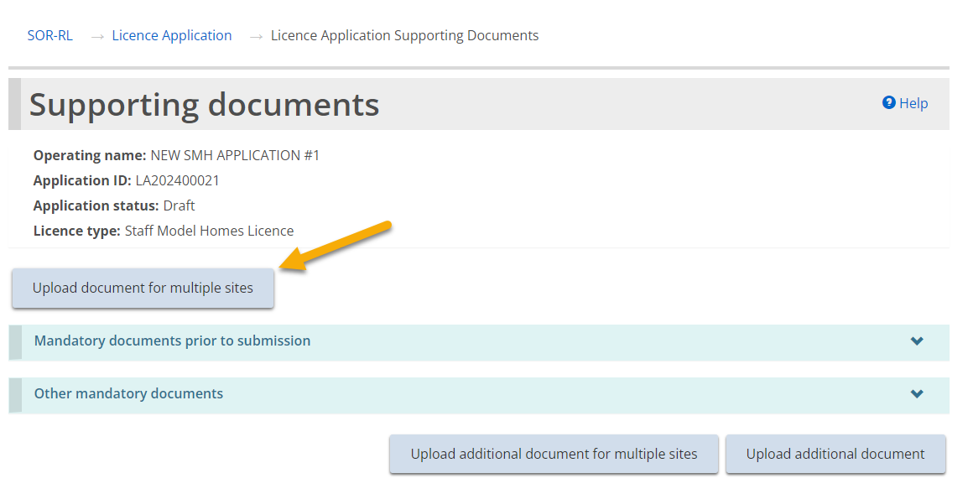
- Select the applicable document type and each site that this uploaded document applies to from the drop-down menus.
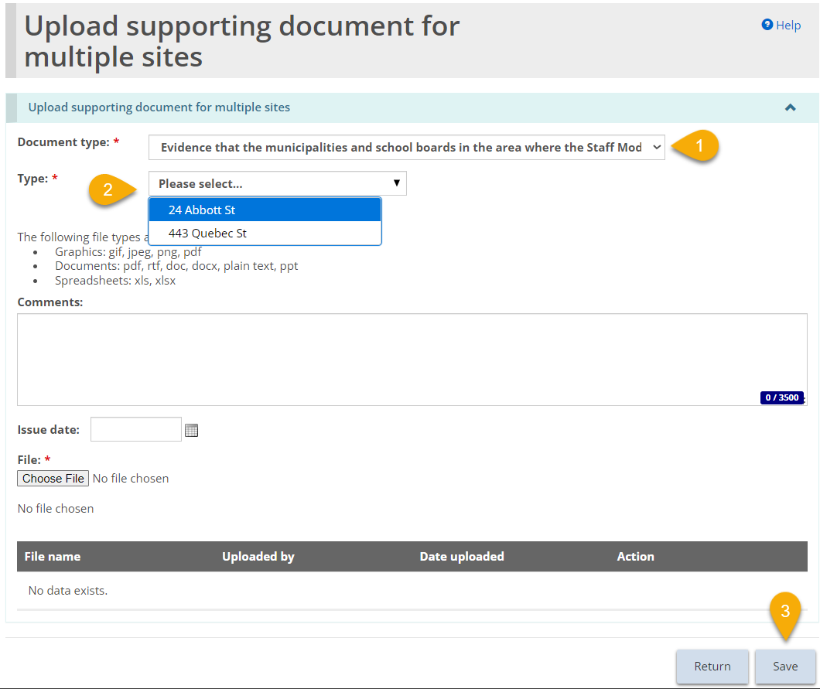
- Upon clicking the “save” button (or ‘submit’ where available, see note below), the uploaded document will be copied to each of the selected sites.
Note: If the user saves a document to multiple sites, but navigates away from this page prior to selecting “submit”, they cannot return to this page to update or submit the documents at a later date. In this instance, the document would have to be updated or submitted individually for each selected site, or submitted to the ministry when the application is submitted.
This functionality is also available for uploading an additional document type.
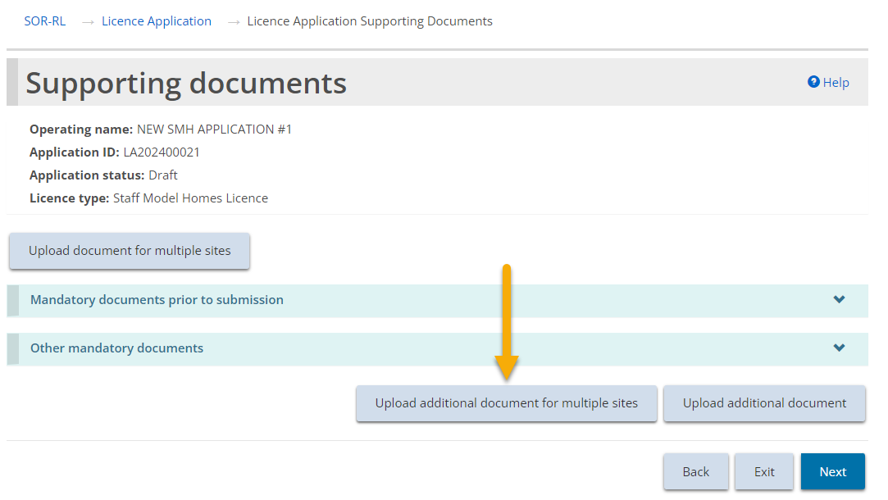
Note: Policies and procedures are uploaded once and apply to the whole licence. See previous section for steps to complete. They cannot be assigned to an individual or multiple sites.

Uploading a document that is not in the supporting document list
If the item (Licence Application, Director’s approval, etc.) status is “Draft” or “Incomplete”, there will be an 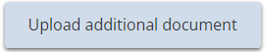 button on the Supporting Documents page. This button allows you to upload other documents.
- From the application/licence, click . The Supporting documents page appears.
- Click . The Upload supporting document page appears at the bottom of the page.
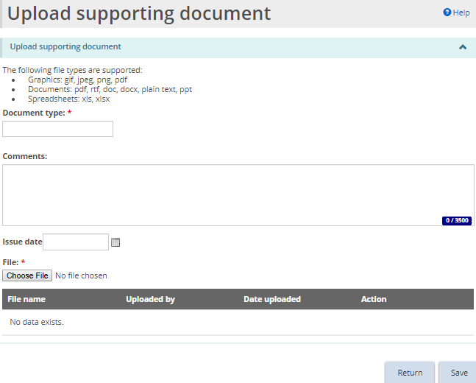
- Enter a short description of the document in the Document type field. (Mandatory)
- Enter a description of the document in the Comments field. (Optional)
- Select the issue date if applicable.
- Click . The Choose File to Upload page appears.
- Select the document and click .
- Click . The file name appears in the table.
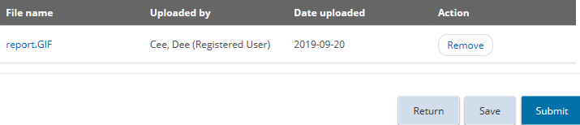
- Click . The document appears in the Additional documents table.
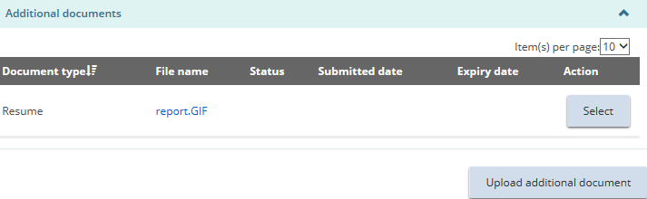

Viewing the contents of an uploaded document
- From the application/licence, click . The Supporting documents page appears.
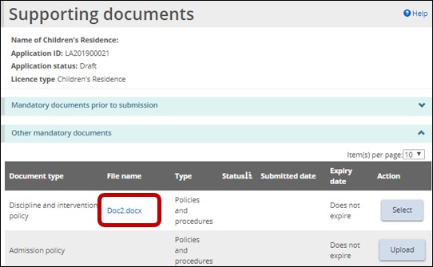
- From the Supporting documents page, click the blue file name link. Depending on your browser, a message appears, or the document name appears at the bottom of your screen.
- Click or click the document name at the bottom of the page. The document opens.
- When you are done, close the document.

Removing a draft document
Note: A document cannot be removed once it is submitted. If a document has been uploaded and saved, it may be removed.
- From the application/licence, click . The Supporting documents page appears.
- Click . The Upload supporting document page appears.
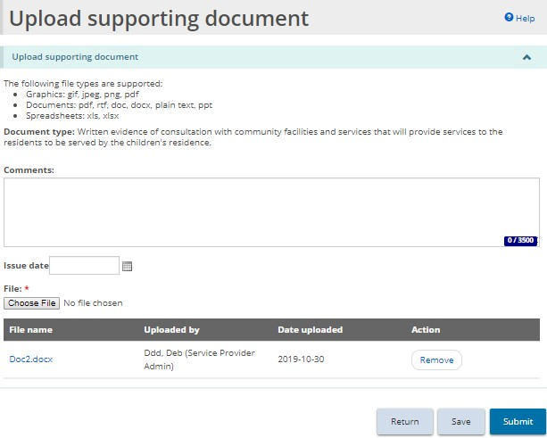
- Click . A confirmation message appears. Click to continue.
- Click .

Working with a submitted document
You will receive an email if a supporting document needs to be updated. In addition, some documents with an expiry date will need to be updated. You can see all the supporting documents requiring updates and those nearing expiry in the Supporting Documents module.
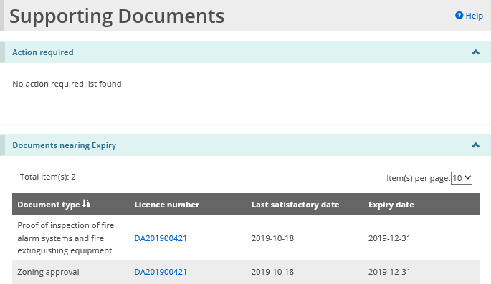

Updating a document when action is required
- From the SOR-RL home page, click . The Supporting Documents module appears. Documents requiring updates have the status of “Pending Revision”.
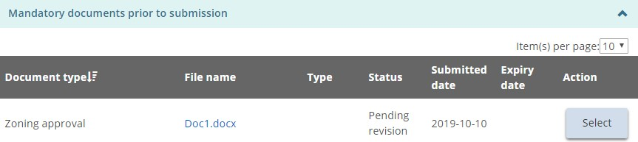
- Select the document to be updated.
- Select the Issue date.
- Click . The Choose File to Upload page appears.
- Select the document and click .
- Click . The document is submitted to the ministry for review.
- Click .
- Enter a reply to the ministry in the History of Ministry/Applicant comments section.
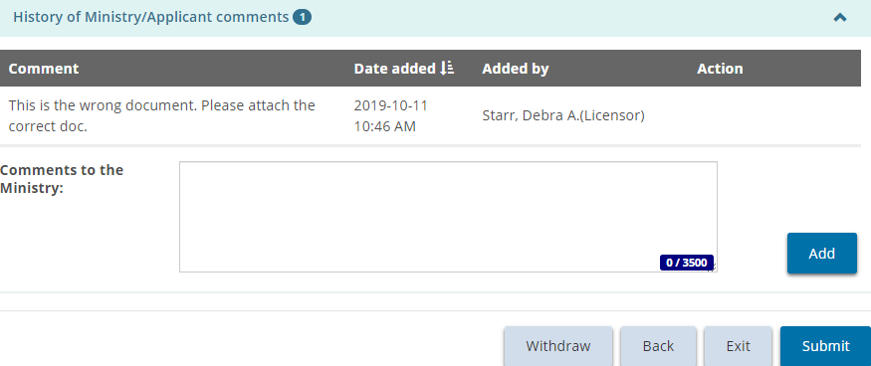
- Click then click . A confirmation message appears.
- Click . The declaration and consent message appears.
- Read the declaration and consent then answer the questions.
- Click .

Updating a document that is nearing expiry
You will be sent a reminder notification before a document expires.
- From the SOR-RL home page, click . The Supporting Documents module appears.
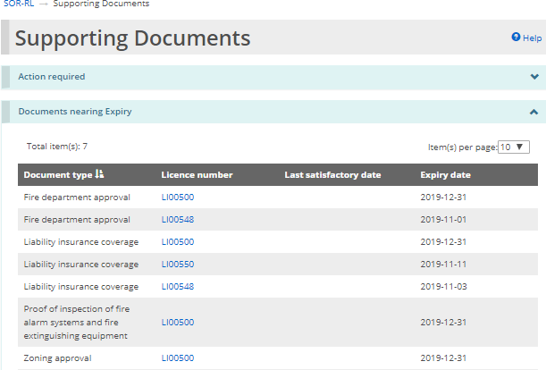
- Click the blue licence number link. The Licence summary page appears.
- Click  . The Supporting documents page appears.
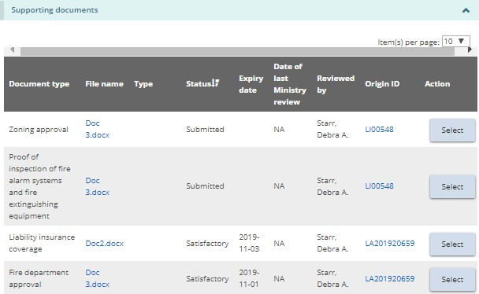
- Click the button of the document type you want to update/upload.
- The Upload supporting document page appears.
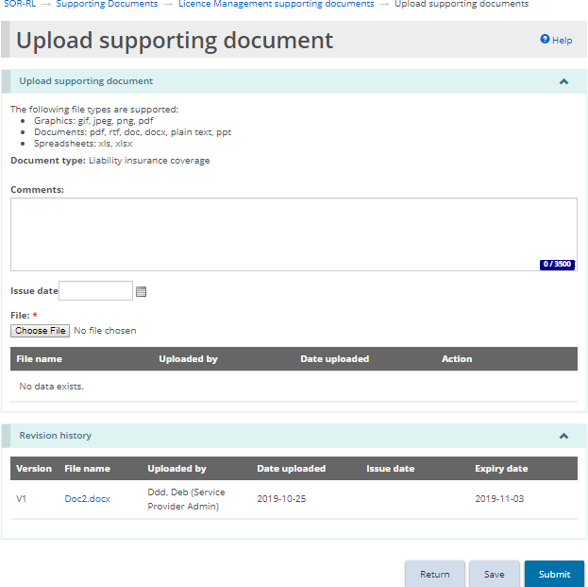
- Click .
- Select the file and click .
- Click . The file name appears in the list.
- Click . The file is submitted to the ministry for review.
- When you open the document link again, the Revision history section displays all the submitted versions of the document.
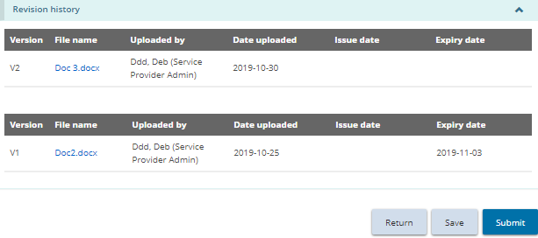

Working with Monthly Reporting
For foster care, children’s residence, and staff model home licensees, a monthly reporting module has been created to help facilitate the monthly reporting of complaints and mechanical restraints to the CYFSA Director as required by the new regulatory requirements (July 1, 2023).
Youth justice facilities are only required to submit the complaint report to the Provincial Director through the new monthly reporting module in SOR-RL. The current process for monthly reporting of mechanical restraints will remain in place for these facilities.
Note: Submission of the monthly report through SOR-RL does not replace the reporting of mechanical restraints or serious complaints as serious occurrences (SORs) to the ministry. All serious complaints and mechanical restraints which meet the SO Reporting criteria set out in the MCCSS SOR Guidelines must be reported as SOs to the ministry through SOR-RL. Any errors or updates identified on the monthly report must also be rectified through the established SOR process.

Monthly Report User
The Monthly Reporting module is only accessible to users with the Monthly Reporting User role assigned to their profile. It can be accessed from the drop-down menu in the top right corner of the SOR-RL landing page.
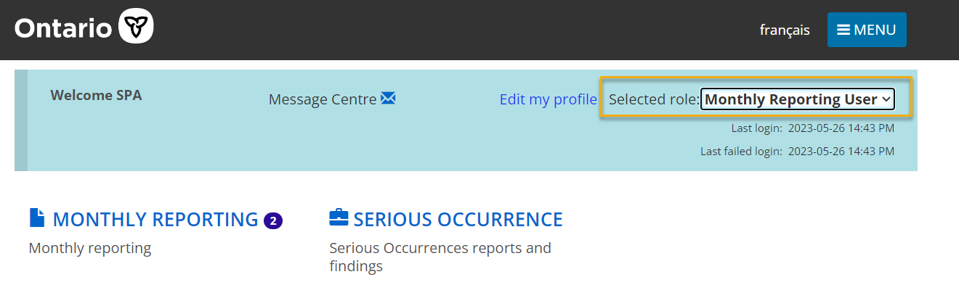
The Monthly Reporting User will have read and write access to the Monthly Reporting module as well as read-only access to the Serious Occurrence module. This access is necessary to ensure they can verify the information populated in the monthly report template. This role can be assigned to any SOR-RL user, by users with the Service Provider Administrator (SPA) role with a Local Registration Authority (LRA) designation.
For privacy purposes, for children's residences, this role is assigned on a site-specific basis. For a service provider with multiple sites, each Monthly Reporting User can be assigned to any or all sites, but they only have access to the monthly report(s) and SORs for their assigned sites. For foster care and staff model homes, monthly reporting users are assigned at the licence level rather than the site level, and therefore have access to monthly reports and SORs for the entire licence.
Note: Only staff deemed appropriate to have access to the information in both the Monthly Reporting and Serious Occurrence modules should be assigned this role in SOR-RL by the SPA with LRA designations.

Assigning New Monthly Report User Role
The process for assigning the Monthly Reporting User role is the same as assigning other roles to a user in SOR-RL. It is completed by users with the Service Provider Administrator (SPA) role with an LRA designation, in the Administration module, under “Manage Users”. When adding the Monthly Reporting User role to a user, one or more sites can be selected at the same time the role is added. The assigned sites can be modified later.
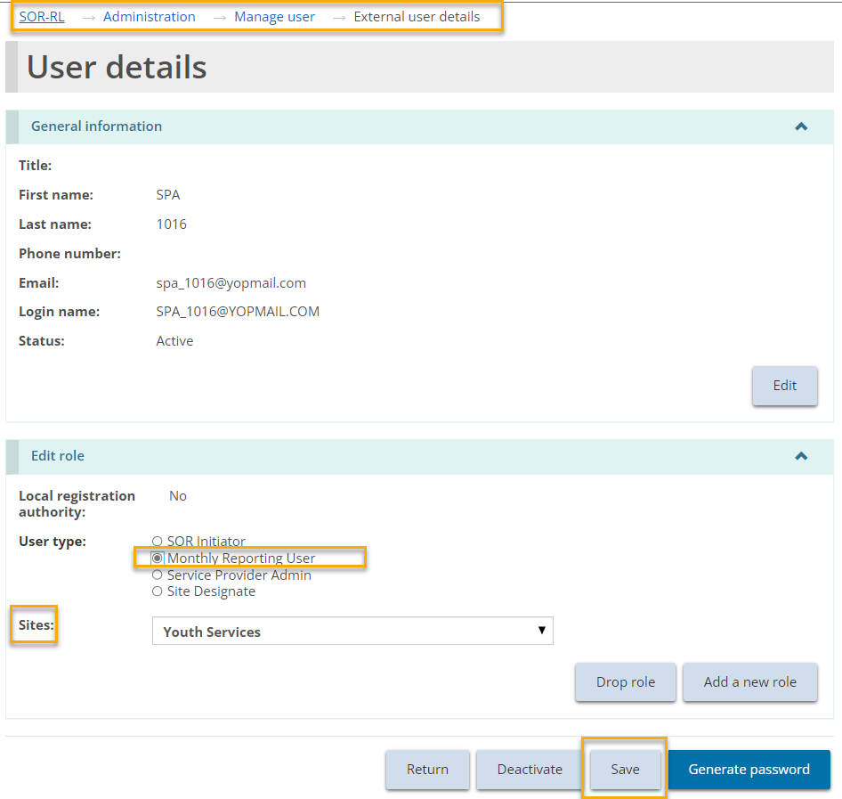

Timelines
SOR-RL auto-generates a monthly report template on the 1st calendar day of each month based on SORs reported to the ministry through SOR-RL for the previous reporting month. Per O. Reg. 155/18 of the CYFSA, the completed monthly report is required to be submitted to the CYFSA Director (Provincial Director for youth justice) by the 5th calendar day of the month.

Autogenerated Report Functionality
All serious complaints and mechanical restraints which meet the SO Reporting criteria set out in the MCCSS SOR Guidelines must be reported as SOs to the ministry through SOR-RL. Mechanical restraint and rights-based serious complaint SORs that are submitted in SOR-RL auto-populate into the monthly report template. Mechanical restraint SORs auto-populate based on the date of the occurrence and rights-based serious complaint SORs auto-populate based on the date the provider became aware of/received the serious complaint. The fields which auto-populate from an SOR cannot be edited in the Monthly Reporting module.
The content of each monthly report refreshes each time it is opened while it is in pending, pending revision, or overdue status. This means that while in these statuses, any updates or revisions made to a mechanical restraint or serious complaint SOR which occurred in the previous reporting month, will be reflected in the monthly report to be submitted to the ministry.
Note: If a change to information auto-populated in the Monthly Reporting module must be made, the SOR itself must be revised, through the SO status “Additional Information/Revision Required”. If the information in the monthly report is incorrect, the SOR itself must be updated. Changes to SORs and any reported details cannot be made through the Monthly Reporting module.

Submitting Monthly Reports
Before submitting a monthly report, Monthly Reporting Users are required to review the mechanical restraint or complaint report templates, liaise with the SOR Initiator to ensure any outstanding revisions to the SORs have been made, and complete the mandatory fields on the monthly reporting details page.
When a monthly report is first opened in SOR-RL, the first page that will load is the summary page. On this page, Monthly Reporting Users will be able to assign the monthly report to themselves and see the summary of all details currently captured in the monthly report, including any comments made to and/or received from the ministry.

Monthly Report Assign to Me Functionality
All Monthly Reports must be assigned to a Monthly Reporting User. If only one user at a licensed site has the role, Monthly Reports will automatically be assigned to them. Where multiple staff have this role, the monthly report will remain unassigned until one of the users assigns themselves a report. In order to do so, the user must press the “assign to me” button in the monthly report at the bottom of the summary page.
Once a monthly report has been assigned to a user, a different user can reassign it to themselves by following the same steps.
Once a report has been assigned to a user, the assignment will appear in their Monthly Reporting Dashboard.
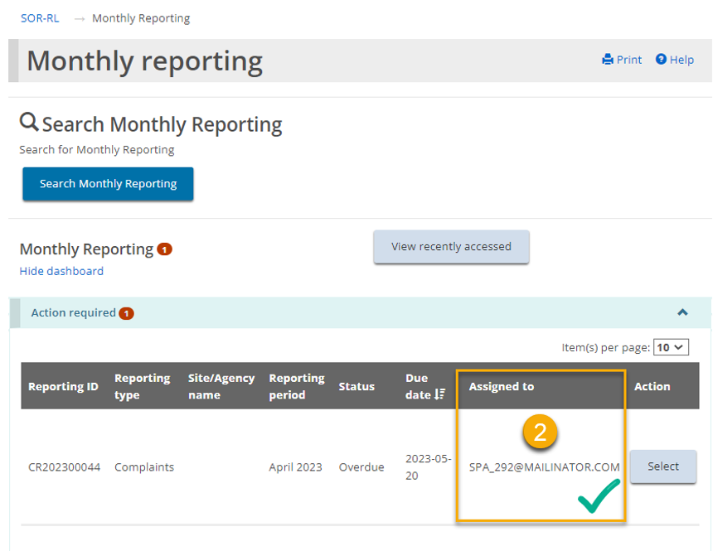

Details Page
All mandatory fields required to be completed before submitting a monthly report to the ministry are located on the reporting details page.

Serious Complaint Monthly Reports
A rights-based serious complaint that has been filed as an SOR will auto-populate into the monthly report. Additional details are required to be manually input. To add these details, on the Complaints reporting details page, click on the pencil icon on the right-hand side of the heading of each serious occurrence. These headings also contain the serious occurrence ID (SOID) hyperlink, which opens a read only summary of the SOR when selected.
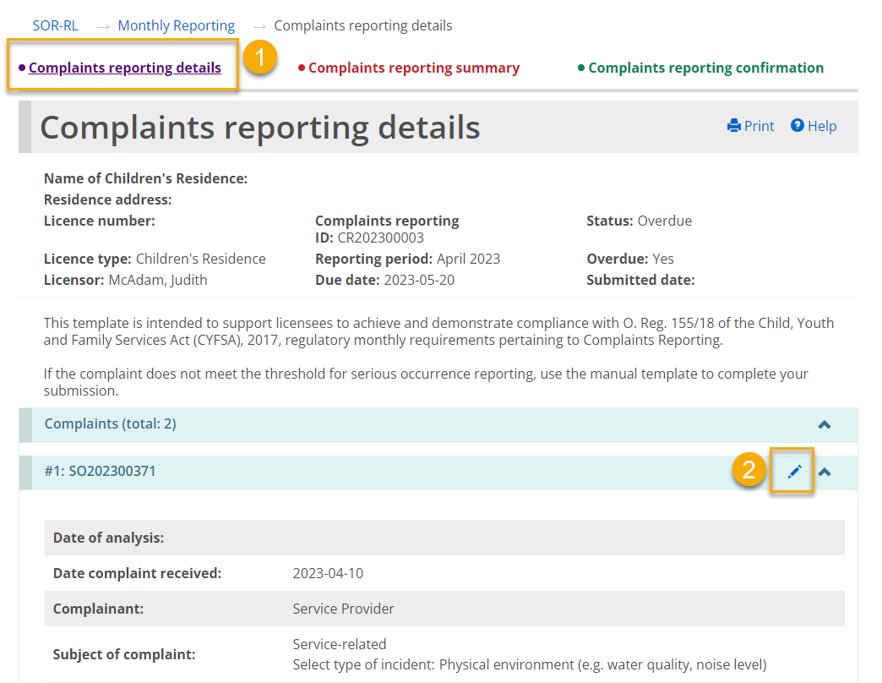
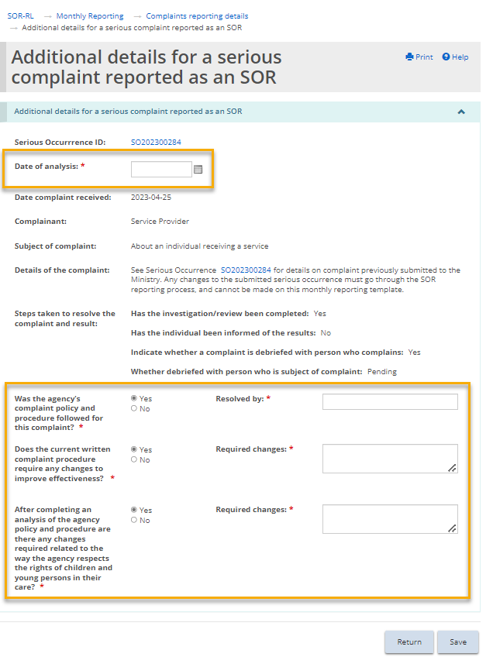
Note: If any details relating to a serious complaint which was reported as an SOR in SOR-RL require revisions or updates, these must be completed within the SOR itself, through the Serious Occurrence module by the SOR Initiator, following the established SO reporting procedures. Changes to SORs and any reported details cannot be made through the Monthly Reporting module.

Manually Added Complaints
Rights-based complaints which do not meet the criteria for SO reporting must still be manually recorded in the monthly report.
- To add an additional complaint manually, navigate to the bottom of the Complaints reporting details screen and click on the “add complaint” button.
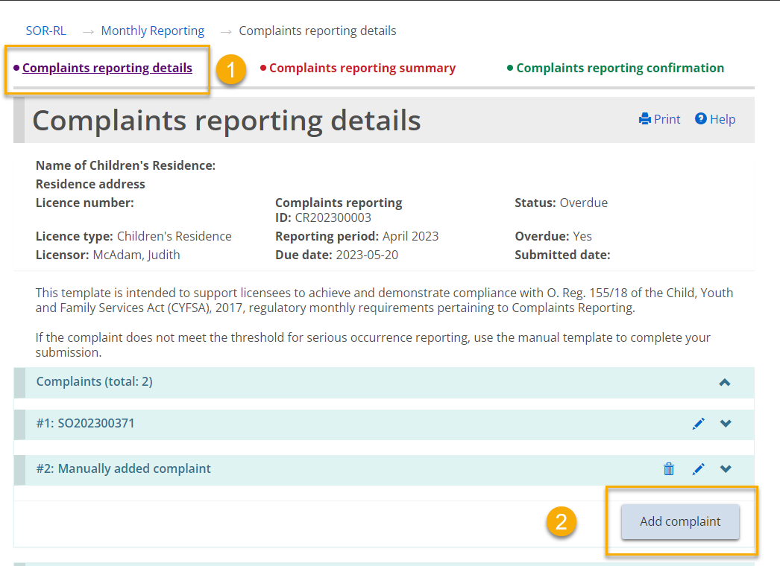
- A new screen will then display the fields which must be manually completed.
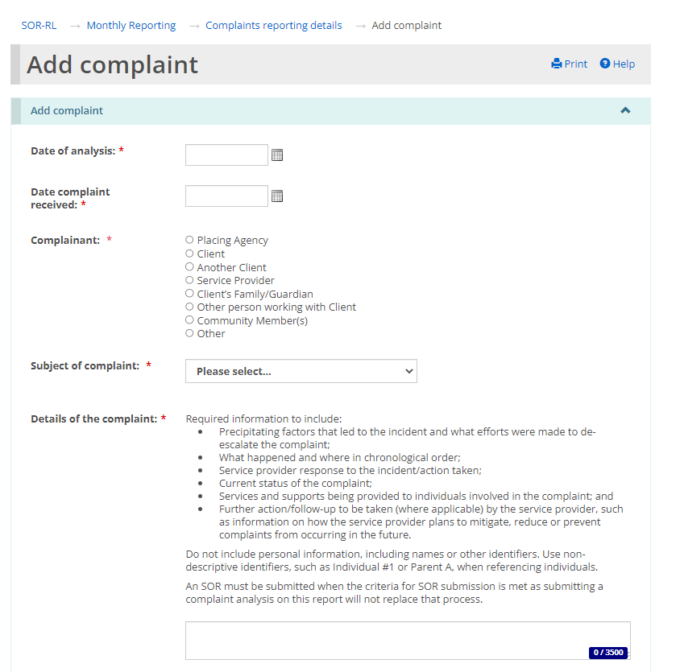
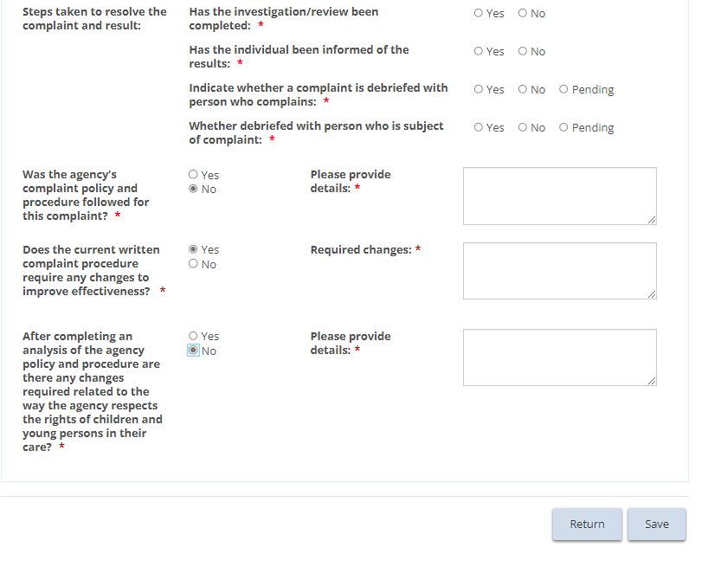

Confirming monthly report is complete
After completing all the fields, users must confirm that the monthly report is complete on the Complaints reporting details page prior to submitting the report.
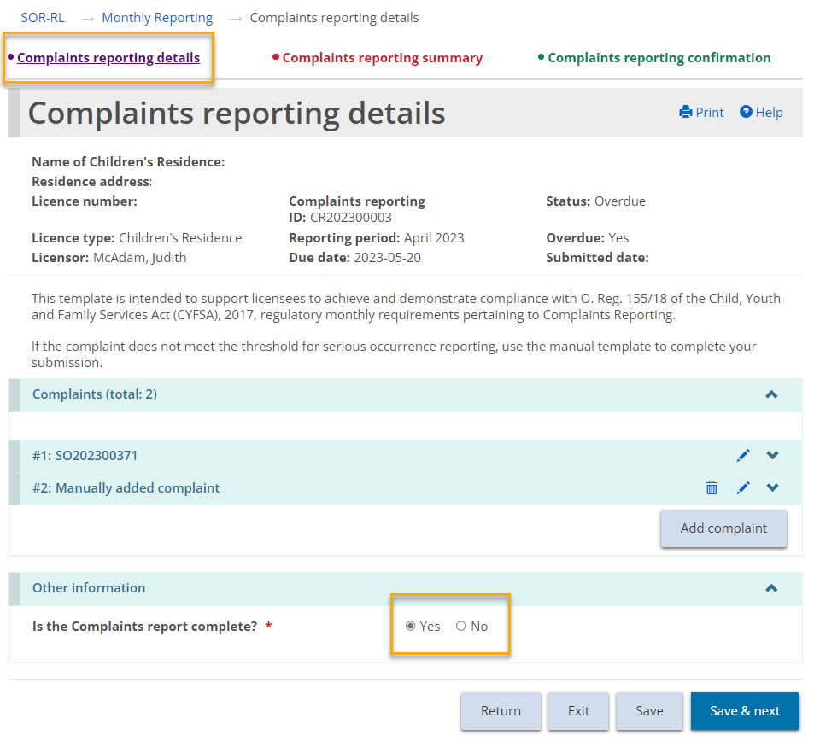

Mechanical Restraint Monthly Reports
For the mechanical restraint monthly report, mechanical restraints will auto populate where they have been reported as an SOR, or can be manually added where it does not meet the SOR reporting guidelines. Review the SO reporting criteria set out in the MCCSS SOR Guidelines to determine if a mechanical restraint must be reported as an SO to the ministry through SOR-RL.

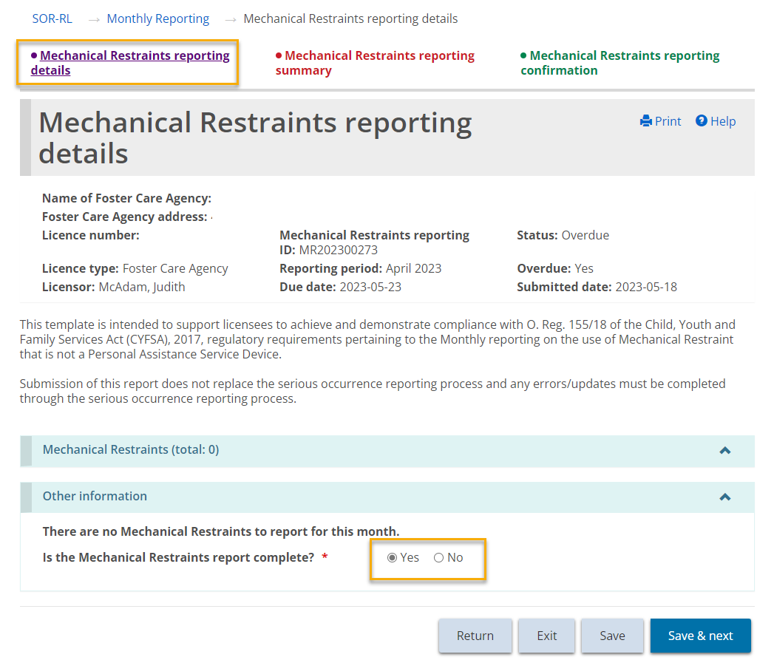
Note: If any details relating to a mechanical restraint which was reported as an SOR in SOR-RL require revisions or updates, these must be completed within the SOR itself, through the Serious Occurrence module by the SOR Initiator, following the established SO reporting procedures. Changes to SORs and any reported details cannot be made through the Monthly Reporting module.

Manually Added Mechanical Restraints
Mechanical restraints that do not meet the criteria for SO reporting must still be manually recorded in the monthly report. Review the SO reporting criteria set out in the MCCSS SOR Guidelines to determine if a mechanical restraint must be reported as an SO to the ministry through SOR-RL.

- To add an additional mechanical restraint manually, navigate to the bottom of the Mechanical Restraint reporting details screen and click on the “Add Mechanical Restraint” button.
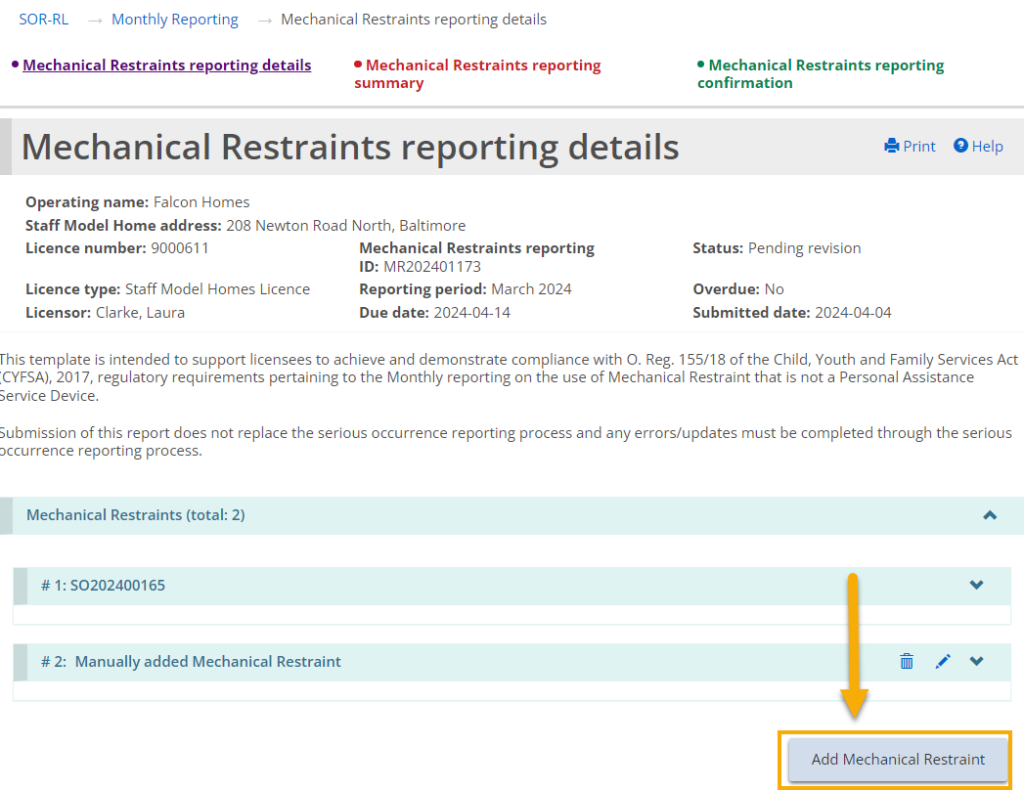
- A new screen will then display the fields which must be manually completed.
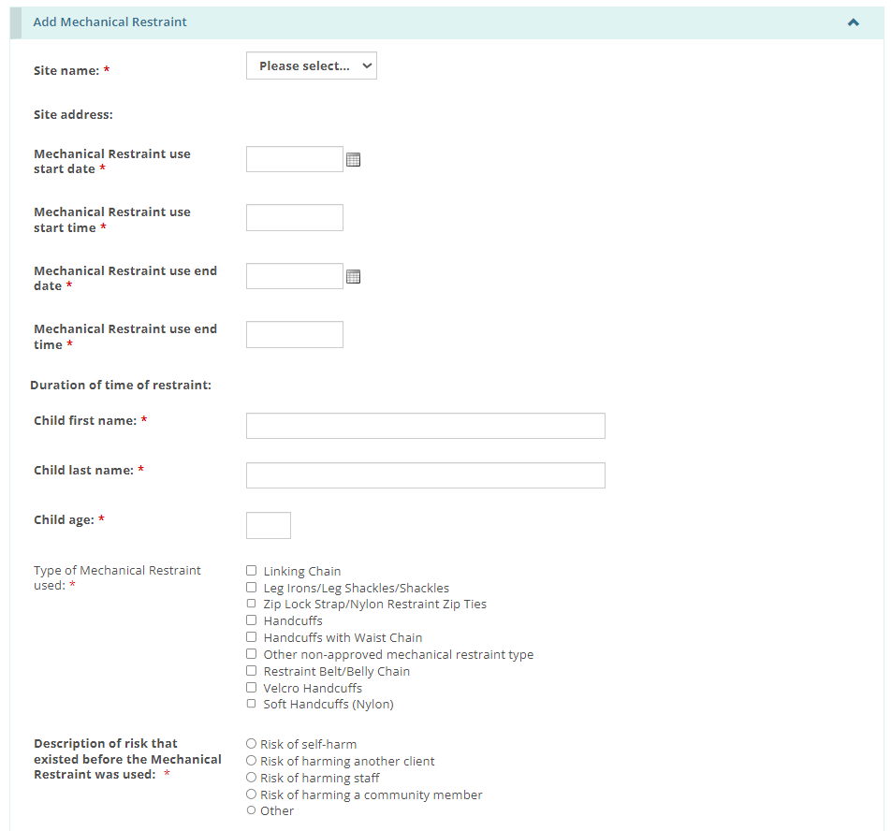

Confirming monthly report is complete
After completing all required fields, users must confirm that the monthly report is complete on the mechanical restraint reporting details page prior to submitting the report.
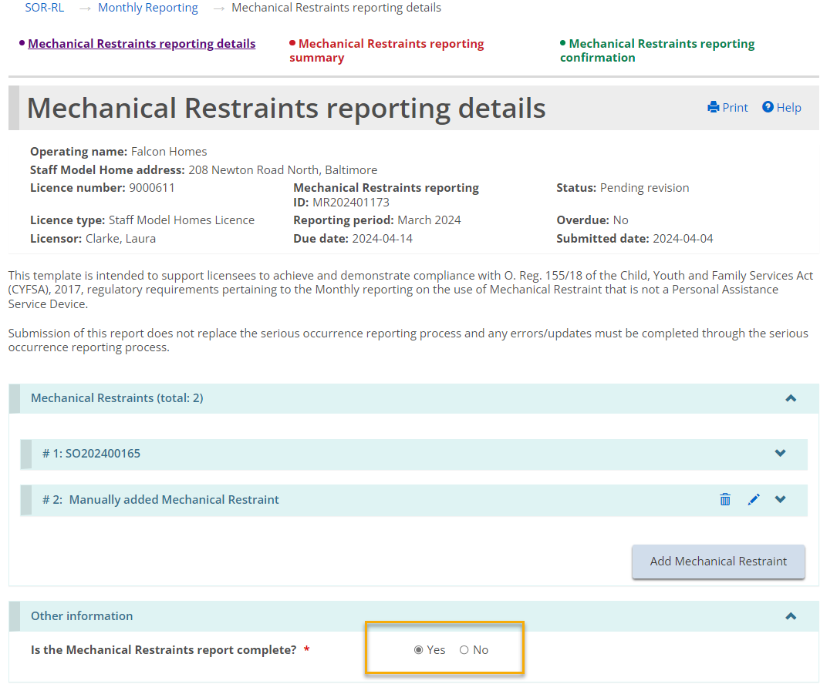

Multiple Incidents (Categories) in a Single SOR
Where multiple mechanical restraints or right-based serious complaints have been reported in the same SOR (please refer to the MCCSS SOR Guidelines, for more information on when more than one category can be added to an SOR), each restraint or complaint will have its own instance on the monthly report. For example, if three mechanical restraints related to a single youth were reported in the same SOR (three mechanical restraint categories added), each one would be reflected separately in the monthly report.
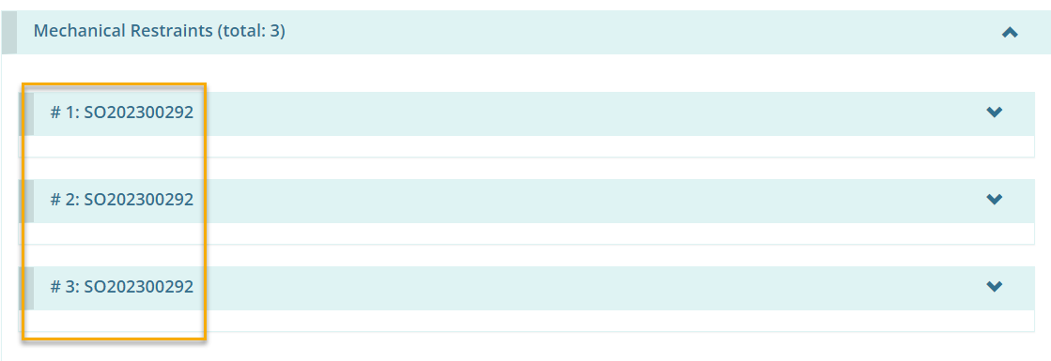
The Monthly Reporting user is required to verify and confirm that all instances of rights-based serious complaints or mechanical restraints are captured correctly in the auto-generated monthly report template prior to submitting to the ministry.
Note: If any details relating to a mechanical restraint or a serious complaint which was reported as an SOR in SOR-RL require revisions or updates, these must be completed within the SOR itself, through the Serious Occurrence module by the SOR Initiator, following the established SO reporting procedures. Changes to SORs and any reported details cannot be made through the Monthly Reporting module.

Nil Report
Where there have been no mechanical restraints or complaints during a reporting period, the Monthly Reporting User provides their attestation and submits a NIL monthly report to the ministry. This is completed on the reporting details page of the report.
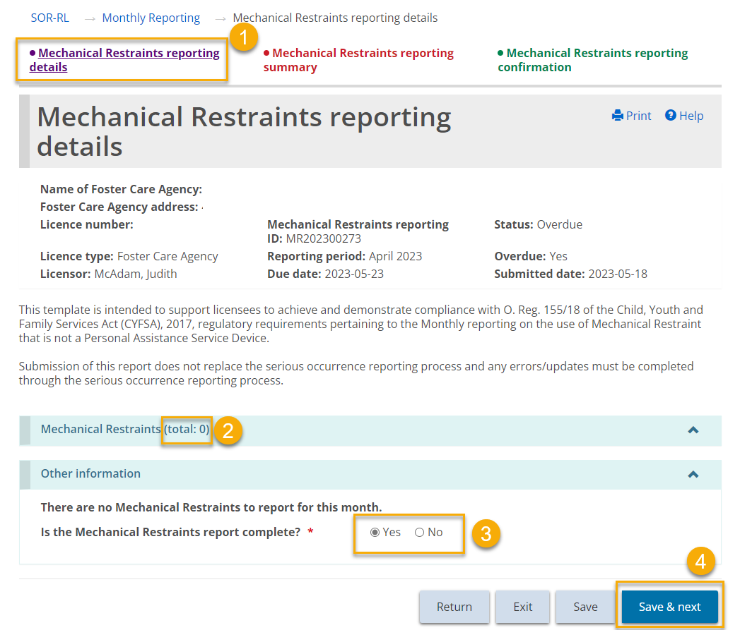

Submitting the Monthly Report on the Summary Page
After completing the required fields on the details page, return to the summary page to add a comment if appropriate (mandatory when overdue or after a report has been returned in “pending revision” status) and submit the monthly report to the ministry by pressing .
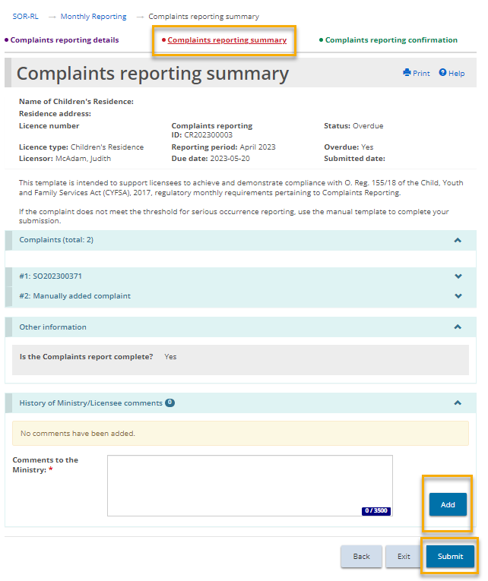
After pressing the Submit button, the Monthly Reporting User will be required to complete an attestation, verifying the accuracy of the content being reported in the monthly report.
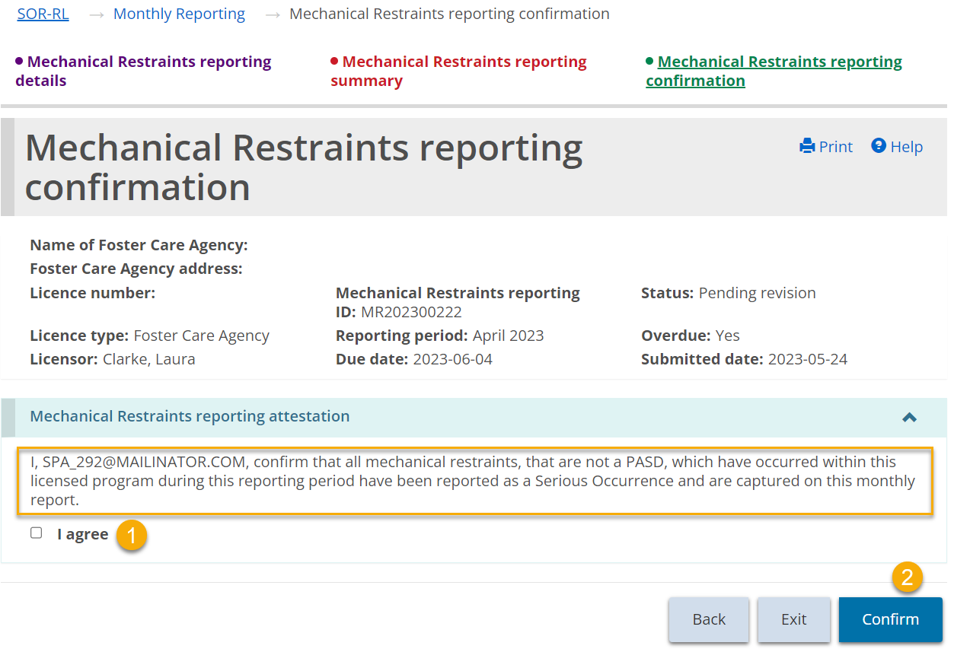

Overdue Status
Where a monthly report has not been submitted within the required timeframe, the status of the monthly report will change from “pending” or “pending revision” to “overdue”. Automated notification emails are then sent to the Monthly Reporting User and the Service Provider Administrator, as well as the licensor, licensing manager, and program supervisor (youth justice only). These notification emails are sent at predefined intervals until the report is submitted to the ministry.
Note: When a monthly report is in “overdue” status, a comment must be added on the summary page before it can be submitted to the ministry.

Working with a Director’s Approval
The applicant/licensee must request a Director’s Approval if there is an exceptional situation, for instance a Children’s Residence using a bedroom in a basement, or a Foster Care Agency placing more than four children in a foster home.
The following is a list of the types of Director’s Approvals that can be submitted:

For a Children’s Residence:
- Secure de-escalation
- Sleeping accommodation – sharing a bedroom, 7 years or older, opposite sex
- Sleeping accommodation – basement bedroom
- Overcapacity
- Alternative to outdoor play space

For a Children’s Residence – Youth Justice:
- Mechanical restraint equipment
- Secure de-escalation
- Sleeping accommodation - basement bedroom
- Sleeping accommodation - alternate arrangement
- Alternative to outdoor play space
- Electronic surveillance
- Wilderness trip
- Overcapacity

For a Foster Care Agency:
- Placement in Foster Home more than four
- Placement in foster home – more than two children under 2 years of age
- Sleeping accommodation – bedroom (no window, detached attic, basement, stairway, hall)
- Sleeping accommodation - no bed, mattress, bedding suitable to age and size
- Sleeping accommodation – Shared bedroom, aged 7 or overSleeping accommodation – Sharing bed or room with adult

For a Staff Model Homes Licence:
- Secure de-escalation
- Sleeping accommodation – sharing a bedroom, 7 years or older, opposite sex
- Sleeping accommodation – basement bedroom
- Alternative to outdoor play space
In most cases, the Director’s Approval is requested for a specific timeframe.
There are no changes to the licence details and as such the licence is not changed. A letter is sent when the request is approved or denied.

Requesting a Director’s Approval
A request for a Director’s Approval can be linked to a Children’s Residence or Staff Model Homes licence application, or an existing licence (including a renewal or change request). For a foster care licence, a request for a Director’s Approval can be linked to an existing Foster Care Agency licence, but not to an application. For Staff Model Homes, each Director’s Approval request must be site-specific. A separate Director’s Approval must be completed for each site.
If you have already submitted a request for a Director’s Approval for an application, you must wait until a decision has been reached before submitting another request.
The examples in this section are based on an existing licence.

Step 1: Start the approval and enter the director’s approval details
- Click the module. The Director’s Approval module appears.
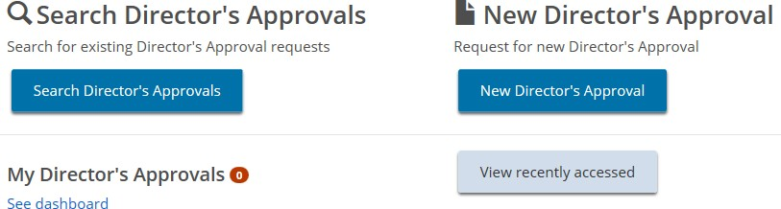
- Click 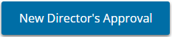. The Select Application/Licence page appears.

- Select the application or licence that the approval is for.
- If you have a Children’s Residence or Staff Model Homes licence and have an in-progress change request or renewal, the following page appears. On this page, you can link the Director’s Approval request to an in-progress renewal or change request.
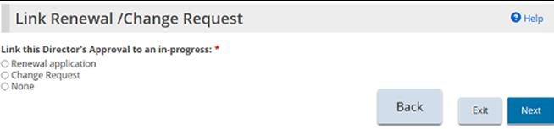
- Make your selection then click .
- The New Director’s Approval page appears.
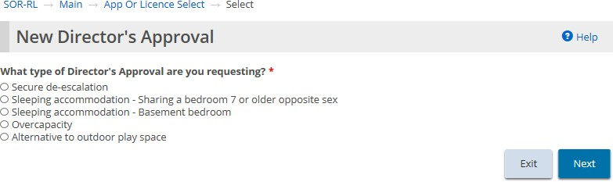
- Children’s Residence example
- If you are linking the Director’s Approval to a change request, the following page appears.
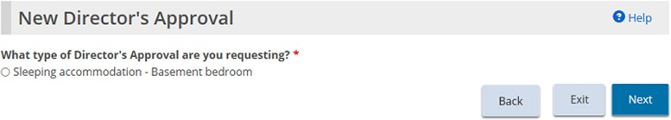
- Select the type of Director’s Approval required. (Only one type can be selected. If you require more than one type, you must create a separate request for each one.)
- Click . The Notice of Collection of personal information page appears.
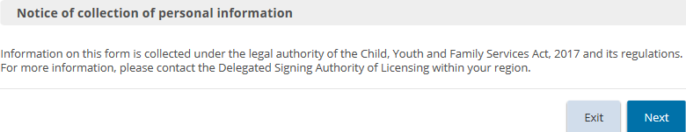
- Read the notice of collection of personal information then click . The Director’s Approval details page appears. (The page that appears depends on the type of Director’s Approval you selected).
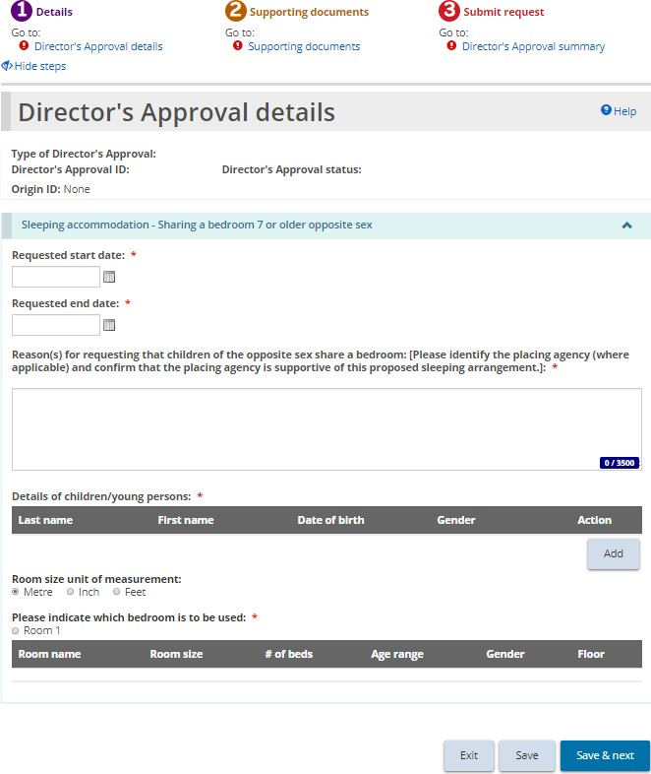
- Expand the sections and answer the questions.
Note: If you are applying for an overcapacity director’s approval, be sure to add information about existing occupants of the room.
Note: For the following types of director’s approvals, the applicant/licensee must specify a start and end date: Sleeping accommodation - Sharing a bedroom 7 or older opposite sex; Overcapacity; Sleeping accommodation - Alternate arrangement; and all Foster Care requests
- Click . The Supporting documents page appears.

Step 2: Upload supporting documents
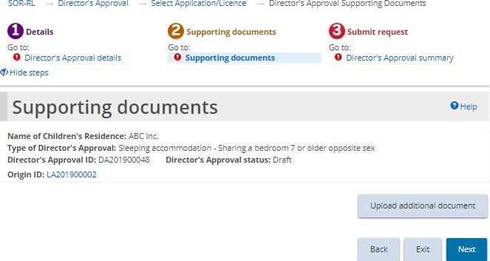
- If the Supporting Documents page is not on your screen, click the Supporting Documents link from the steps section.
- Depending on the type of request, there may be mandatory documents to be submitted. You may also have documents that substantiate your request. Upload the documents as applicable.
- Click . The Director’s Approval summary page appears.

Step 3: Review and submit
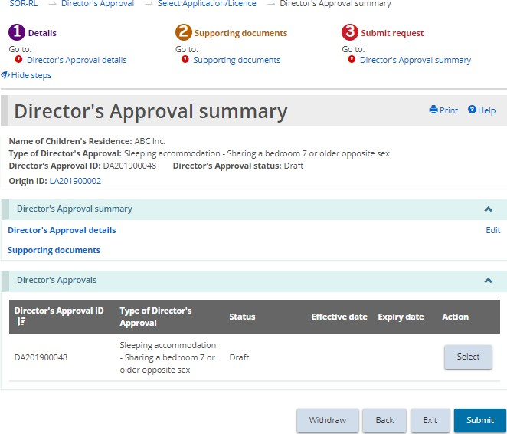
- If the Director’s Approval summary page is not on your screen, click the Director’s Approval summary link from the steps section.
- Review the information in the summary.
Tip: To see information under a blue section sub-heading, click the sub-heading.
- To edit the information, click the Edit link.
- To withdraw a director’s approval request, click . A confirmation window appears. Click . To cancel the action, click .
- Click . A confirmation message appears.
- Click . The Declaration & consent page appears.
- Read the declaration and consent and then answer the questions, then click . A confirmation message appears.
- Click 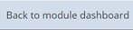. The request appears in the submitted section of your dashboard with a status of “Under Ministry review”.
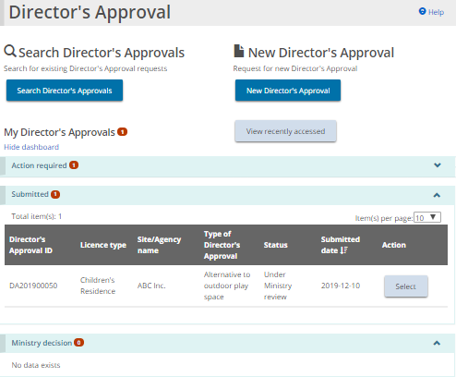

Viewing the ministry decision
- An email will be sent advising of the ministry decision once a Director’s Approval has been reviewed.
- Click . The Director’s Approval menu appears.
- Click See dashboard. The Director’s Approval appears in the Ministry decision section.
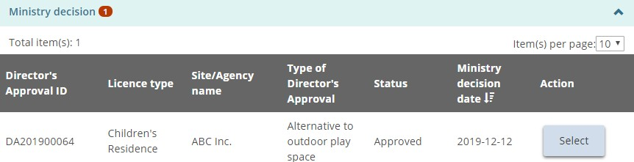
- Click . The Director’s Approval summary page appears.
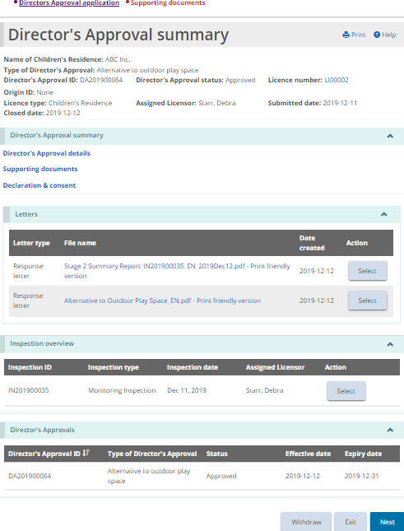
- On this page you can view the request details, the letters, and, if an inspection was completed as part of the Director’s Approval review, the inspection overview as well as any conditions imposed if applicable. Expand the blue “Supporting Documents” link to see the documents that you uploaded.

Viewing inspection reports and findings
A licensing inspection may be performed for a new licence application, licence renewal application, and licence change request application. A monitoring inspection may be required for other applications, like a director’s approval application, complaint application, and serious occurrence. In addition, licensors can also create an ad hoc inspection for an existing licence at any time.

Opening an inspection report
- From the SOR-RL home page, click . The Inspection module appears.
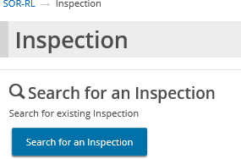
- Click 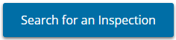. The Search for an Inspection page appears.
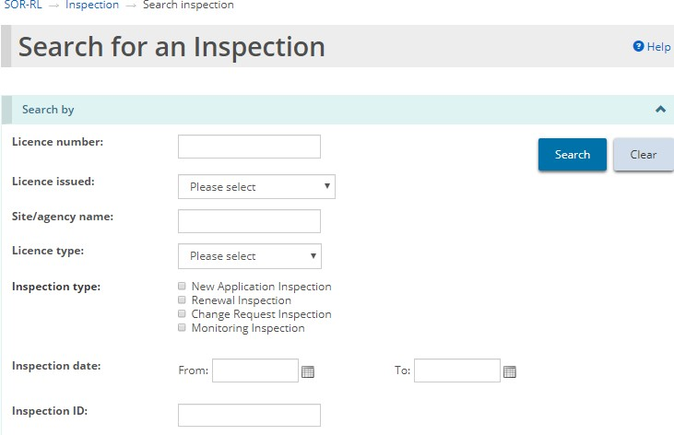
- Enter the search criteria then click 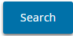. The search results appear.
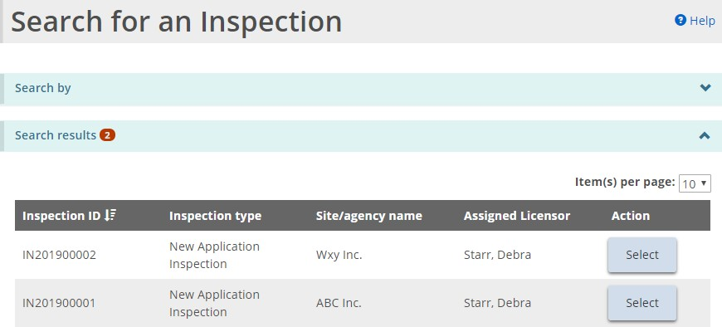
- Click . The Inspection summary page appears.
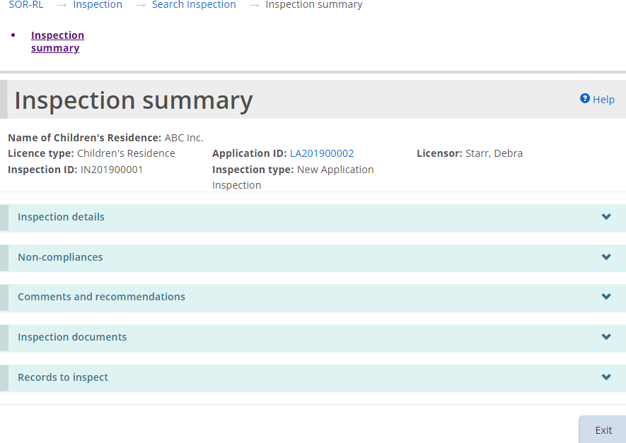
The page example is similar for Foster Care Agency inspections.

Examples of inspection sections
The following are examples of the Inspection Summary sections:
Inspection details section
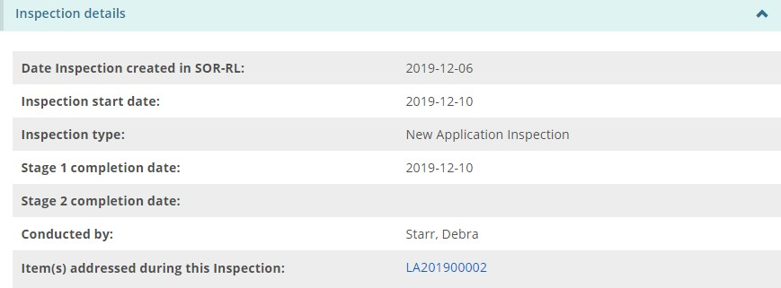
Tip: Click the blue link to see the items addressed during the inspection.
Non-compliances section
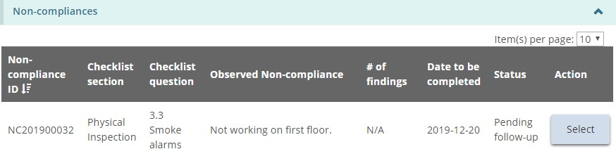
Comments and recommendations section
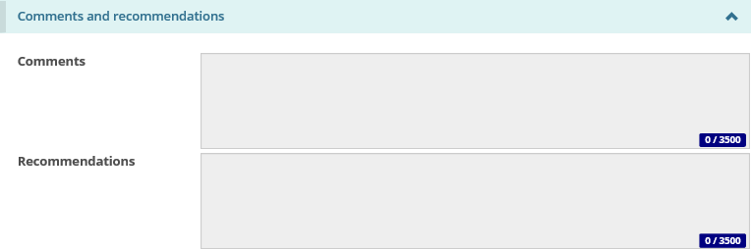
Inspection documents section
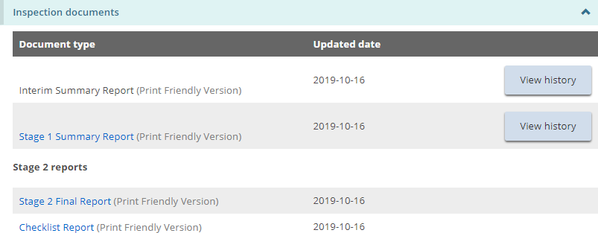
Tip: Click the blue link to see the report.
Records to inspect section
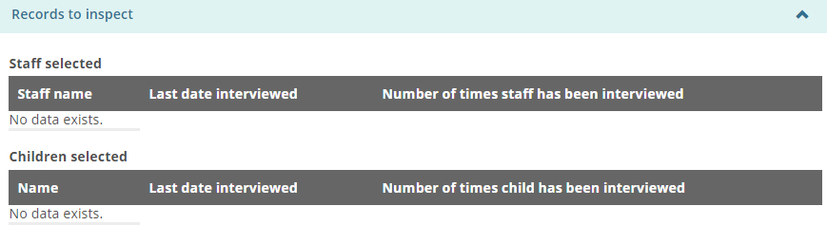

Working with non-compliances
During an inspection, the licensor may post one or more non-compliances on your application or licence. The non-compliances must be cleared before your licence, renewal, etc. can be issued.

Viewing non-compliances for a licence
There are two ways to see a list of non-compliances for a licence:

Method 1:
- From the SOR-RL home page click 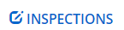.
- Click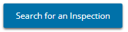. The Search Inspection page opens.
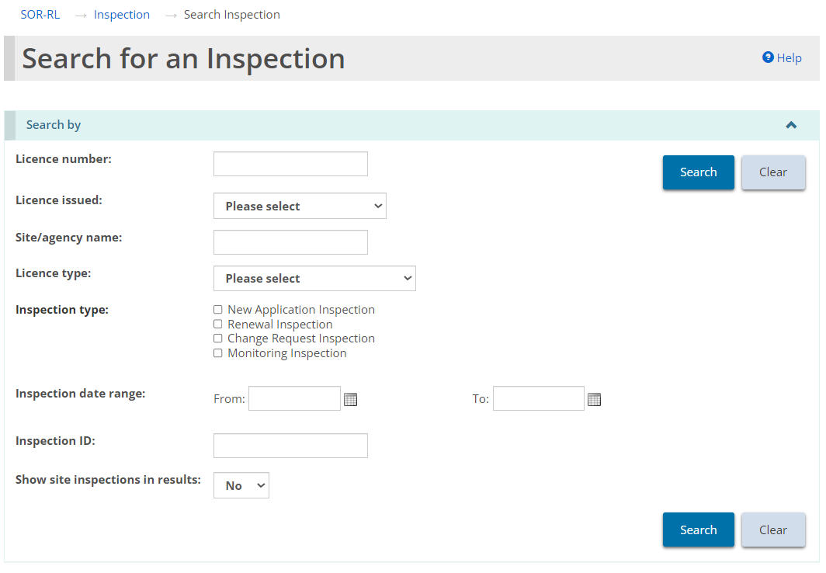
Note: Site-based inspection results are only applicable to Staff Model Home licence types.
- Enter the search criteria for the Inspection and click .
- The Inspection summary screen opens. Navigate to the non-compliances section to review and action non-compliances.
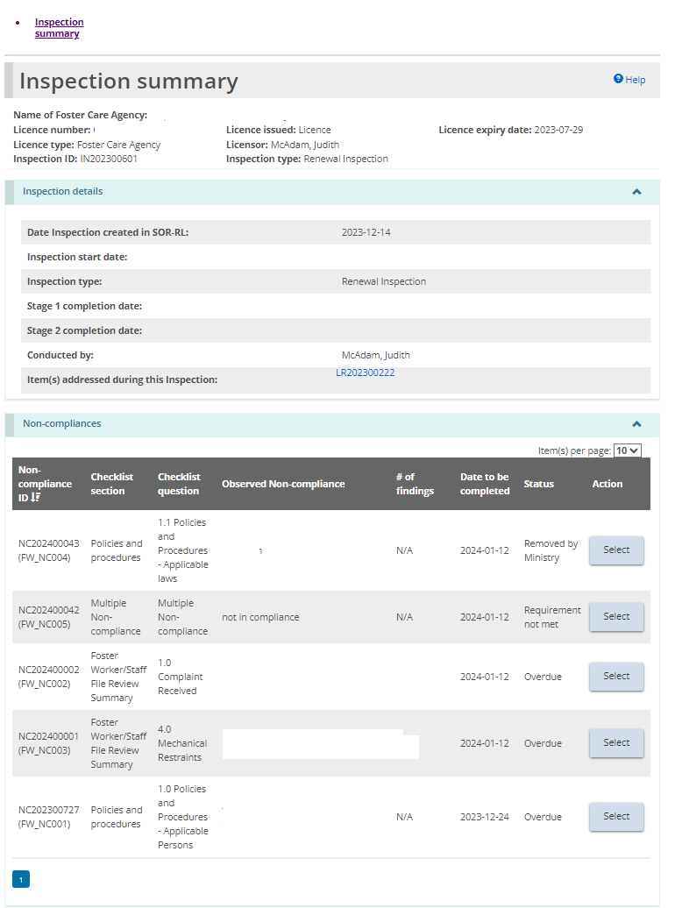
Note: This non-compliance view from the inspection summary page offers a comprehensive view of all non-compliances applicable to this inspection.

Method 2:
- From the SOR-RL home page, click . The Non-Compliance module appears.
- Click 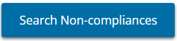.
- Enter the search criteria for the licence and click .
- Click .

Responding to a non-compliance that require action
- Using either Method 1 or 2 above, navigate to the non-compliance. Press the “select” button beside the non-compliance to open it.
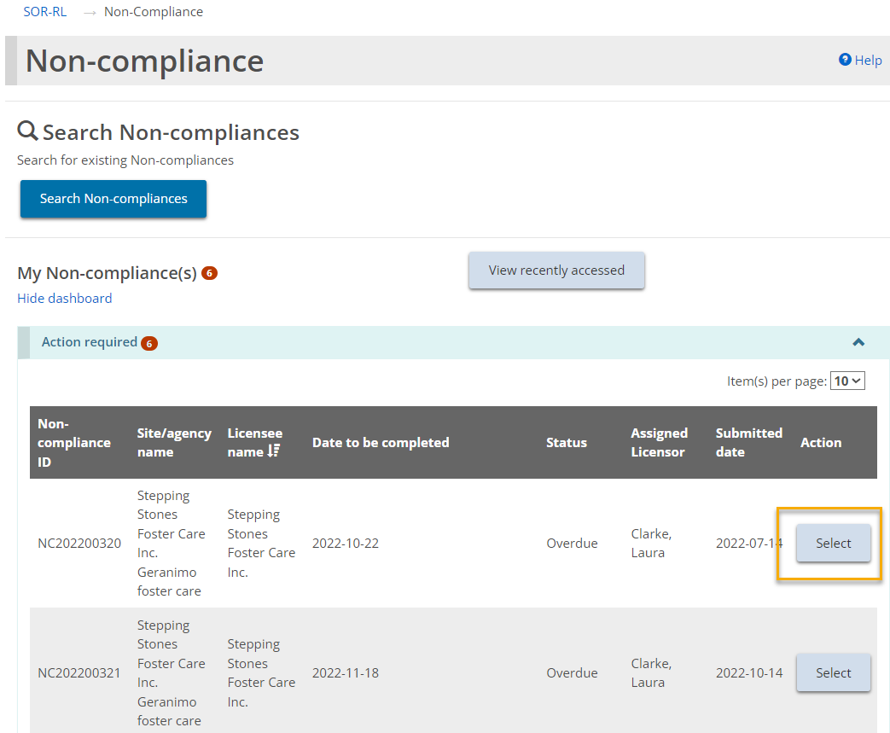
This screenshot is the view of non-compliances from the non-compliance module.
- The Non-compliance summary page appears showing the non-compliance details.
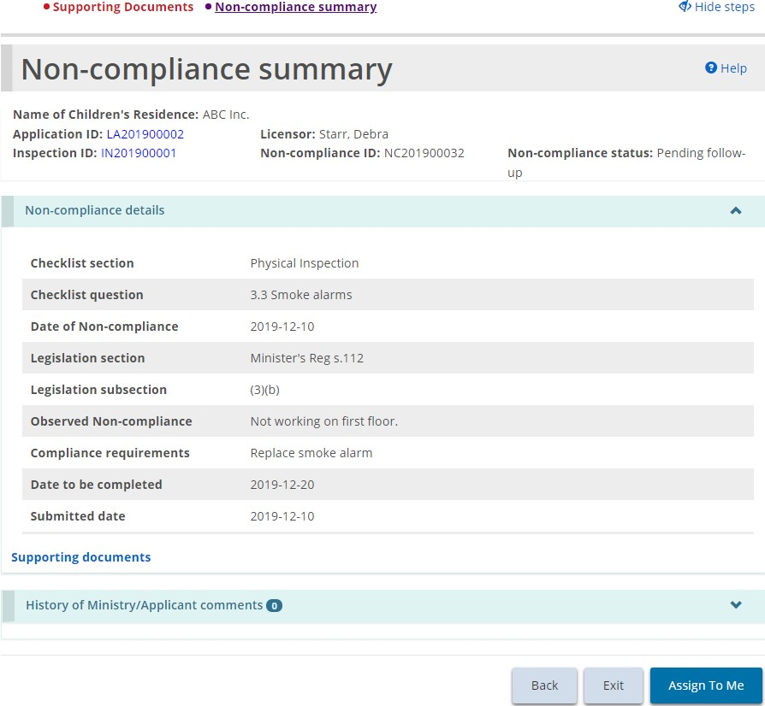
- The user may have to scroll to the bottom of the summary screen and click 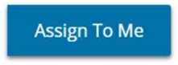.
- Once an action is assigned to a user, the summary page updates to include a History of Ministry/Applicant comments section.
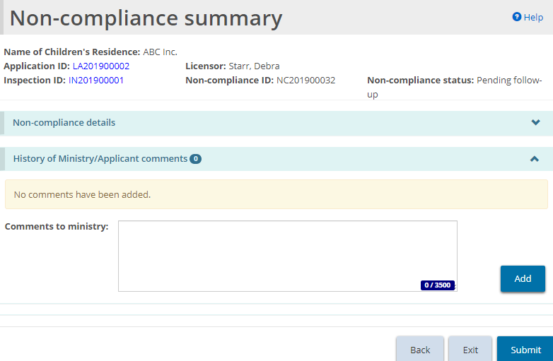
- Enter your response to the non-compliance in the Comments to ministry field. Click .
- If you are required to add supporting documents as part of your response, click . The Supporting documents page appears.
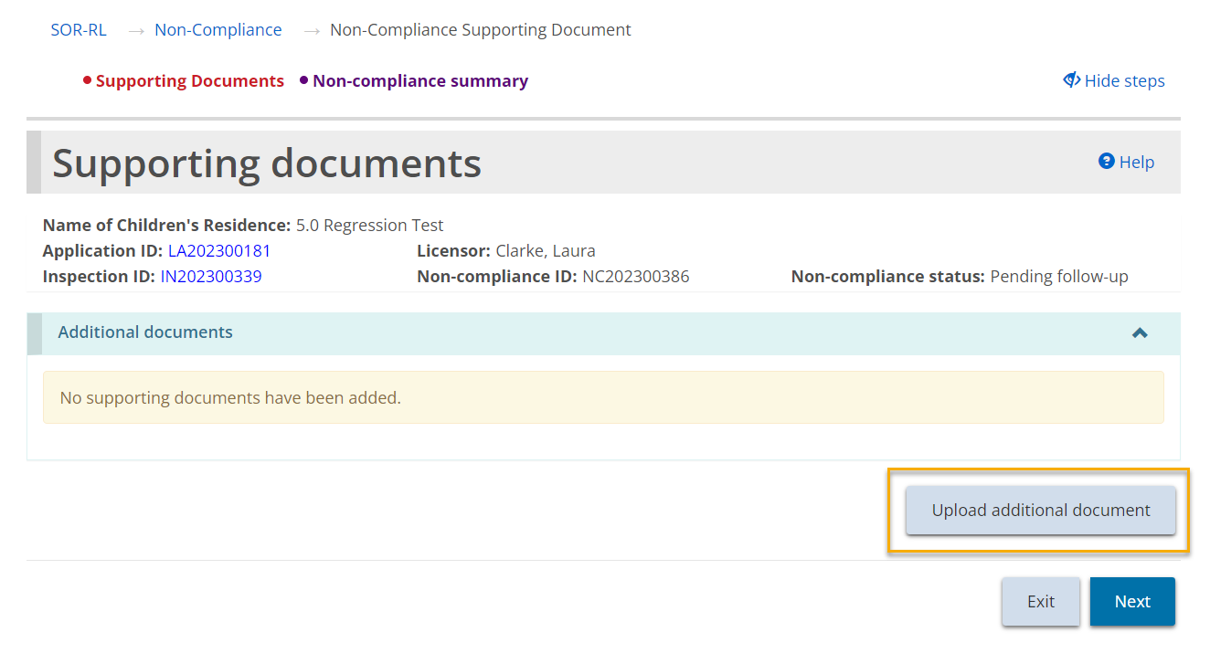
- Click and upload the document.
- Click then click .
- Click . The Non-compliance summary page appears.
- Review your response and click . A confirmation message appears.
- Click . A submitted message appears at the top of the page.
- The non-compliance status changes to “Under ministry review” and can be found in the Submitted section.
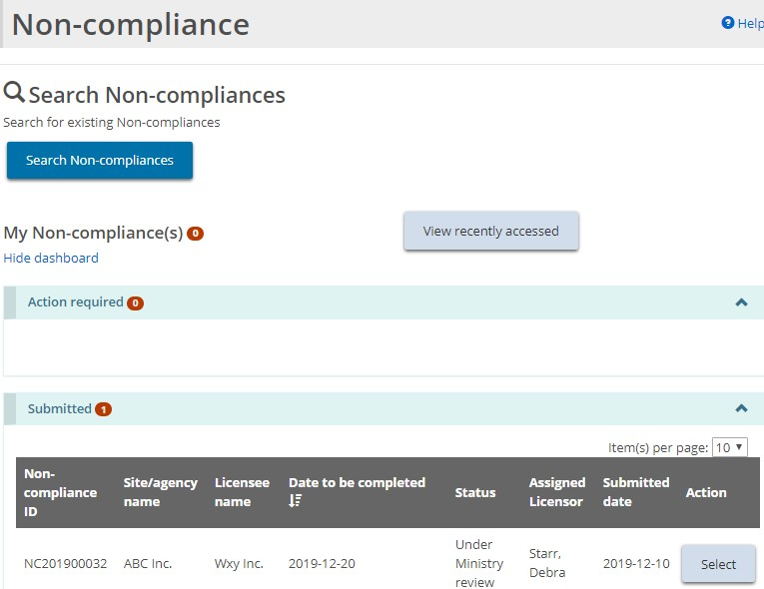

Working with conditions
When your license is approved, there may be one or more, one-time or recurring (deliverable) conditions.
Examples of a condition is the requirement to submit a document. Another example is to confirm that an action was taken. A condition can also be a combination of submitting a document and confirming that an action was taken.
The top part of the Condition page outlines important information including the condition ID number, the condition status and the licence the condition is linked to.
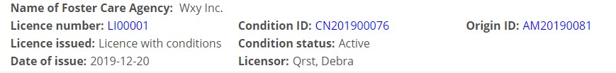
Note: See Appendix C: Statuses for a list of condition statuses.

Viewing all conditions on a licence
There are two ways to view the conditions on a licence; through the Licence Management module and the Conditions module.

Method 1:
- From the SOR-RL home page, click . The Licence Management module appears.
- Select the licence. The Licence summary page appears.
- Scroll down to the Condition section.
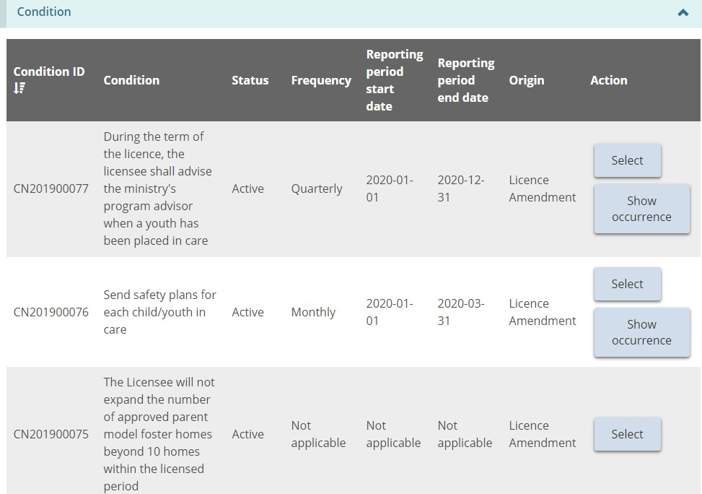

Method 2:
- From the SOR-RL home page, click . The Conditions module page appears.
- Click 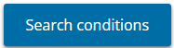 and enter the search criteria.
- Click . The list of conditions for that licence appears.

Viewing your condition occurrence workload
- From the SOR-RL home page, click . The Conditions module appears.
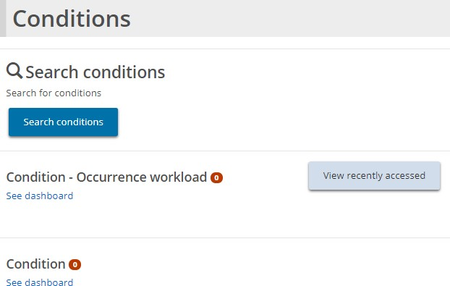
- Click the link under Condition - Occurrence Workload. The dashboard appears.
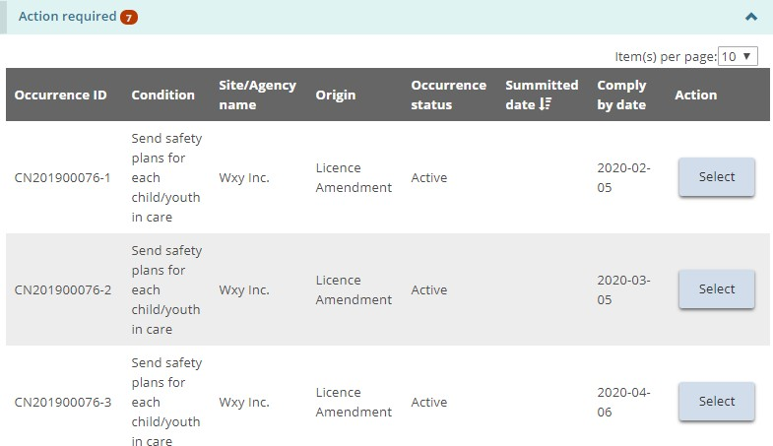
Note: In the above example, there are 2 conditions, but the conditions have more than one occurrence. The occurrence IDs are the same for a condition except for the last number.
- To open an occurrence, click . The Condition summary page appears.
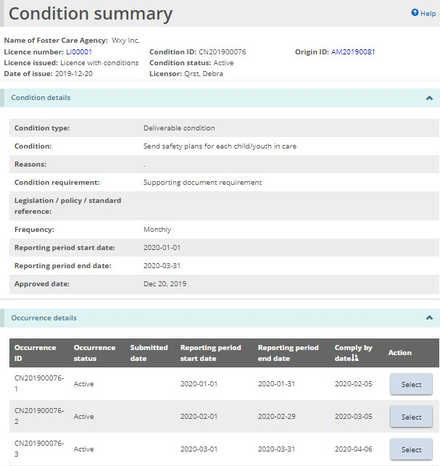
- Example of a deliverable condition requiring a confirmation and a document to be submitted.

Complying with a condition
- Open the condition occurrence. The Occurrence summary page appears.
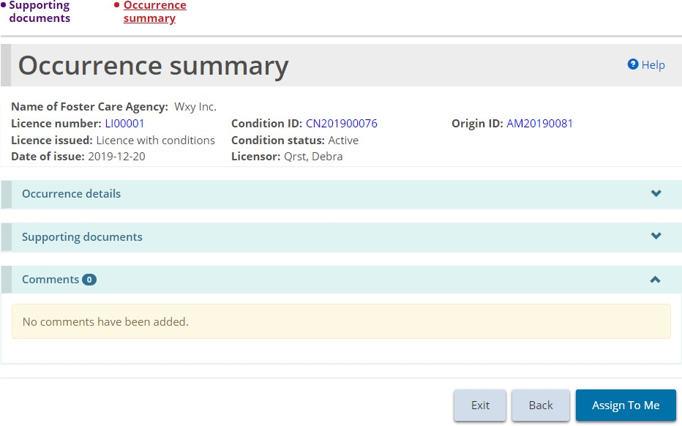
- The user may need to click 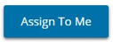 before responding to the condition. The Occurrence Summary page updates
- If your condition includes uploading a supporting document:
- Click . The Supporting documents page appears displaying the Mandatory documents prior to submission.
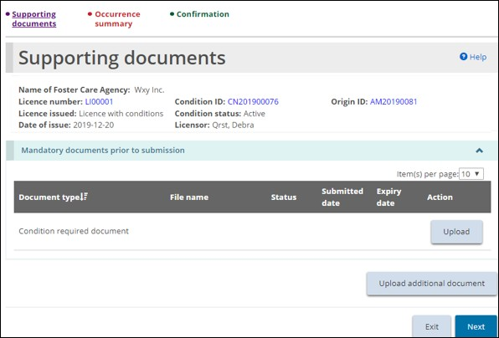
- Click and upload the document.
- Click . The Occurrence Summary page appears. The document you added can be seen in the Supporting documents section.
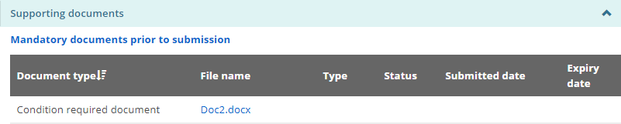
- Click .
- If a confirmation is included in the condition, the Confirmation page appears.
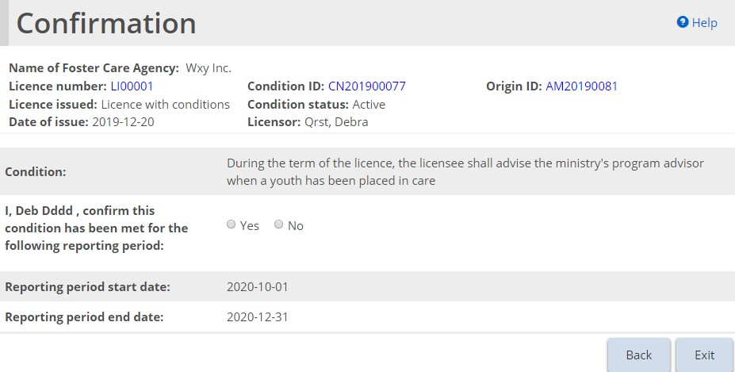
- Confirm the condition by answering the question.
- When you click “Yes”, the button appears.
- Click . A confirmation message appears. The occurrence can be found under the Submitted section of the dashboard.

Viewing completed condition occurrences
- From the SOR-RL home page, click . The Condition module page appears.
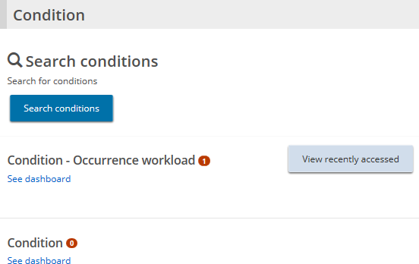
- Click See dashboard under the Condition-Occurrence workload section. The Submitted section appears.
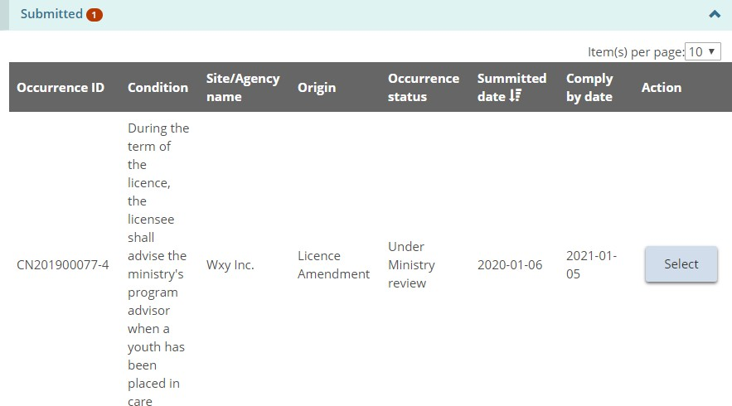
- To see the details, click .

Licence management
You will be notified when you receive the decision about your application. When your licence is approved, you will have access to the following modules:
- Profile
- Licence Application
- Licence Management
- Licence Renewal
- Change Request
- Director’s Approval
- Conditions
- Inspections
- Non-Compliance
- Supporting Documents
- Administration
- Serious Occurrence

Viewing a list of your licences
- From the SOR-RL home page, click . The Licence management page appears showing a list of your licences. From this page you can see the licence summary/details and the history of the licence.
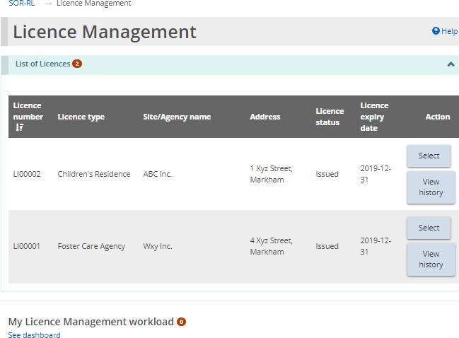

Viewing the licence summary
- From the SOR-RL home page, click . The Licence management module appears.
- Click . The Licence summary page appears.
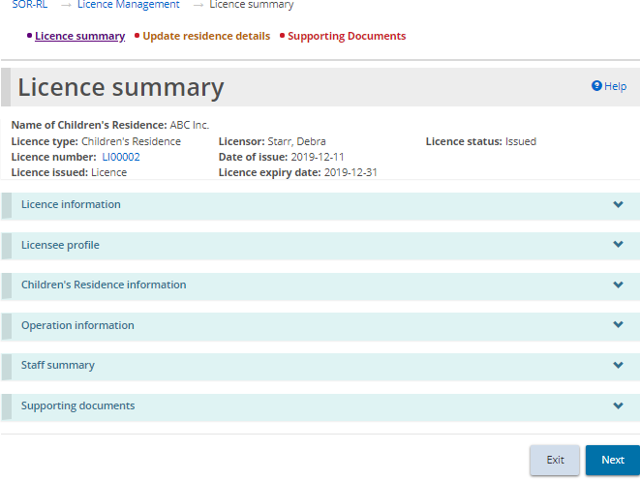
Children’s Residence example
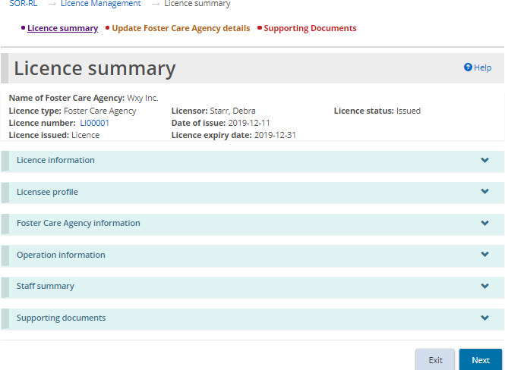
Foster Care Agency example
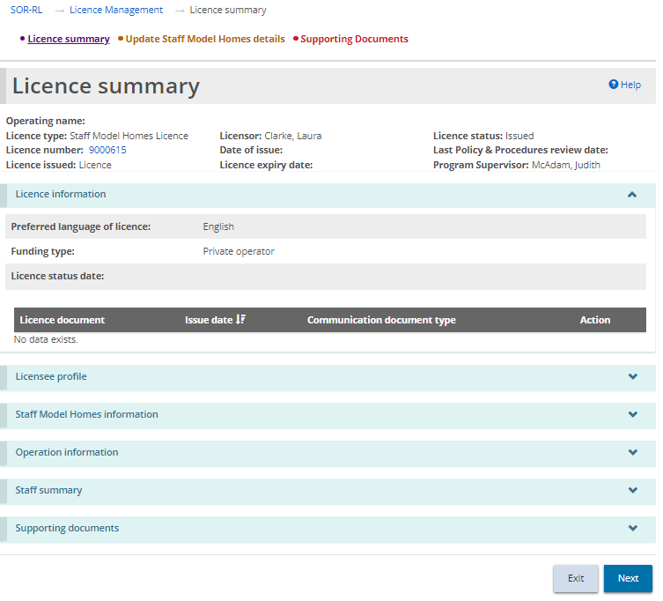
Staff Model Homes Licence example
Tip: The top of the page, also known as the “tombstone”, displays the basic licence information including the name of the children’s residence/staff model homes licence/foster care agency, licence type, licensor, licence status, licence number, date of issue, licence issued, and licence expiry date.
The Licence Summary page is divided into three tabs: Licence summary, Update [Licence] details, and Supporting Documents. Let’s begin with the Licence Summary tab.
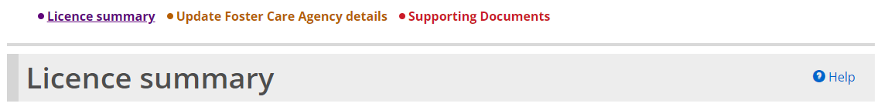

Licence information
- From the Licence summary page, expand the Licence information banner.
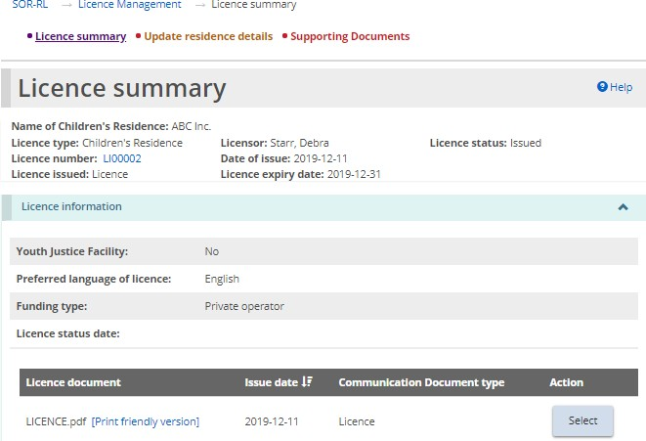
Children’s Residence example
- To view a licensing document, click or click the blue link.
- To print the document, click the blue link. The document opens a printable format. Press <Ctrl P> to open the print menu.

Licensee profile
- From the Licence summary page, expand the Licensee profile banner.
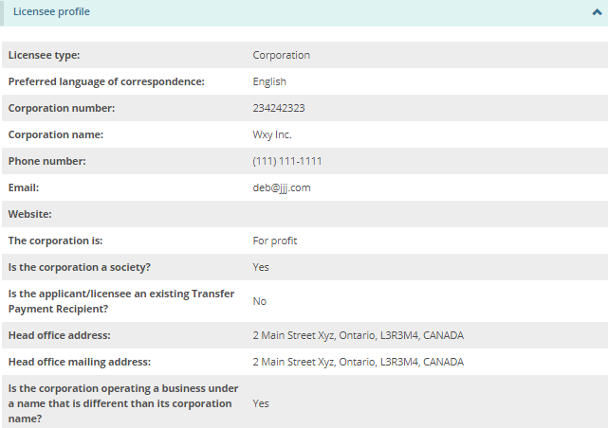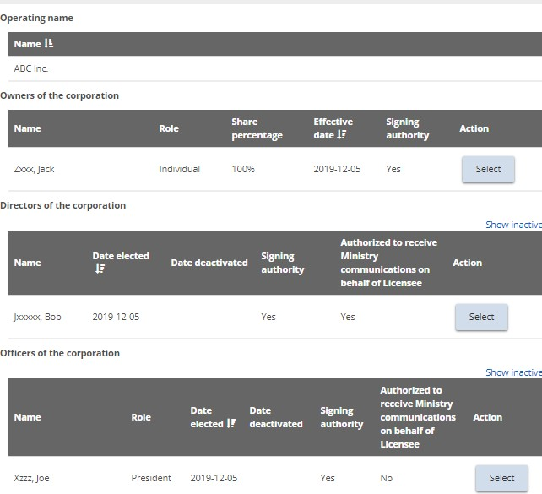
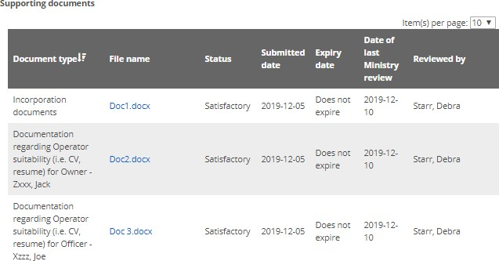
Tip: To make changes to the profile information, see the Editing a Profile section.

Children’s Residence/Staff Model Homes/Foster Care Agency information
Note: Licence information differs between the three licence types. As such, the information below is organized by licence type.

Children’s Residence
- From the Licence summary page, expand the Children’s Residence information banner.
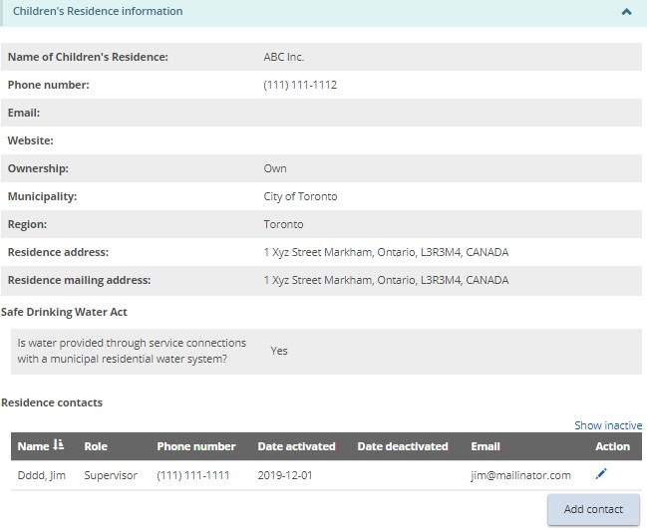
Note: A Children’s Residence licence displays the address of the location where the residence is located which may not be the same as the head office address in the profile. The head office can be anywhere, but the children's residence must be in Ontario and is the one mentioned in the Licence.
Note: Only the Children’s Residence contacts can be edited and/or added from this section. Other changes, such as a change to the residence name, must go through a formal change request process. See the Requesting a change to a licence section.
- To see the Children’s Residence contacts, scroll down to the Residence contacts section.
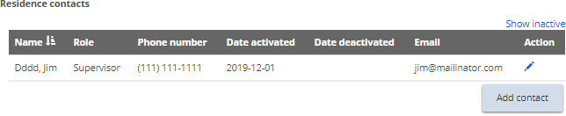
Note: This page shows all active contacts. To see all contacts, click Show inactive.
- To view contact details, to edit contacts, or to deactivate contacts, click the edit icon . The Residence Contact Details page appears.
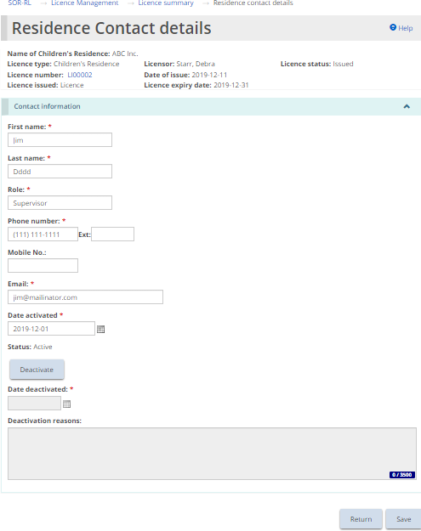
- Make the changes. If deactivating a contact, click and make the updates.
- Click then click .
- To add contacts, click 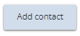. The Residence Contact Details page appears.
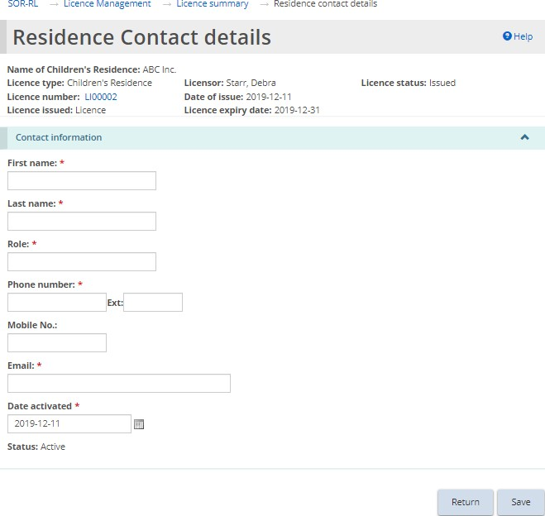
- Enter the contact information. Click , then click . The contact appears on the Residence contacts list on the Licence Summary page.

Staff Model Homes
- From the Licence summary page, expand the Staff Model Homes information banner.
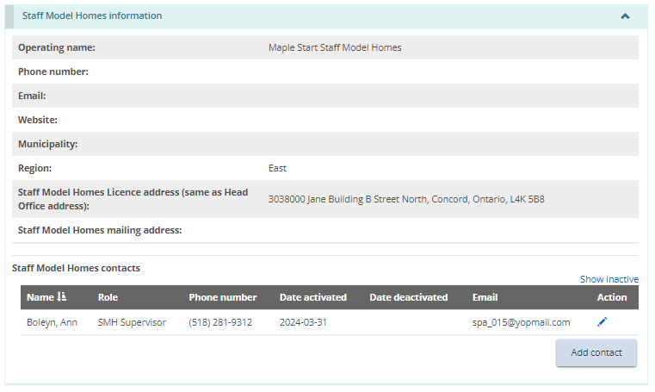
Note: A staff model home licence address reflects the address of the licence, which is likely the same as the head office address in the profile. The license address does not reflect the address of individual staff model home sites. Staff Model Home site addresses are indicated in the next section, Operation Information.
Note: Only the Staff Model Homes contacts can be edited and/or added from this section. Other changes, such as a change to the operating name, must go through a formal change request process. See the Requesting a change to a licence section.
- To see the Staff Model Homes contacts, scroll down to the Staff Model Homes contacts section.
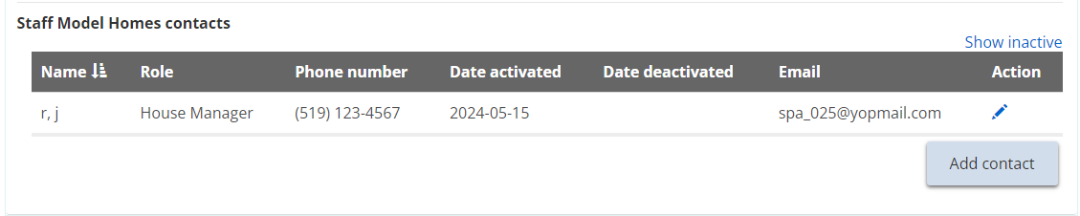
Note: This page shows all active contacts. To see all contacts, click Show inactive.
Note: Contacts for the staff model homes licence are recorded at the licence level.
- To view contact details, to edit contacts, or to deactivate contacts, click the edit icon . The Staff Model Homes contacts page appears.
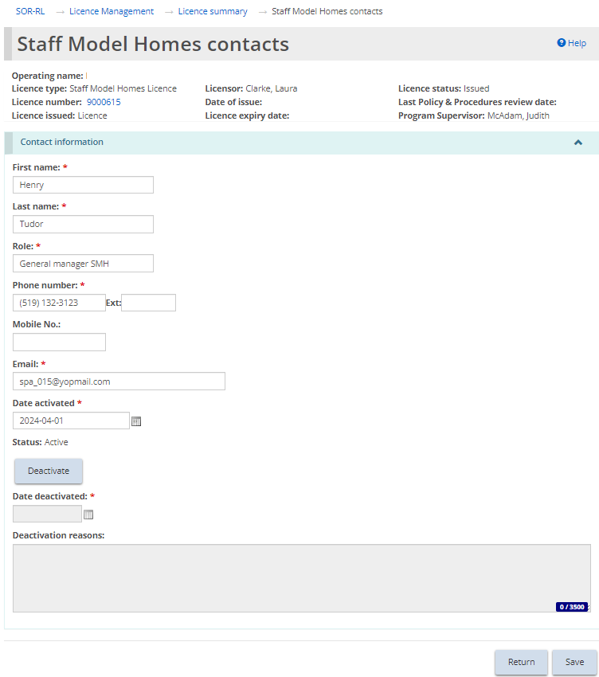
- Make the changes. If deactivating a contact, click and make the updates.
- Click then click .
- To add a staff model home licence level contact, click . The Staff Model Homes Contacts page appears.
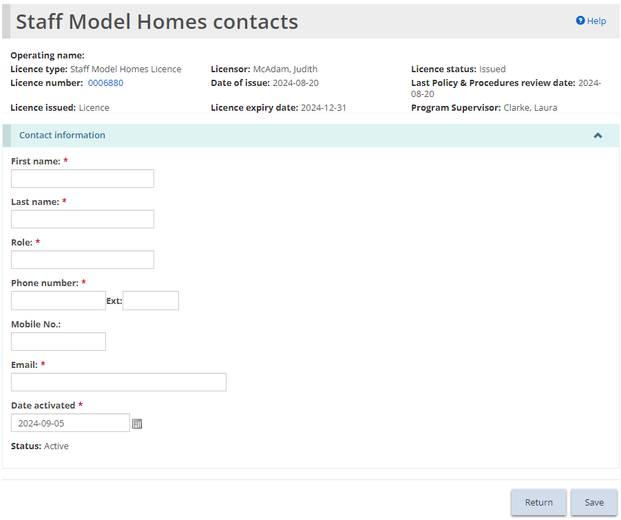
- Enter the contact information. Click , then click . The contact appears on the Staff Model Homes contacts list on the Licence Summary page.
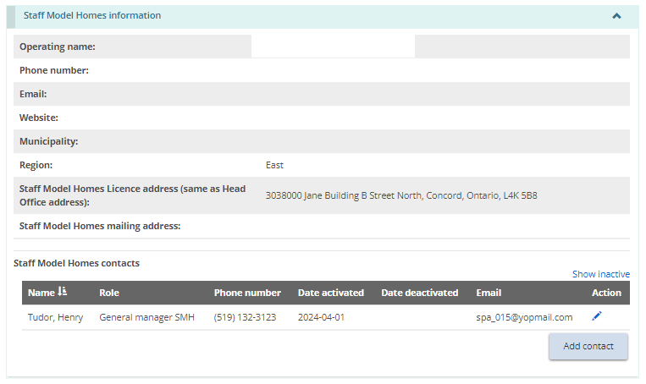

Foster Care Agency
- From the Licence summary page, expand the Foster Care Agency information banner.
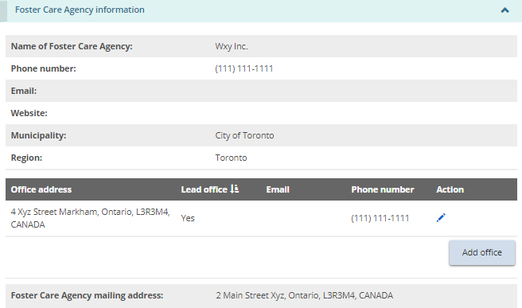
Note: Only the Foster Care Agency office address can be added or edited on this page. Other changes, such as a change to the Foster Care Agency name, must go through a formal change request process. See the Requesting a change to a licence section.
- To add an office, from the Foster Care Agency information section, click 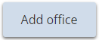. The Office address page appears.
- Manually populate the address fields or utilize the predictive address search field. An address verification mechanism is available.
Note: An address is not required to be verified for it to be saved in the system.
- Enter the office information, including indicating whether the office is the lead office.
- Click then click . The office appears on the Licence summary page.
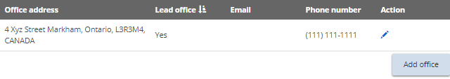
- To edit an office, from the Foster Care Agency information banner, click the edit icon .
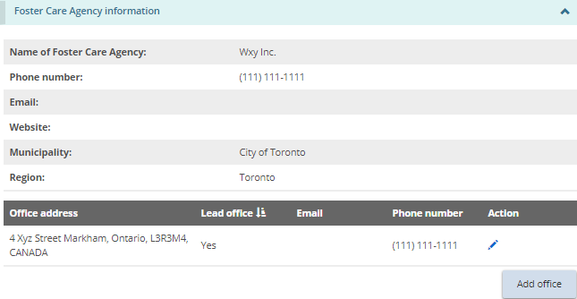
- The Office address page appears.
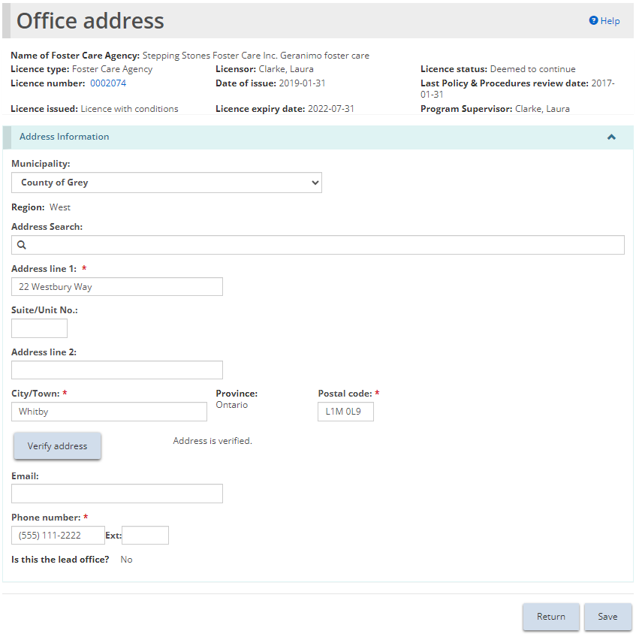
Note: If the office is the lead office, only the phone number and email are editable.
- Edit the information.
- Click then click .

Operation information
Note: Operation information differs between the three licence types. As such, the information below is organized by licence type.

Children’s residence
This section displays a brief description of the premises, program, and capacity. There is also a list of the children that have been added.
Note: Some changes such as those to the capacity and to children, can be made without a change request. Other changes must go through a formal change request process. See the Requesting a change to a licence section.
- From the Licence summary page, expand the Operation information banner.
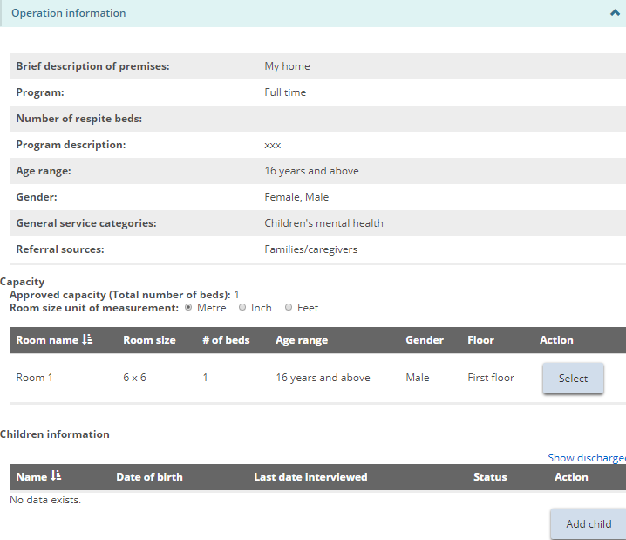
- To view capacity/room information, scroll down to the Operation information – Capacity section.
- To see the room information, click .
- To view Children information, scroll down to the Operation information – Children information section.
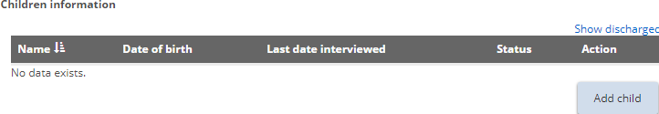
Note: The name of children will be displayed in full or with initials depending on your system role.
- To add a child, click 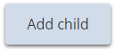. The Child details page appears.
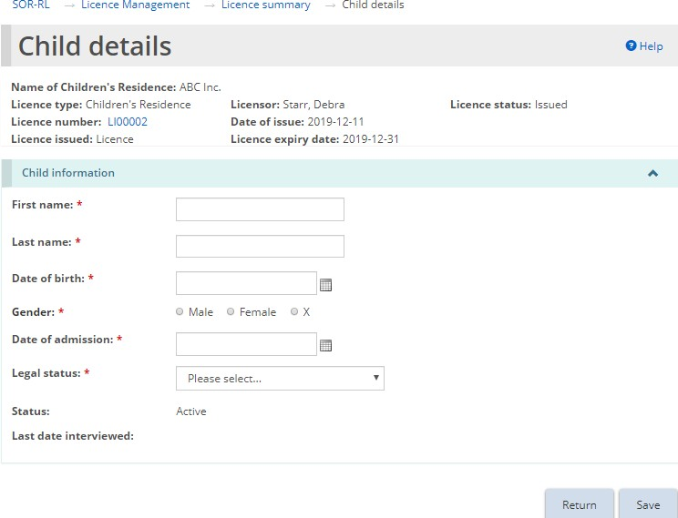
- Enter the child information. Click then click . The child appears in the Children information list on the Licence Summary page.
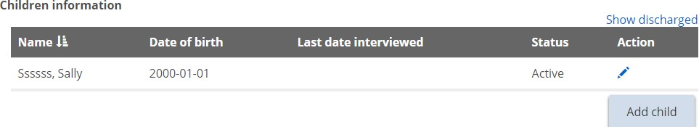
- To edit or discharge a child, click the edit icon. The Child details page appears.
- Make the changes. Click then click .

Staff Model Homes
This section displays the program details for the Staff Model Homes licence and a brief description of the premises, program and capacity for each Staff Model Homes site. There is also a list of the children that have been added to each site.
Note: Some changes to the sites/capacity/children/contact details can be made without a change request. Other changes must go through a formal change request process, including the addition or removal of a site from a Staff Model Home licence. See the Requesting a change to a licence section.
- From the Licence summary page, expand the Operation information banner.
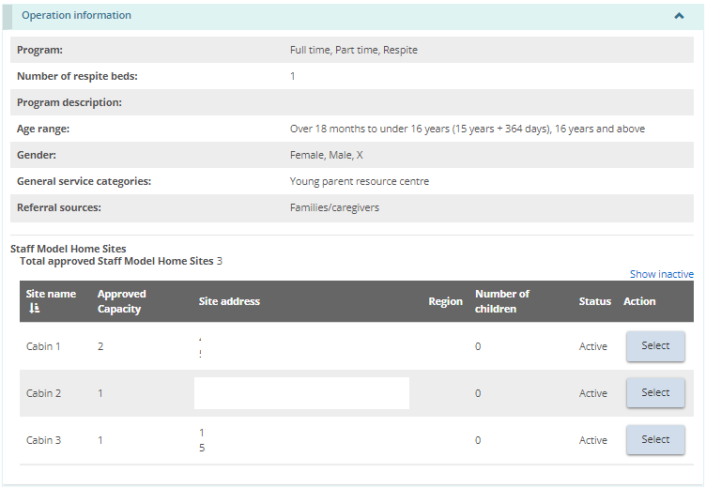
- To view Staff Model Home sites information, scroll down to the Staff Model Home Sites list.
- To view information for each Staff Model Homes site, click . The Staff Model Home Site details page displays.
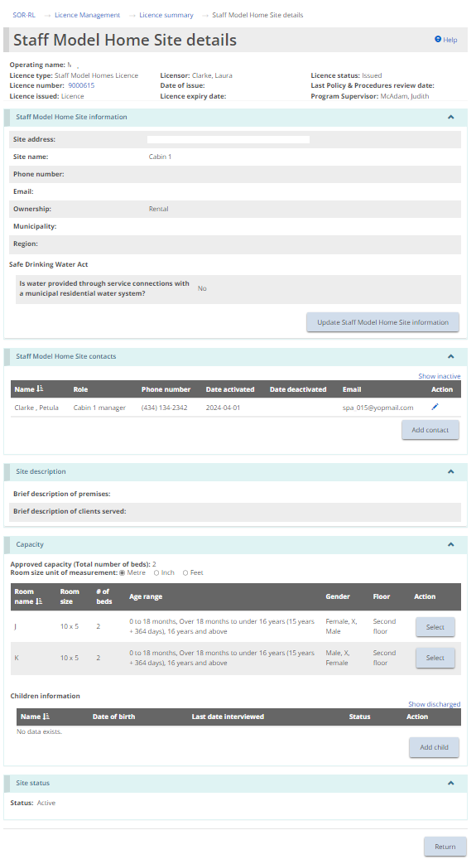
Note: The Staff Model Home site address reflects the location of the approved site and may not be the same as the head office address in the profile. The head office can be anywhere, but the staff model home sites must be in Ontario.
- To view Staff Model Home site contact details, scroll down to the Staff Model Homes contact banner.
- To add a contact at the staff model home site level, click Add Contacts. The Staff Model Home Site contact details page appears.
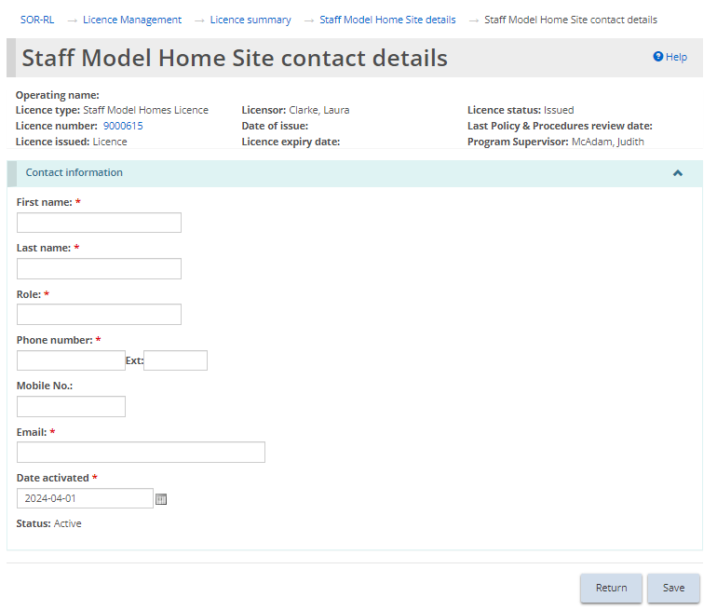
- Enter the contact information. Click , then click . The site contact appears on the Staff Model Home site contacts list on the Staff Model Home Site details page.
- Repeat these steps for all site contacts.
- To edit or deactivate a site contact, click the edit icon . The Staff Model Home Site contact details page appears.
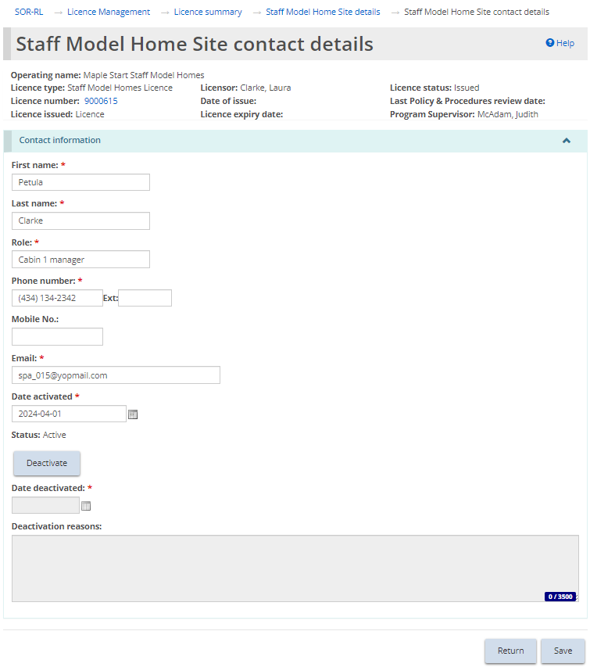
- Make the changes. If deactivating a contact, click and make the updates. Click then click . The Staff Model Home Site details page displays.
- To view capacity/room information, scroll down to the capacity section.
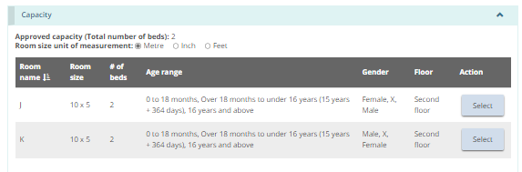
- To see the room information, click .
- To view the Children information, scroll down to the Children information section.
Note: The name of children will be displayed in full or with initials depending on your system role.
- To add a child, click . The Child details page appears.
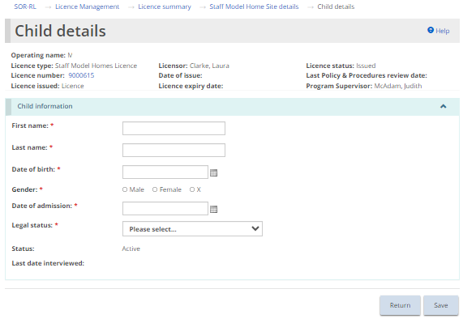

- Enter the child information. Click then click . The child appears in the Children information list on the Staff Model Home Site details page.
- To edit or discharge a child, click the edit icon . The Child details page appears.
- Make the changes. Click then click .
- Repeat steps for all staff model home sites listed and active children.

Foster Care Agency
- From the Licence summary page, expand the Operation information banner.
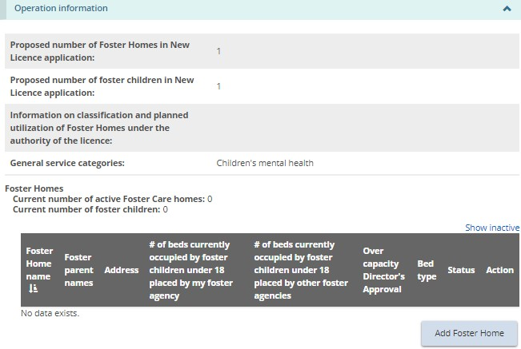
- To view foster home information, scroll down to the Foster Homes section.

Adding a foster home
- To add a foster home, from the Licence Summary page, expand the Operation information banner and scroll down to the Foster Homes section.
- Click 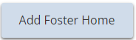. The Foster Home information page appears.
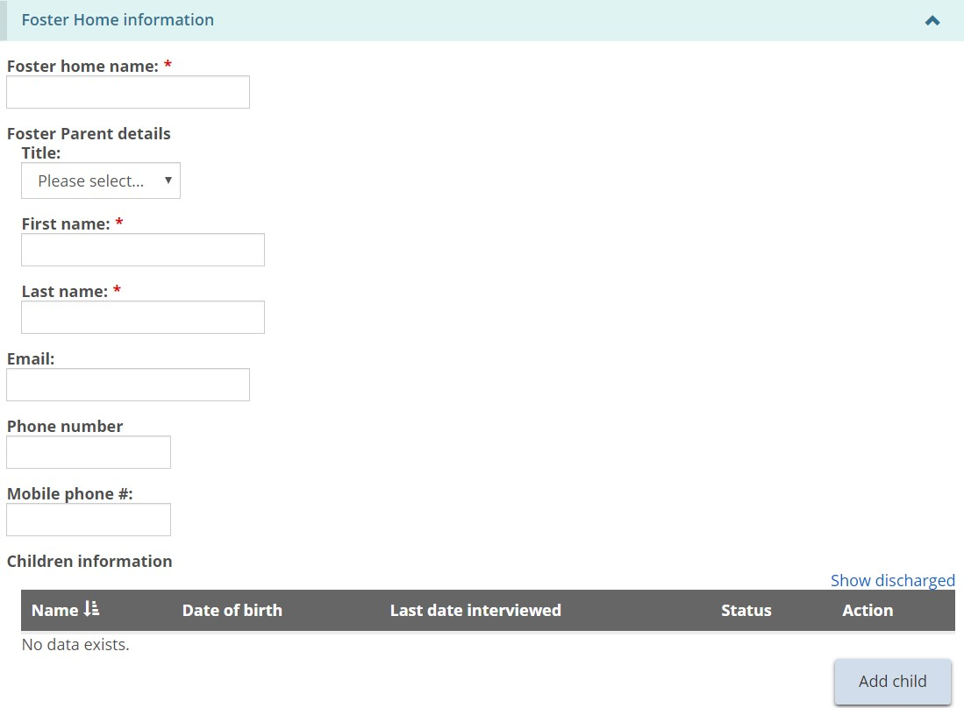
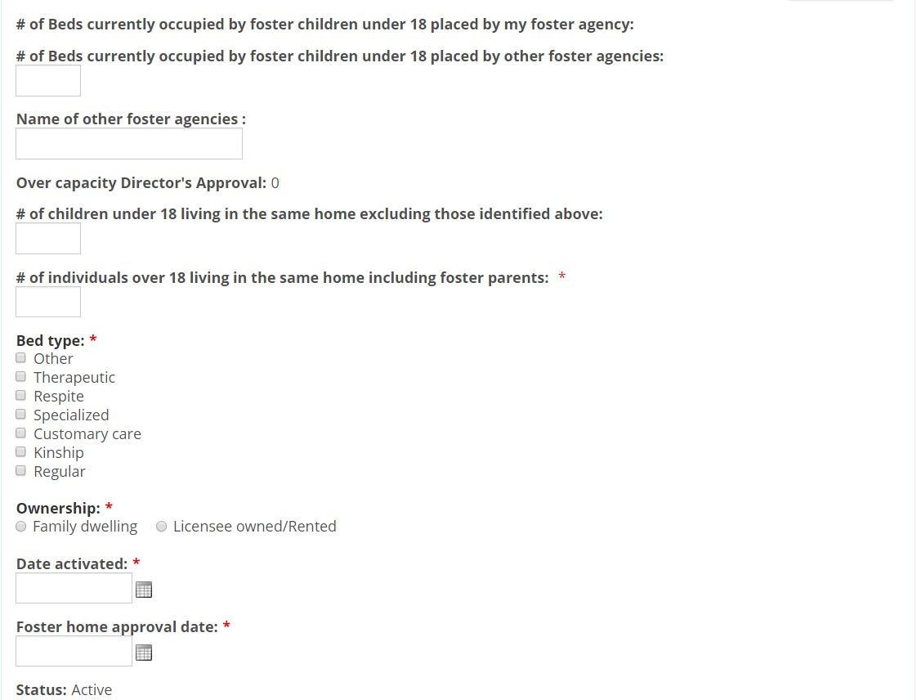
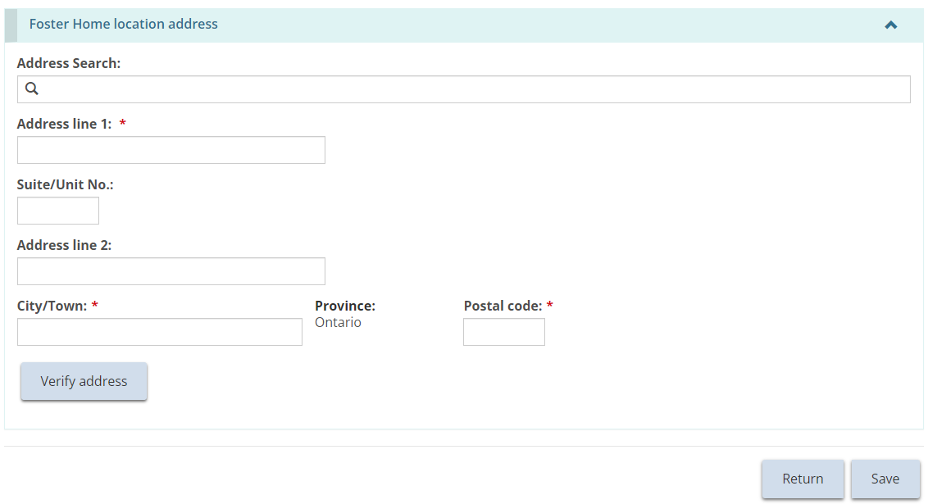
- Enter the foster home information.
Note: There can be more than one parent. Additional parents can be added once the page is saved. See instructions further below.
- To add a child, click . The Child details page appears.
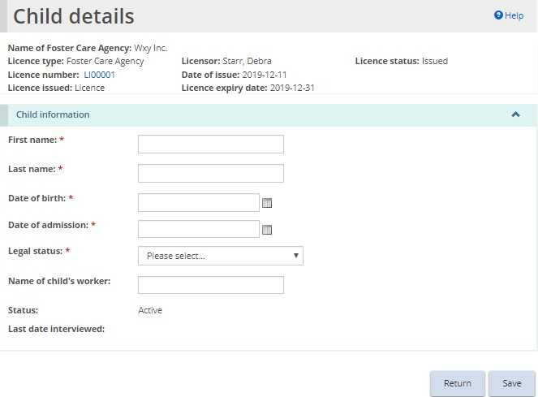
- Enter the child information. Click , then click . The child appears in the Foster Home information page.
- Scroll down to the Foster home location address section.
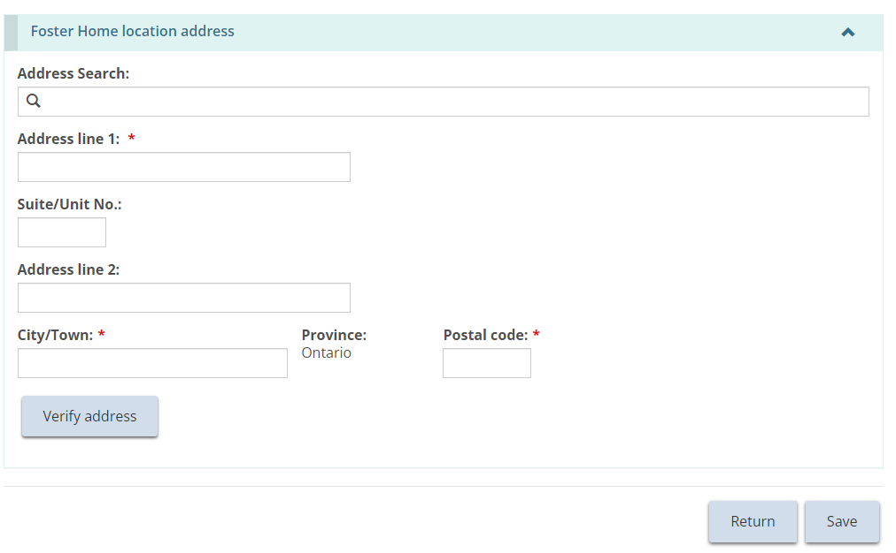
- Manually populate the address fields or utilize the predictive address search field. An address verification mechanism is available.
Note: An address is not required to be verified for it to be saved in the system.
Note: The Foster Home location address reflects the location of the approved home and will not be the same as the head office address in the profile. The head office can be anywhere, but the foster home sites must be in Ontario.
- Click .
- An additional foster parent can now be added. To add a foster parent, press 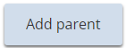. The Foster parent details page appears.
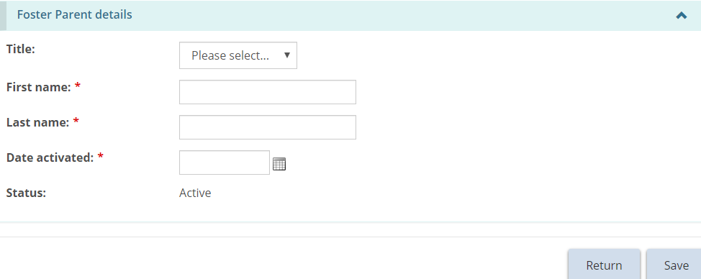
- Enter the foster parent information. Click then click . The foster parent appears in the list.
- Once done, click then click . The foster care home appears in the list.
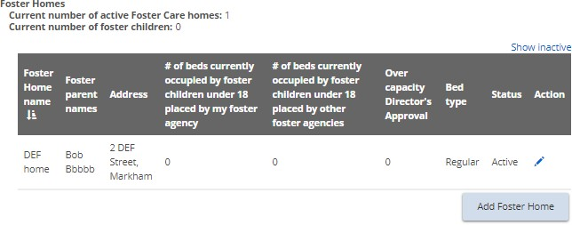

Editing a foster home or foster children
- From the Licence Summary page, expand the Operation information banner and scroll down to the Foster homes section.
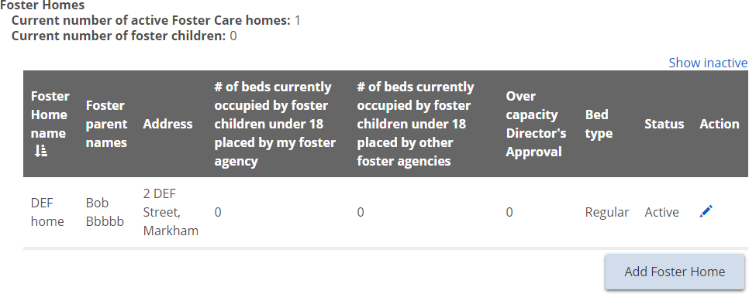
- Click the edit icon . The Foster Home page appears.
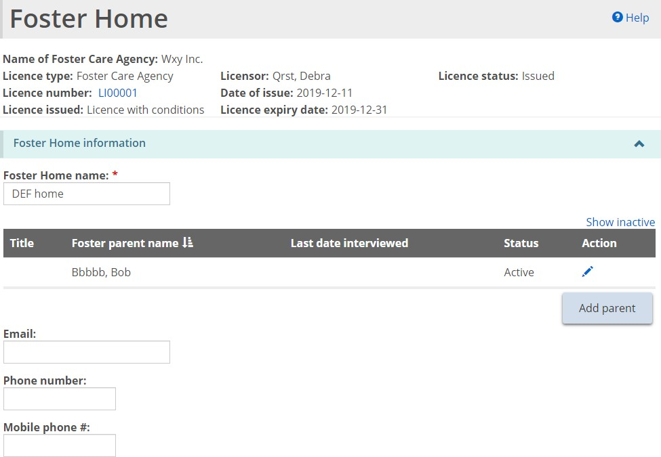
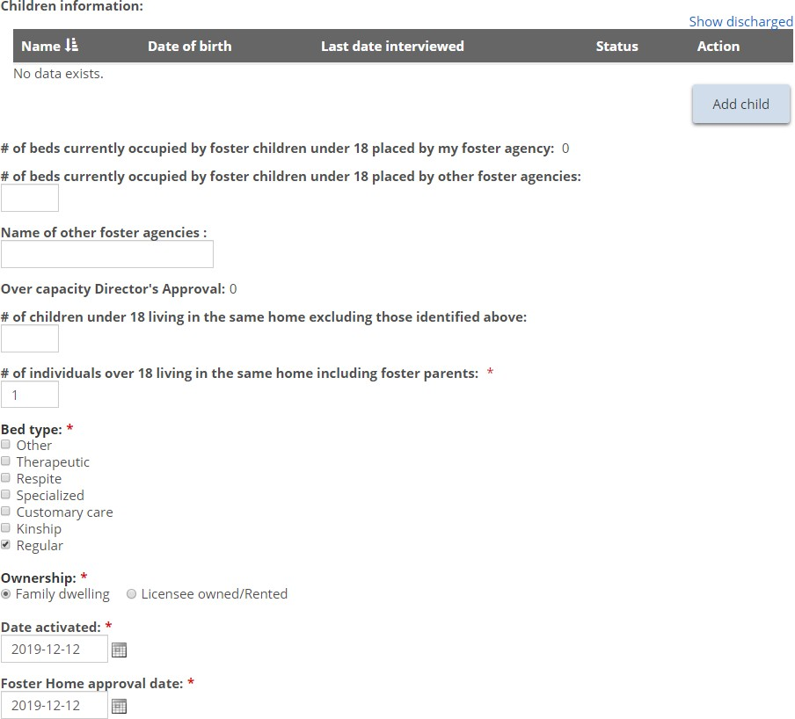
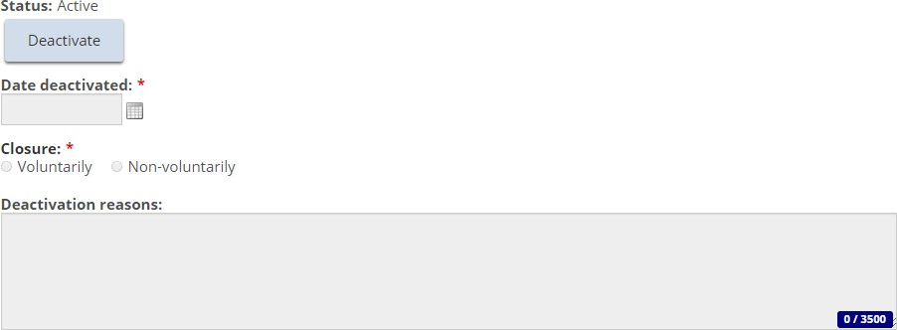
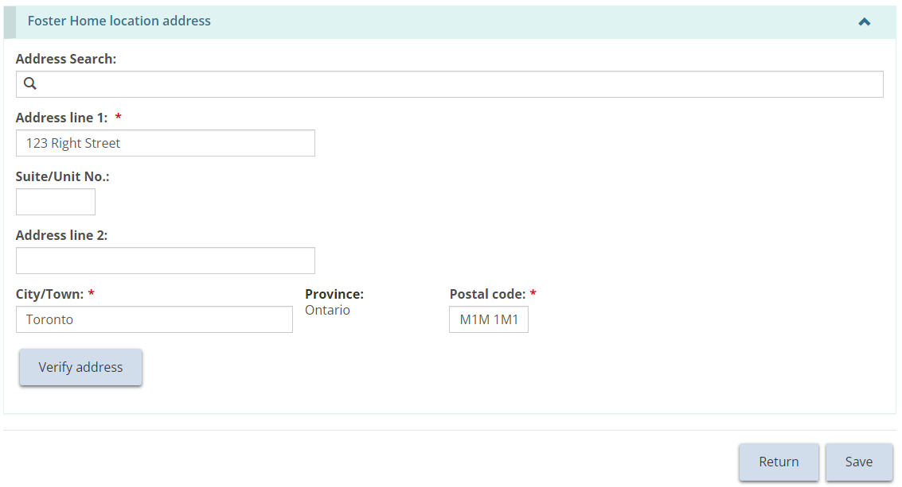
- Make the changes required.
- To edit or discharge a child, scroll down to the Children information section.
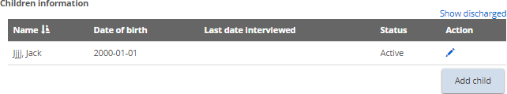
- Click the edit icon . The Child Details page appears.
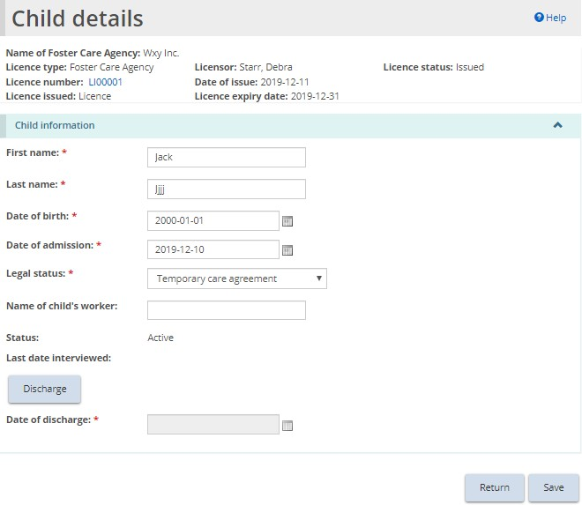
- Make required changes or click 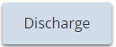. Enter the discharge date.
- Click then click .
- If discharged, the child’s status changes to “Discharged” and the child’s name disappears from the Children information list on the Licence Summary page.

Deactivating a foster home
Note: There cannot be any active children in the home before being deactivated.
- From the Licence Summary page, expand the Operation information banner and scroll down to the Foster homes section.
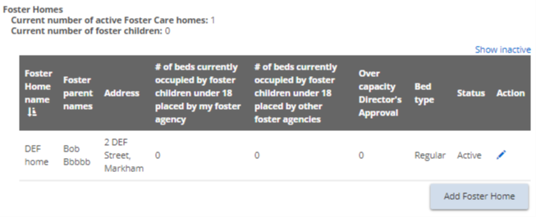
- Click the edit icon . The Foster Home page appears.
- Click .
- Enter the date deactivated, and indicate whether the closure was voluntary or non-voluntary.
- Enter the Deactivation reasons.
- Click then click .

Director’s Approval
Note: This section will only be displayed on the Licence Summary page if there is a Director’s Approval for the licence.
Note: Changes to a Director’s Approval cannot be made here, however a Director’s Approval can be withdrawn.
- From the Licence summary page, expand the Director’s Approvals banner.
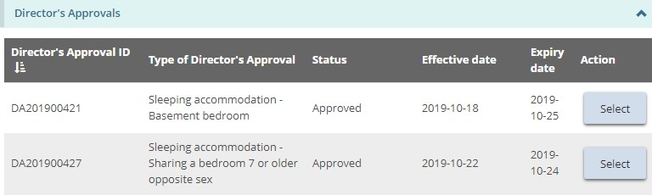
- Click to see the details. The Director’s Approval summary page appears.
- To withdraw a Director’s Approval, click .

Conditions
Note: A Conditions banner will only be displayed on the Licence Summary page if conditions are applied on the licence.
- From the Licence summary page, expand the Condition banner.
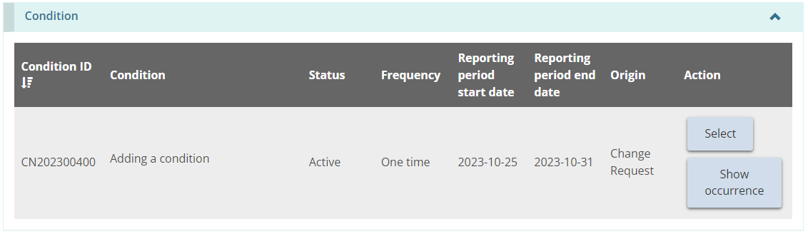
- Click . The Condition summary page appears.
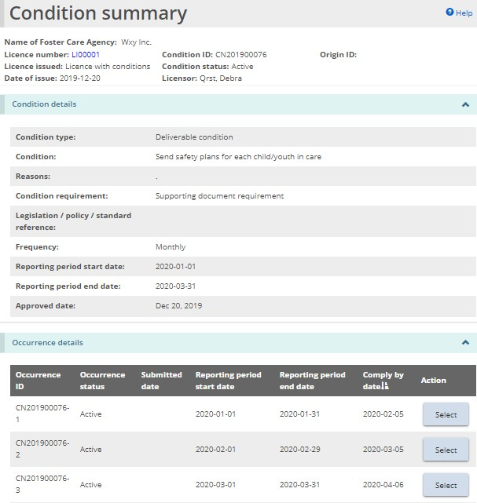
- To see the occurrences only, click 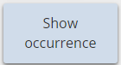.
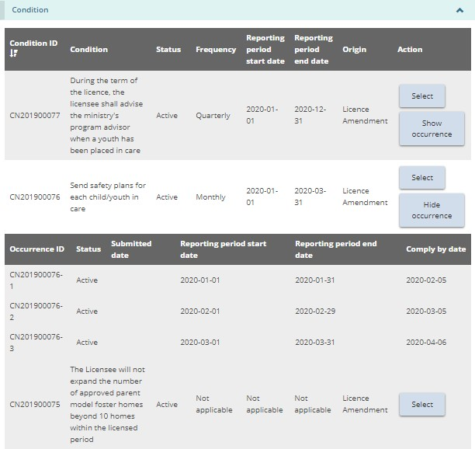
Tip: For more information about conditions, see the Working with conditions section.

Staff summary
- From the Licence summary page, expand the Staff Summary banner.
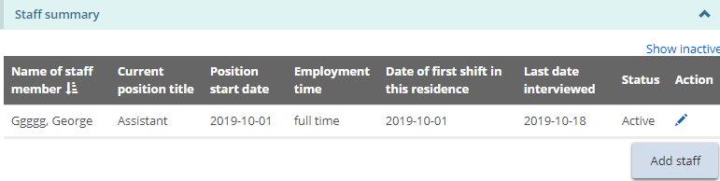
Tip: Click the Show Inactive link to include inactive staff in the list.
- To add a staff member, click 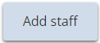. The Staff details page appears.
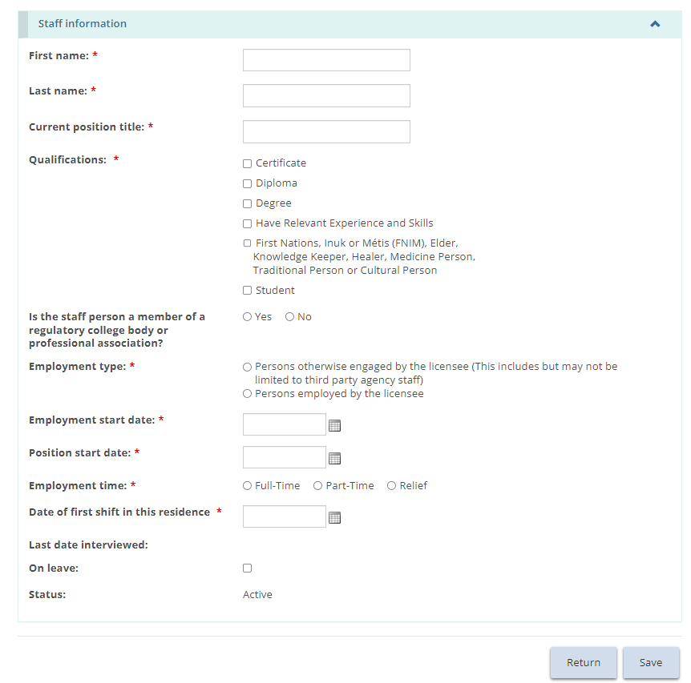
- Enter the staff information.
- For Staff Model Homes, staff can be added to 1 or more Staff Model Homes site.
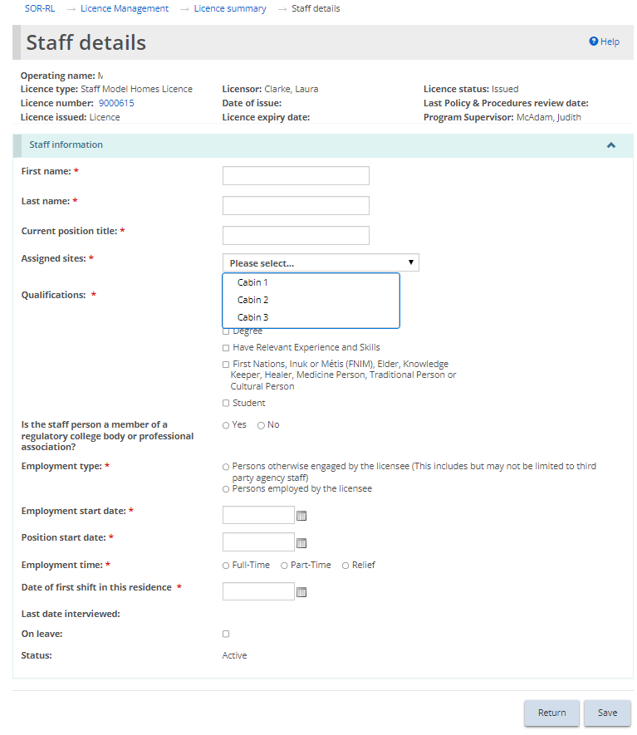
- Click then click . The staff appears on the Staff Summary list on the Licence Summary page.
- To edit or deactivate a staff member, click the edit icon. The Staff details page appears.
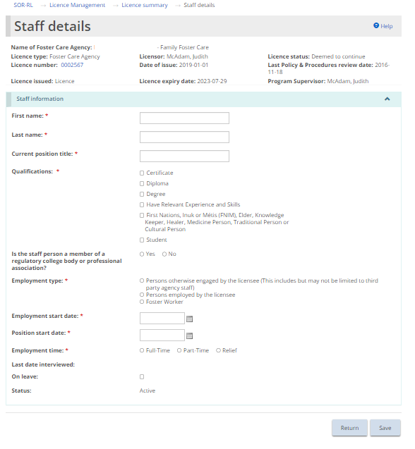
- Make the changes required.
- If the staff member is on leave, click the On leave checkbox.
- To deactivate a staff member, click 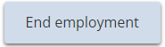. Enter the employment end date.
- Click then click .

Supporting documents
Supporting documents are listed at the bottom of the Licence Summary tab, for reference only.
Note: Documents cannot be uploaded, edited or deleted from this tab. Documents can only be viewed or downloaded. See the Uploading Supporting Documents section of this guide for information on how to upload documents from the Licence Management module.
- From the Licence Summary page, expand the Supporting Documents banner.
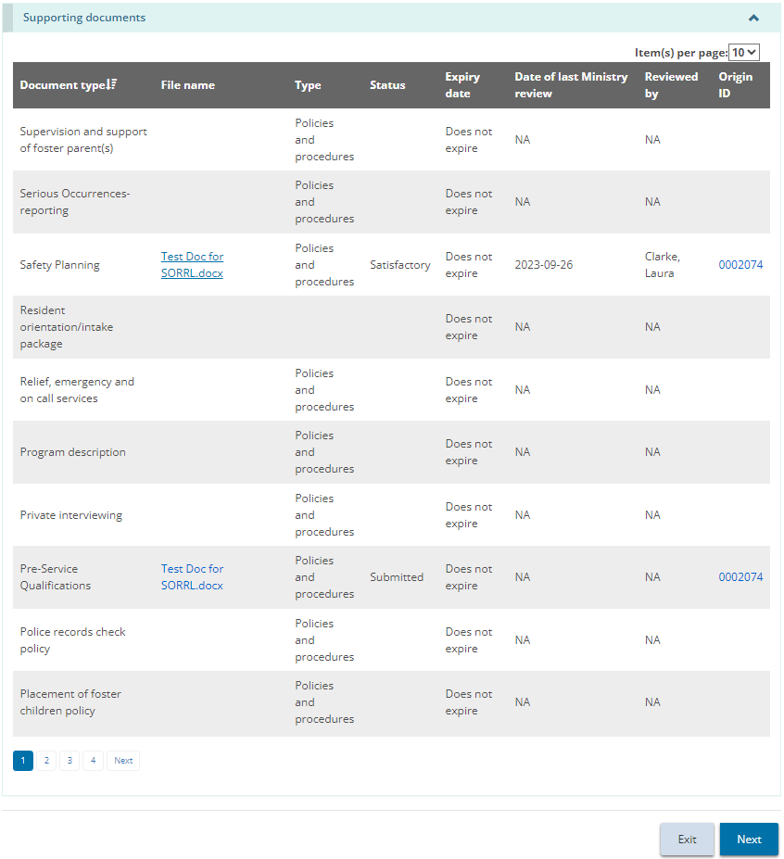
- To view a document, click on the blue file name link. The file will download to your computer.

Updating licence details from the licence summary
- From the SOR-RL home page, click . The Licence management module appears.
- Click . The Licence summary page appears.
Children’s Residence example
Note: The Licence Summary page is divided into three tabs: Licence summary, Update Licence details, and Supporting Documents.
- From the top of the licence summary page, click Update Licence details.
Note: The name of the tab depends on the type of licence.
- The Update licence details tab appears.
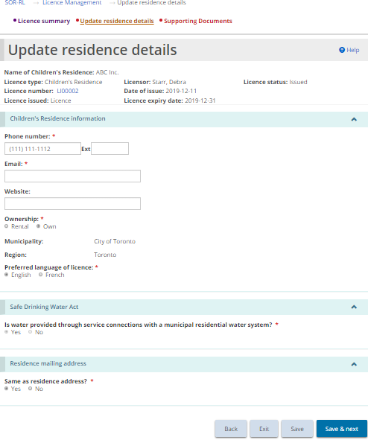
Children’s Residence example
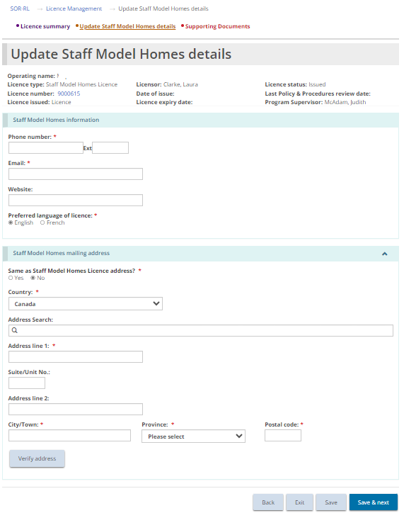
Staff Model Homes example
- Make the changes required and click .

Viewing/uploading supporting documents from the licence summary
- From the SOR-RL home page, click . The Licence management module appears.
- Click . The Licence summary page appears.
Children’s Residence example
Note: The Licence Summary page is divided into three tabs: Licence summary, Update Licence details, and Supporting Documents.
- From the top of the licence summary page, click . The Supporting documents tab appears.
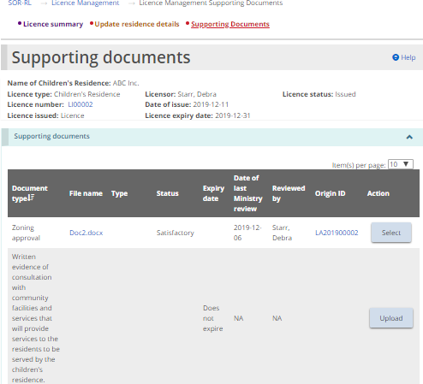
- To upload a document that has not yet been uploaded, click .
Note: You cannot upload a document directly from this page if the document has already been uploaded through a Licence Application, a Director's Approval or a Change Request. See the Working with Supporting Documents section.
- To view the contents of an uploaded document, click the blue document link in the File name column.
- To view details about a document that has already been uploaded or to see the submitted document versions, click . The Upload supporting document page appears.
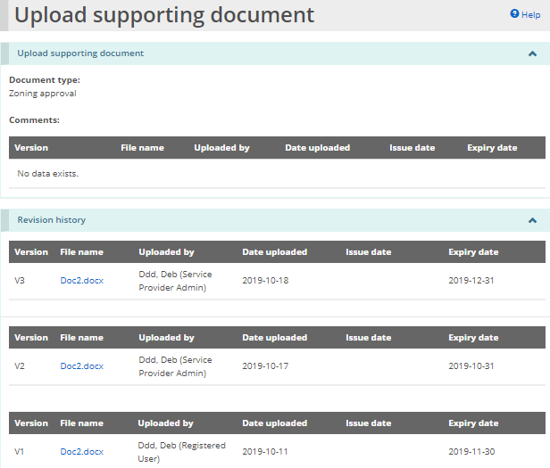
- Click the blue file name link to see the document details.

Viewing the licence history
- From the SOR-RL home page, click . The Licence management module appears.
- Click 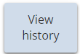. The Licence history page appears.
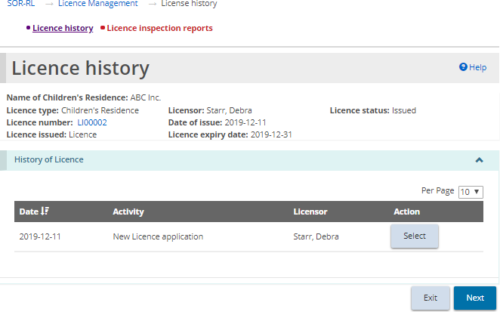
The Licence history page is divided into two tabs: Licence history, and Licence Inspection reports. Let us begin with the Licence History tab.
The Licence History tab displays a list of activities that have occurred on the licence including new Licence Applications, Renewal applications, Licence Amendments, Change Requests, and Director’s Approvals. The list also indicates when the licence status has changed.
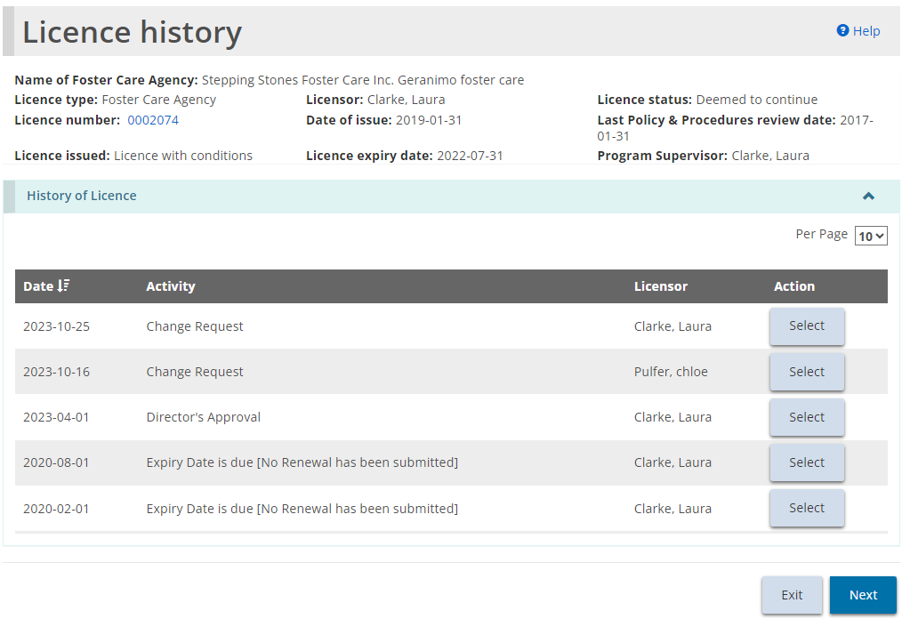
- To see an activity item in detail, click .

Viewing inspection reports from the license history
- From the SOR-RL home page, click . The Licence management module appears.
- Click . The Licence history page appears.
The Licence history page is divided into two tabs: Licence history, and Licence Inspection reports. Let us proceed to the second tab, Licence inspection reports. If an inspection was done, a copy of the report can be found in the Licence Inspection reports tab.
- Click the tab.
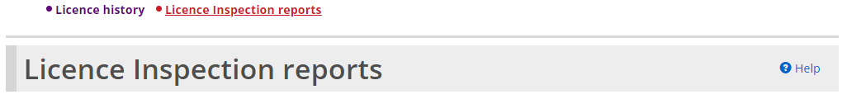
- The Licence inspection reports page appears.
Note: The page examples are similar for Children’s Residence licences, Staff Model Home licences, and Foster Care Agency licenses. Only the Children’s Residence page examples appear in the instructions below.
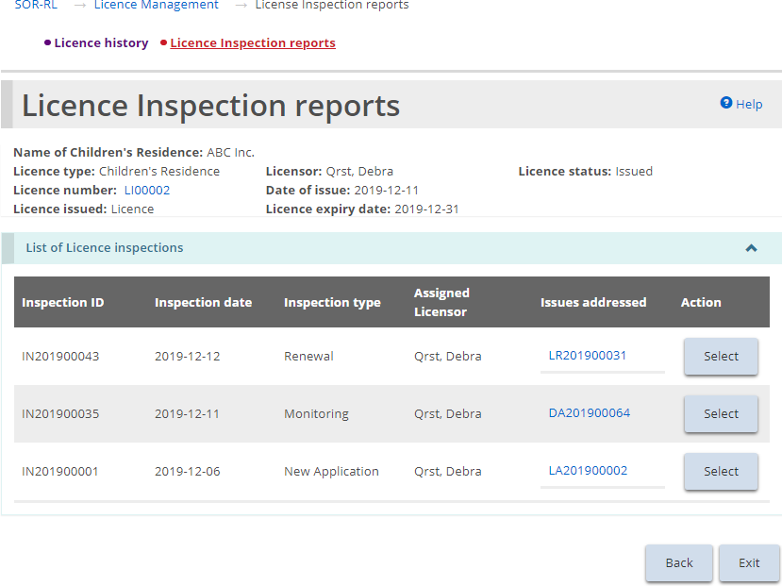
- Click to view the inspection details. The Inspection summary page appears.
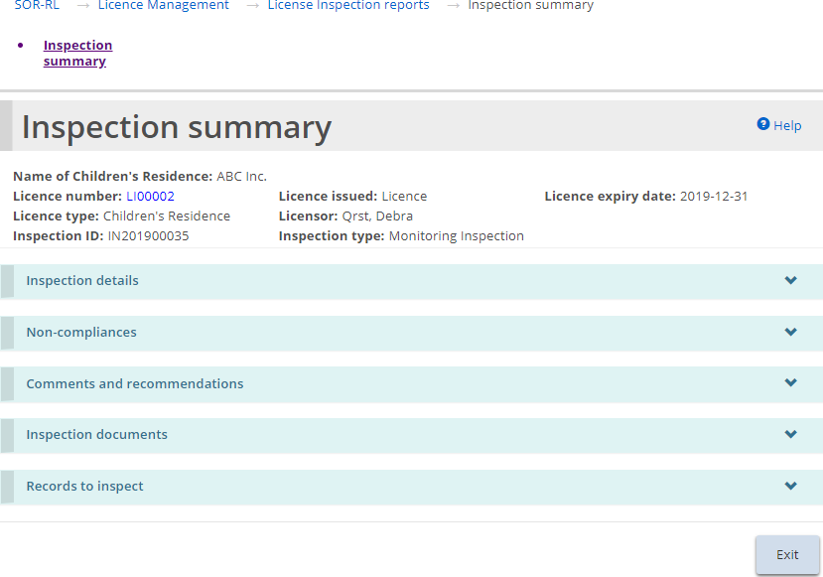

Viewing the Licence Management dashboard

Confirming/amending children/parent/staff lists
During an inspection, your licensor may add staff, children, or parents not already listed in SOR-RL. Anyone added needs to be confirmed by the licensee from the licence management dashboard.
- From the SOR-RL home page, click .The Licence management module appears.
- Click See dashboard. The dashboard expands.
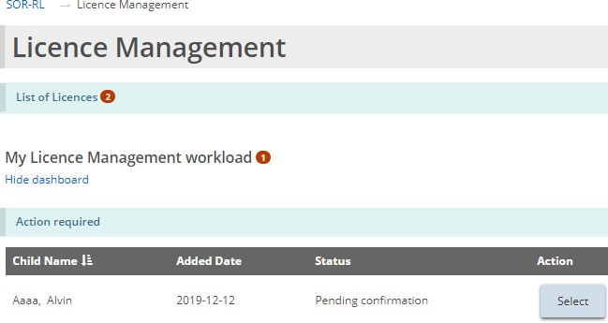
- Click . The page requiring action appears.
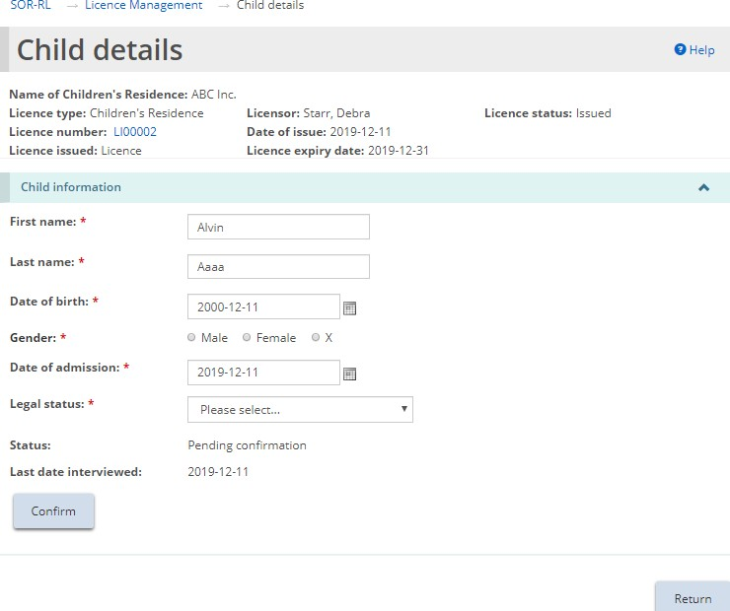
Example of a child’s information pending confirmation
- Review/edit the information as required. Click 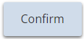. If a message appears, click . The page expands.
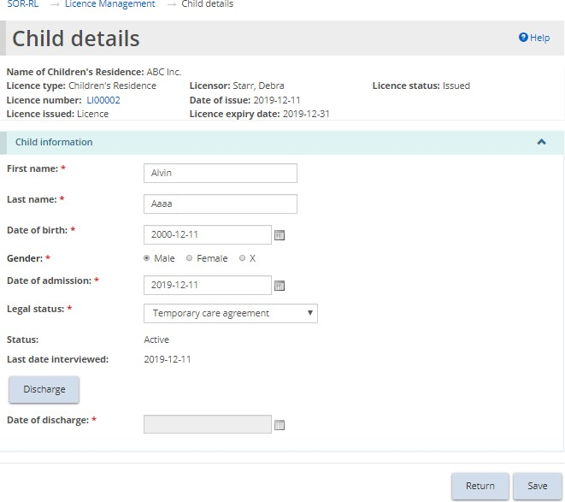
- Click then click . The item disappears from the action required list in your Licence Management dashboard.

Requesting a change to a licence
A Licensee can submit the following types of change requests:
- Change capacity (Children’s Residence, Staff Model Home)
- Change program description (All licence types)
- Change site/floor plan or renovation (Children’s Residence, Staff Model Home)
- Change Children’s Residence name (Children’s Residence, Staff Model Home)
- Change Foster Care Agency name (Foster Care Agency)
- Change Foster Care Lead office address (Foster Care Agency)
- Licence closure (All licence types)
- Add or Remove a site (Staff Model Home only)
Change requests are given a number beginning with CR.
Note: A request to increase capacity in a children's residence needs to be entered as a capacity change request. If the purpose of a renovation is to change the home's capacity, the change request must be filed as a capacity change request, and information on the renovations must be entered on the ‘renovations' page.
Note: The licensed capacity of a Staff Model Home site can only change to/from one or two.
Note: The purpose of a capacity change request is different from that of a site/floor plan or renovation change request. A licensee cannot apply for both, and renovations may not necessarily change capacity. Hence, similar information is asked in different types of change requests.
Note: A Foster Care Agency licence lead office can be changed via a Change Request.
Note: Changing an address on a Foster Care Agency licence generates an updated licence with a new address.

Filing a change request
- From the SOR-RL home page, click . The Change Request module appears.
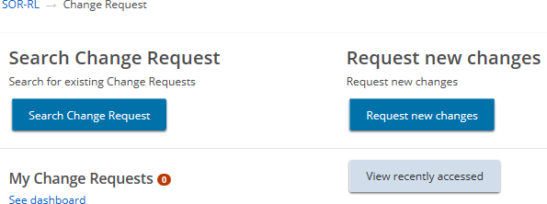
- Click 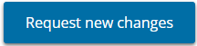.The Select Licence page appears.
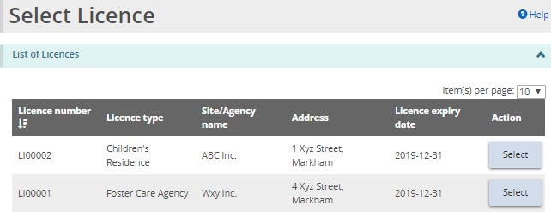
- Select the licence the change request is for.
- The Request new changes page appears (page contents differ depending on the licence type).
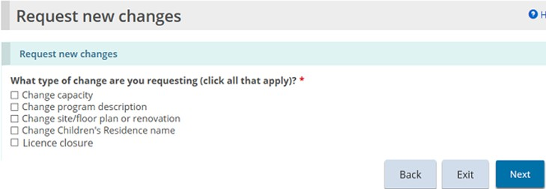
Example of a Children’s Residence page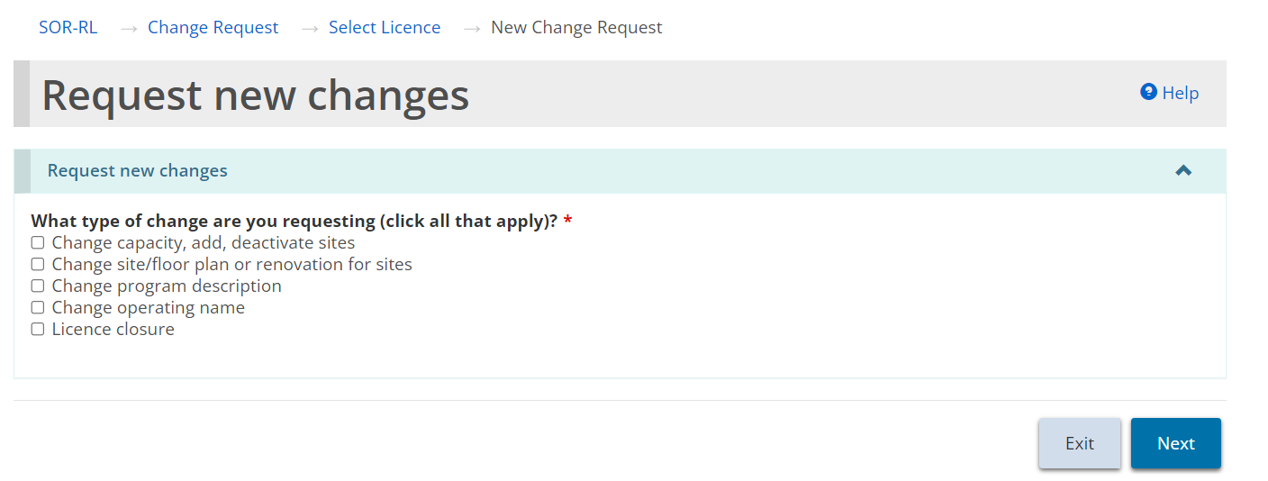
Example of a Staff Model Home page
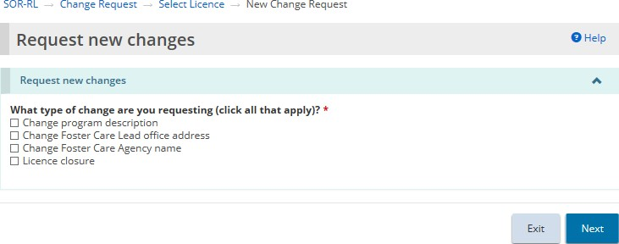
Example of a Foster Care Agency page
- Select the type of change being requested. You can select more than one type.
- Click .
- If you select “Change capacity” or “Change program description”, the following window appears. Click OK to continue.
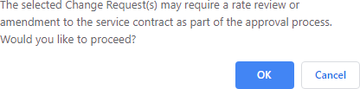
- The Notice of collection of personal information page appears. Read the notice then click .
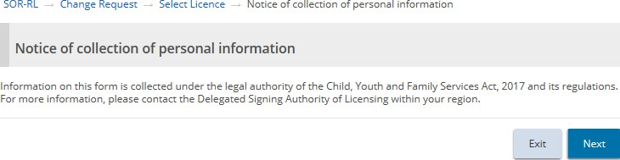
- A page appears displaying the steps of the request at the top of the page.
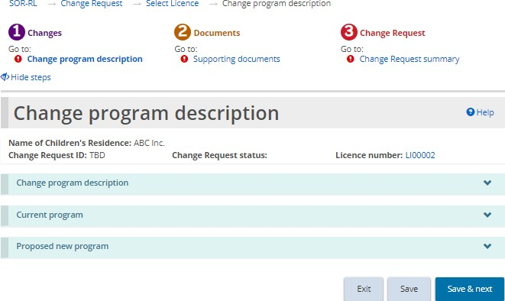
Children’s residence example
- Expand each banner in the first section and complete the information. Click .
- The Supporting documents section appears.
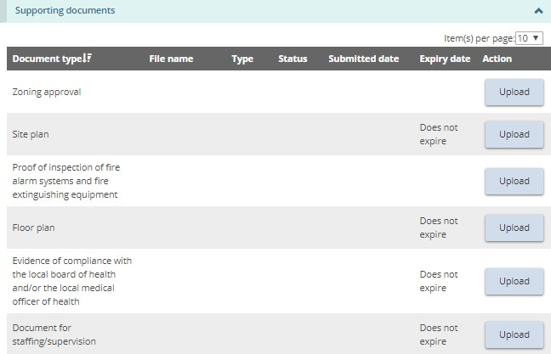
Note: The list of supporting documents required varies depending on the type of licence and the change(s) requested.
- Upload the supporting documents and click .
- The Change Request Summary section appears.
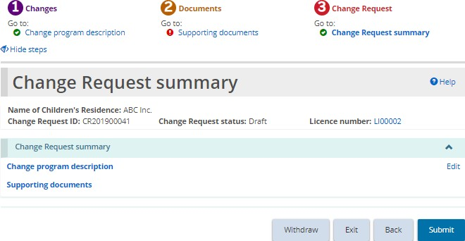
- Review the information. If edits are required, click the applicable section to edit from the top of the screen.
- Click . The Declaration & consent page appears.
- Read the declaration and consent and then answer the questions.
- Click . A confirmation message appears.

Filing a change request for a licence closure
- From the SOR-RL home page, click . The Change Request module appears.
- Click .The Select Licence page appears.
- Click . The Request new changes page appears (page contents differ depending on the type of licence).
Example of a Children’s Residence page
- Select “Licence closure”.
- Click . The Notice of collection of personal information page appears.
- Read the notice then click . The Licence closure page appears.
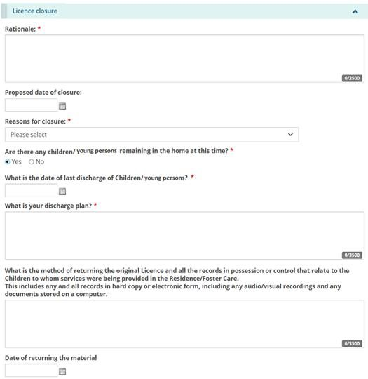
Children’s Residence example
- Enter the information.
- Click . The Supporting documents page appears.
- Upload supporting documents if required.
- Click . The Change Request summary page appears.
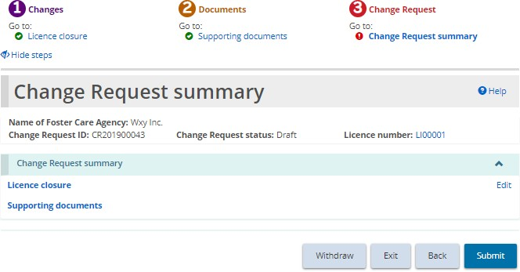
- Review the summary. Click . The Declaration & consent page appears.
- Read the declaration and consent and then answer the questions.
- Click . A confirmation message appears.

Filing a Change request to add or deactivate a site (Staff Model Homes only)
- To add or deactivate a site for a staff model homes licence, a change request must be initiated. From the SOR-RL home page, click . The Change Request module appears.
- Choose the Change capacity, add, deactivate site(s) change request type.
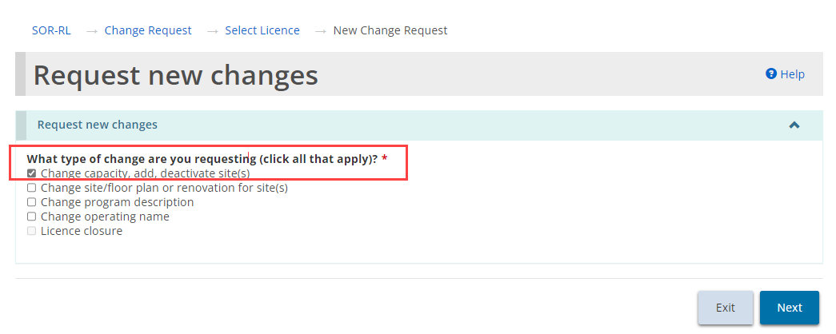
- Click . The Notice of collection of personal information page appears.
- Read the notice then click . The Change capacity, add, deactivate site(s) site page displays.
- To add a new site, click 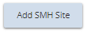.
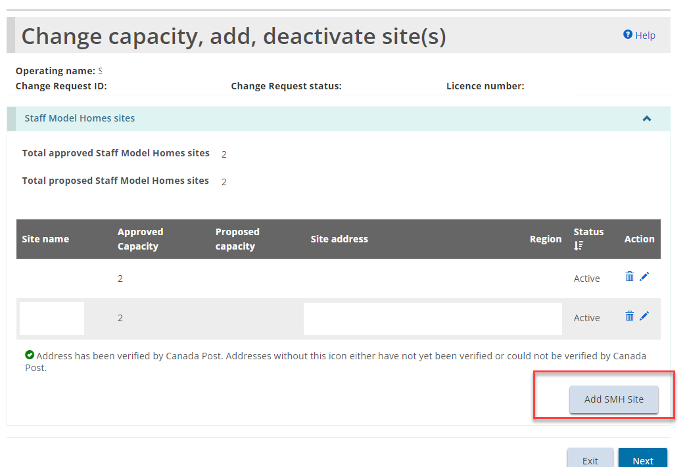
- The Staff Model Home Site details page appears.
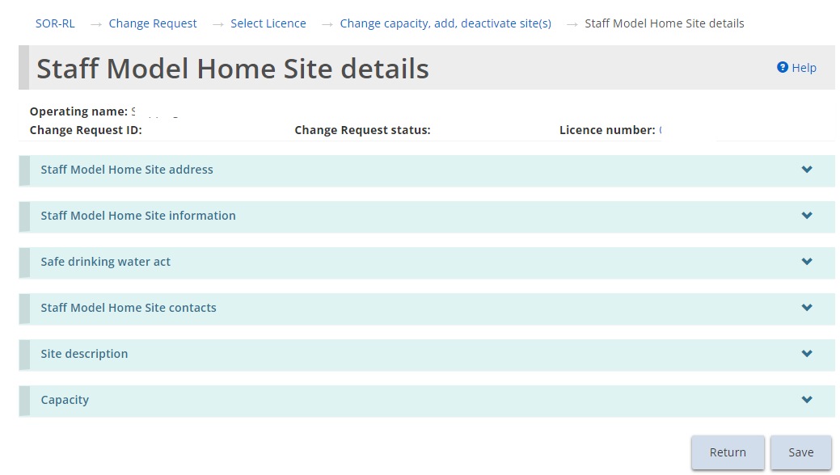
- Expand the banners and complete all the required information. Click 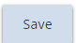.
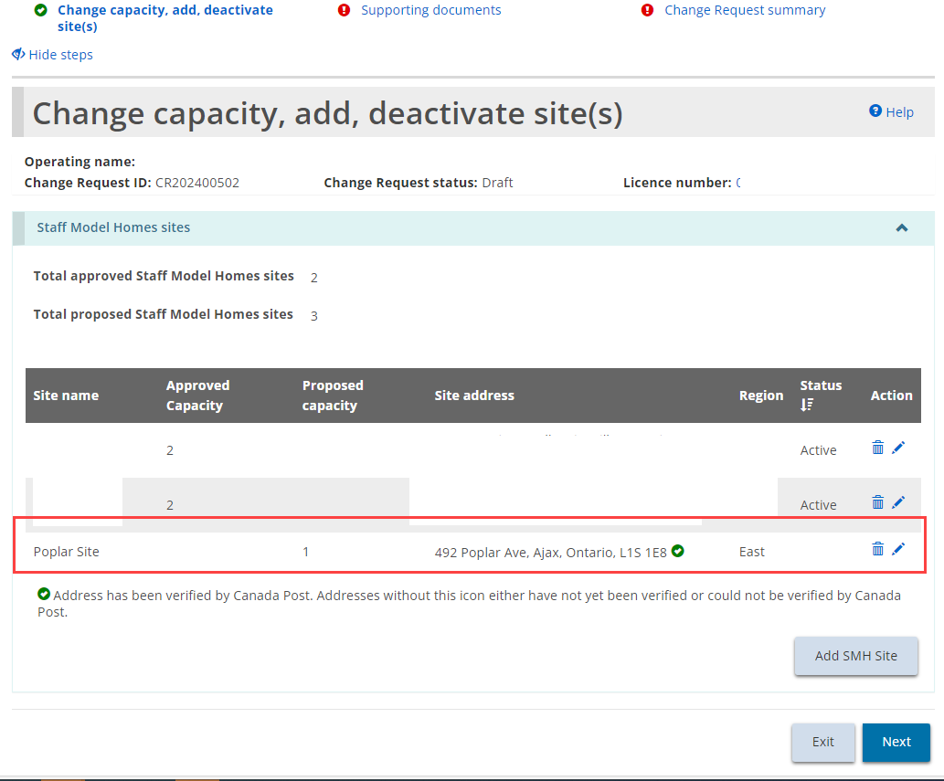
- The proposed new site now shows in the Staff Model Homes sites list. This action can be repeated for each new site to be added.
- Click . The Supporting documents page appears.
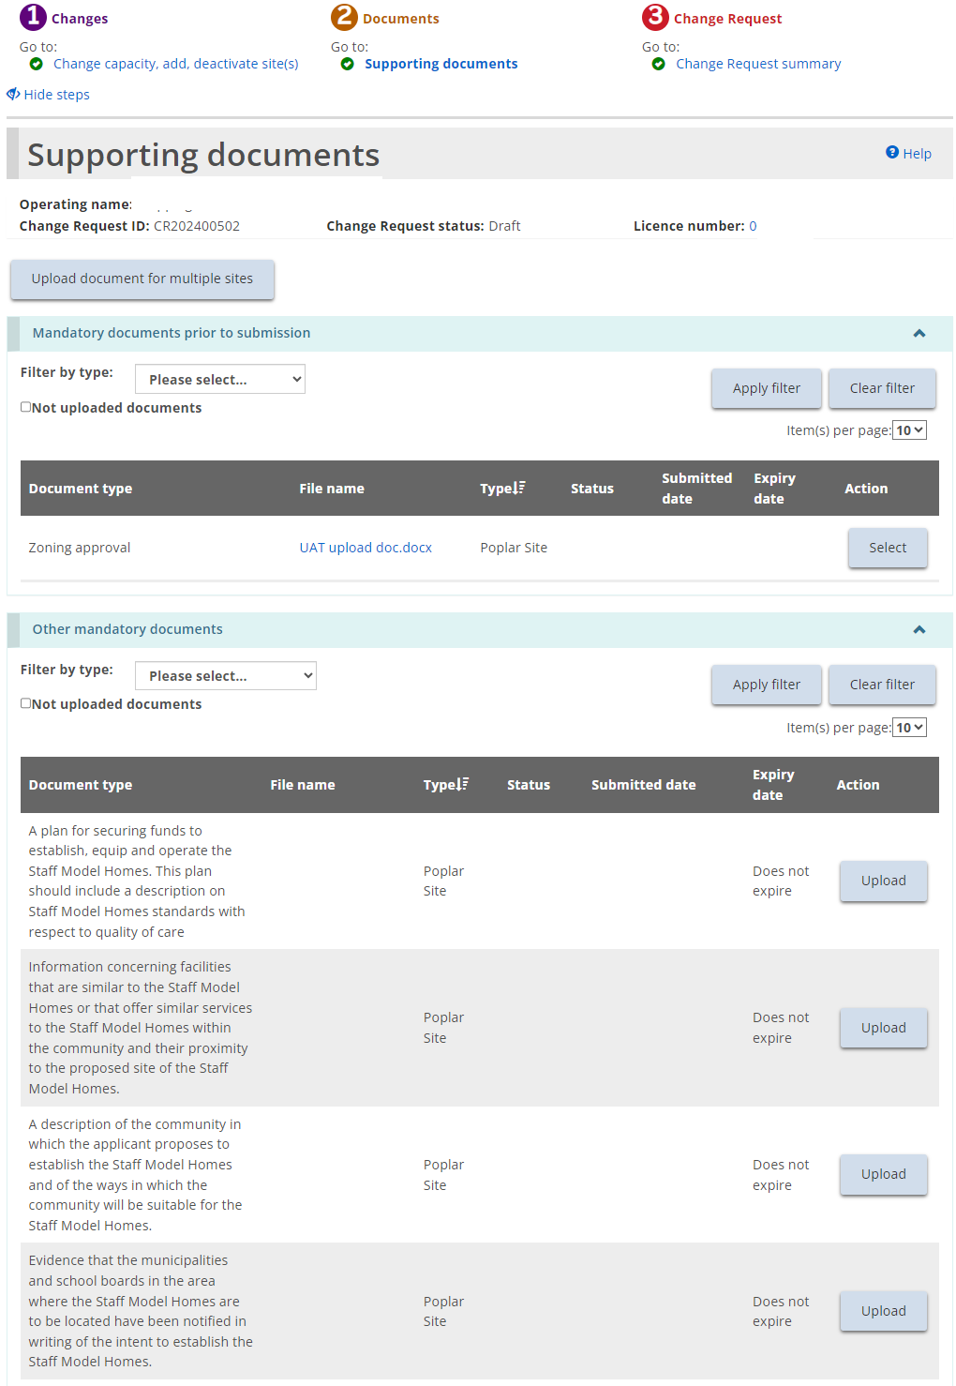
- Upload the supporting documents.
- Click . The Change Request summary page appears.
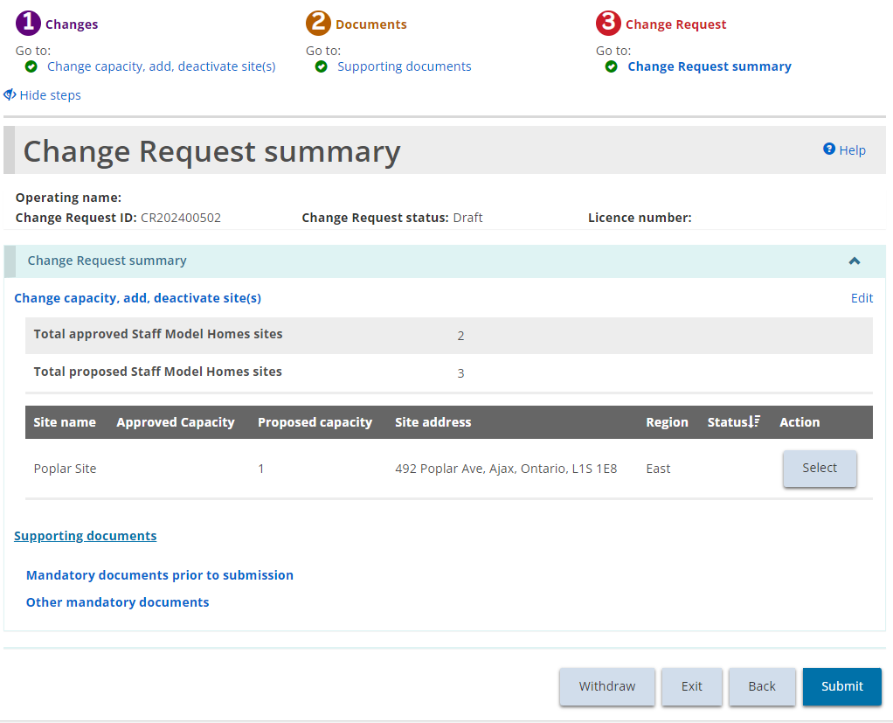
- Review the summary and click . The Declaration & consent page appears.
- Read the declaration and consent and then answer the questions.
- Click . A confirmation message appears.
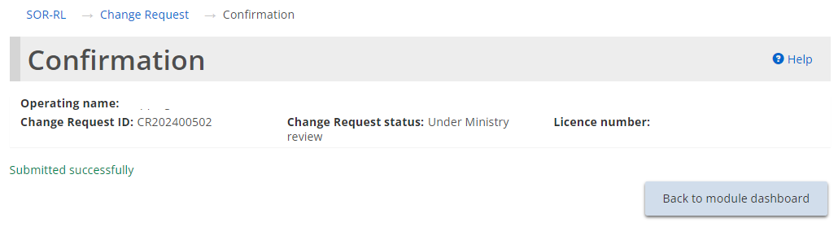

Withdrawing a Change Request
- From the SOR-RL home page, click . The Change Request module appears.
- Open the change request from your dashboard. The Change Request summary page appears.
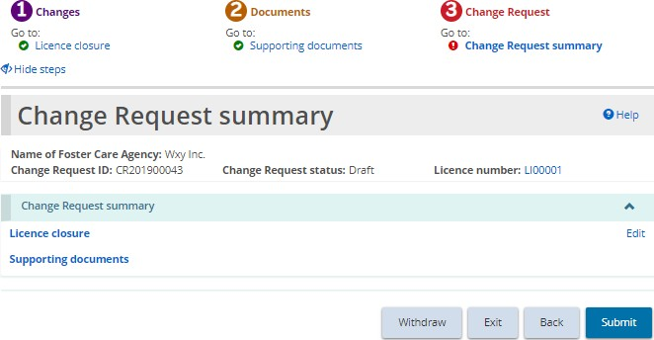
Children’s Residence example
- Click .
- If the change request was already submitted (not a draft), select a reason for the withdrawal.
- Click . A confirmation message appears.

Renewing a licence
You will be sent an email reminder 120 days before your licence expires. During that time, you must submit your licence renewal application. Supporting documents can be submitted after the renewal is submitted.
Renewals can be found in the Upcoming Renewals section of the Licence Renewal dashboard if:
- you have not submitted a renewal, and
- the licence expiry date is equal to or less than 120 days.
Completing a renewal is similar to creating a new application except that the majority of fields are already completed. Review and edit the information and upload documents as required.

Start the renewal
- From the SOR-RL home page, click . The Licence Renewal module appears displaying all licences that will expire within 120 days.
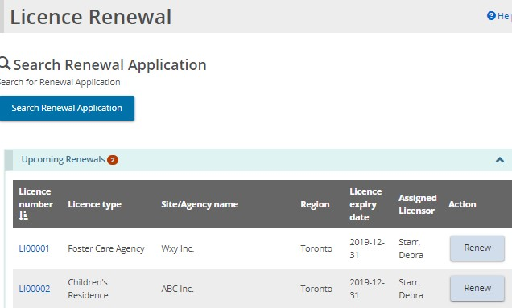
Tip: If you have several licences in the list, sort the upcoming renewals list by Licence Expiry Date by clicking on the column header to sort.
- Click to open the licence to be renewed. The Notice of collection of personal information page appears.
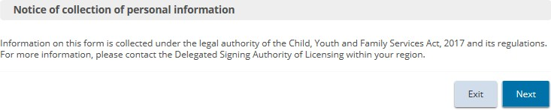
- Read the notice then click . The Licence information page appears.
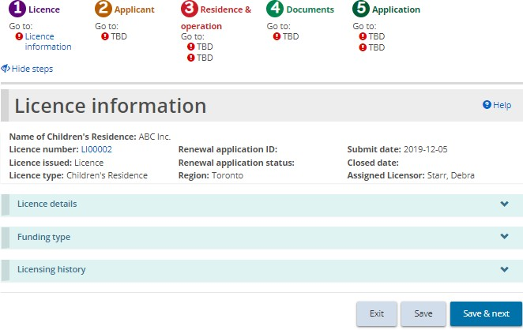
The Foster Care agency page is similar to the Children’s Residence page.
- As you saw when completing a new application, the steps section appears with a green checkmark as a page is completed.
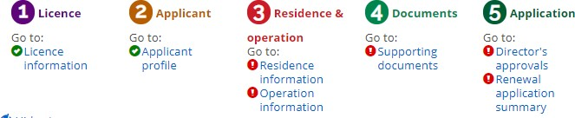
Example of a Children’s Residence page
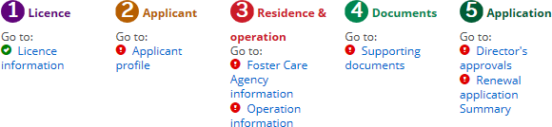
Example of a Foster Care Agency page
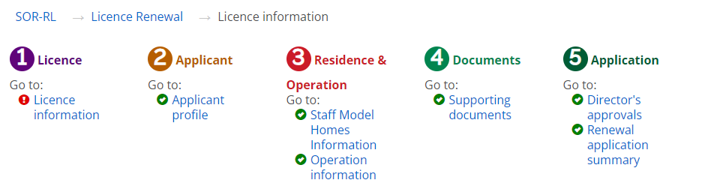
Example of a Staff Model Homes page

Step 1: Review/update the licence information
- From the Licence information page, expand the Licence information banner.
- Change the Preferred language of Licence if required.
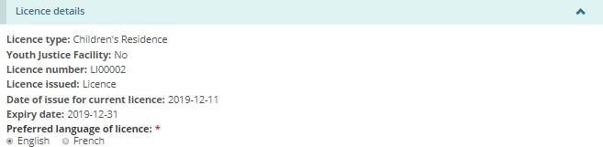
- Answer the questions in the Licensing history section.
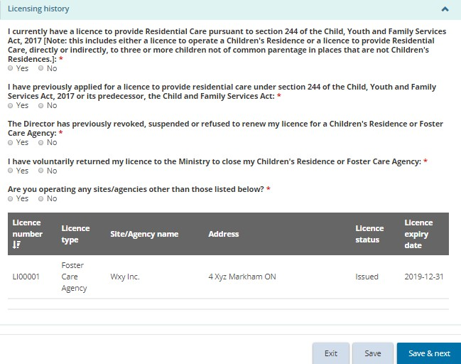
- Click . The Applicant profile page appears.
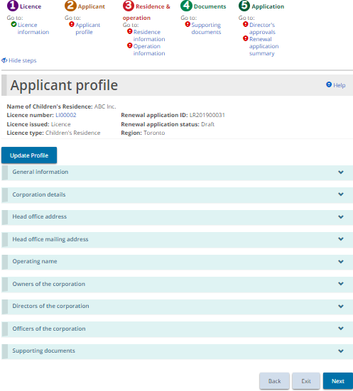
Your page may look different

Step 2: Review/update the applicant profile
- Review the applicant profile.
- No changes can be made directly on the Applicant profile page. If changes are required, click 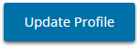.This brings you to the Profile Module.
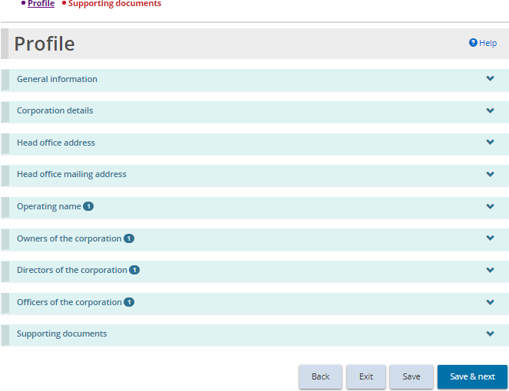
- Make the change.
Note: Some changes cannot be made in the profile page; a Change Request may be required.
- Click . The Supporting documents page appears.
Note: This list of supporting documents is related to your profile, not your licence.
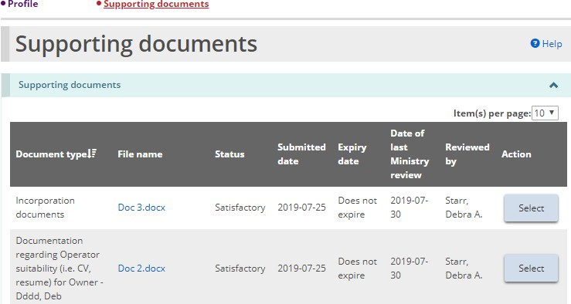
- Upload any new versions of supporting documents.
- Go back to the Licence Renewal by clicking the Applicant Profile breadcrumb at the top of the page.
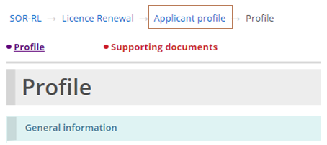
- Click .

Step 3: Review/update the Children’s Residence/Staff Model Homes/Foster Care Agency information
- The Residence information, Staff Model Homes information or Foster Care Agency information page appears.
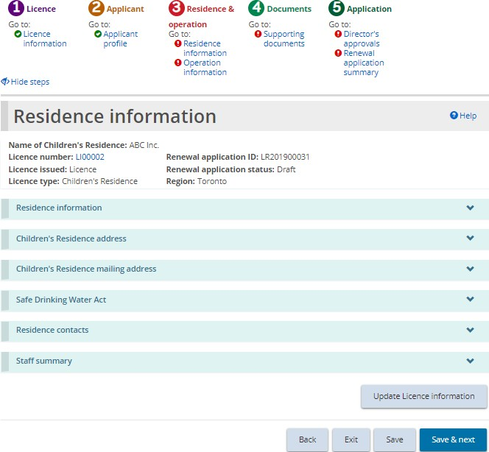
Example of a Children’s Residence page
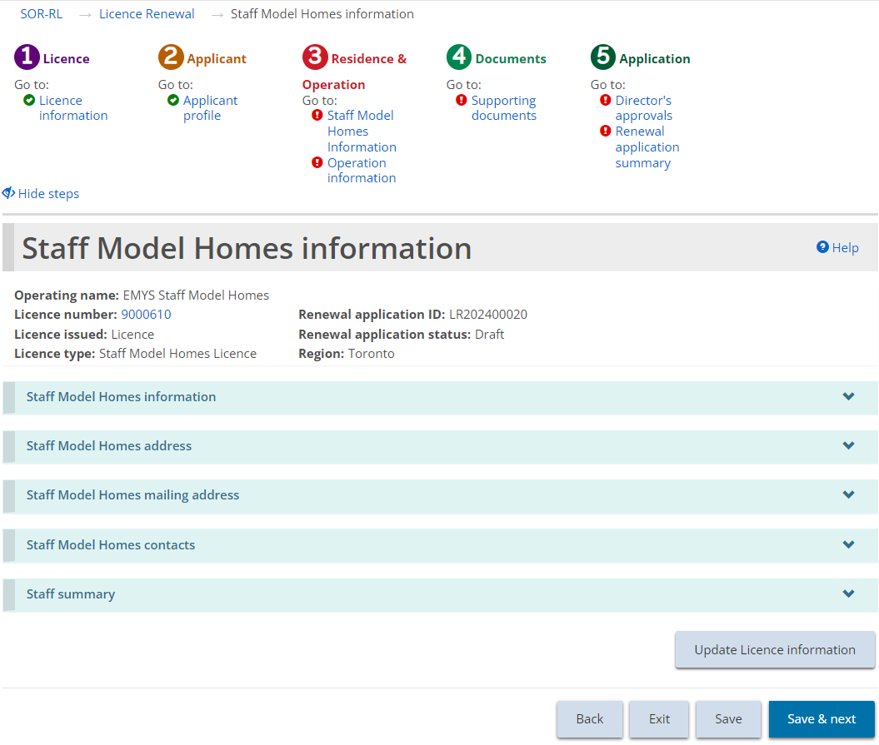
Example of a Staff Model Home information page
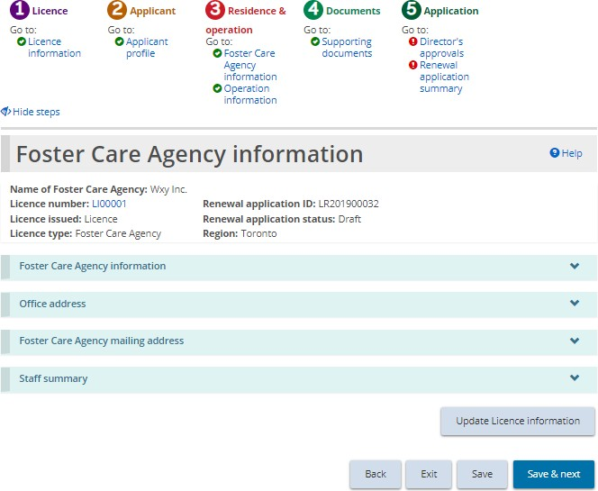
Example of a Foster Care Agency page
- Review and update the information. Answer the questions that appear.
- For a Children’s Residence, edit or add a contact if required.
- For a Foster Care licence, review, edit or add office information if required.
- To add/edit contacts, children, staff, or a foster home, click 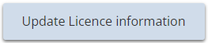. The Licence summary page appears.
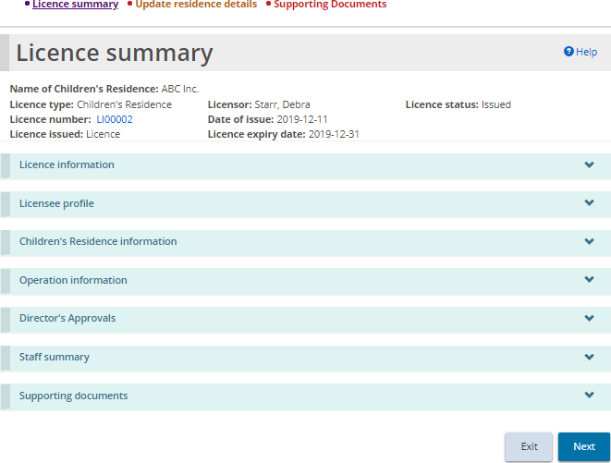
Example of a Children’s residence page
- Make the changes.
- Return to the Children’s Residence/Staff Model Homes/Foster Care Agency Information section by clicking the section from the breadcrumbs at the top of the page.
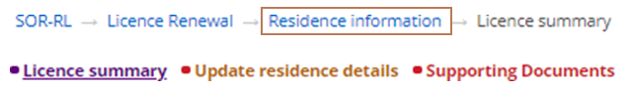
Children’s Residence example
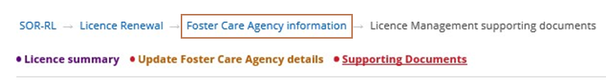
Foster Care Agency example
- Click . The Operation information page appears.

Step 4: Review the operation information
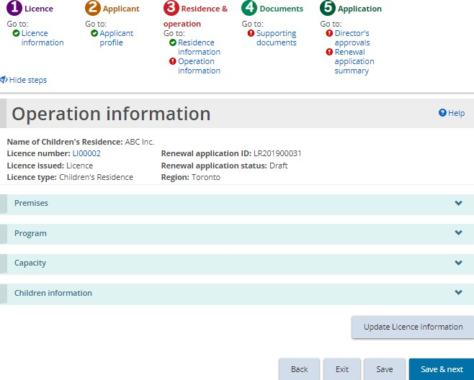
Children’s Residence page
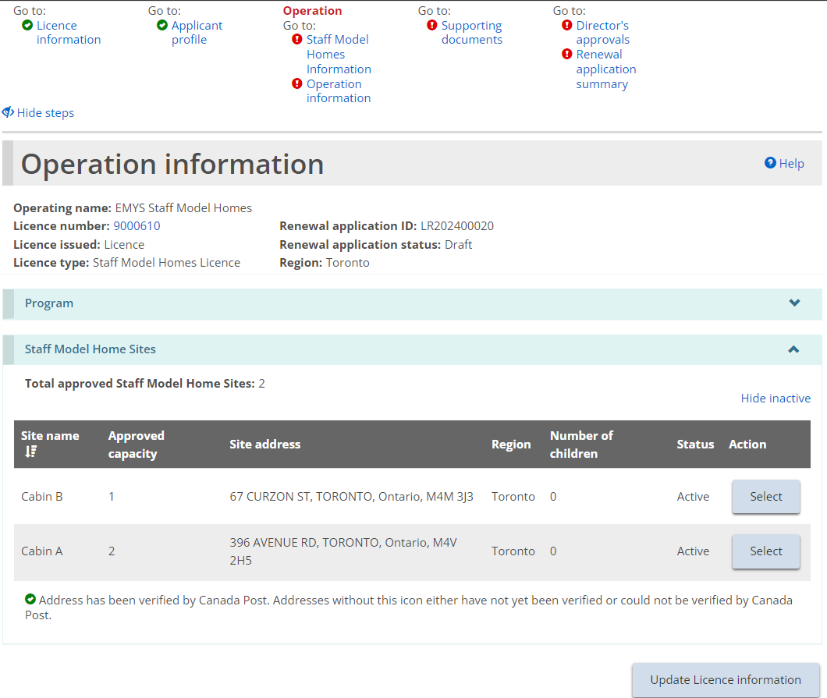
Staff Model Home operation page
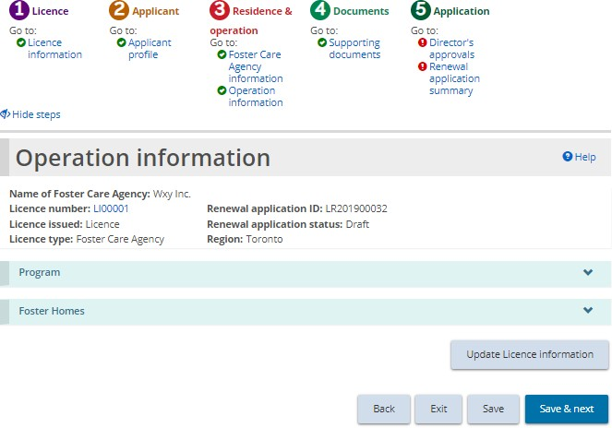
Foster Care Agency page
- Review the operation information.
Note: The Referral sources can be edited in the Program section.
- To add/edit contacts, children, staff, or a foster home, click . The Licence summary page appears.
Example of a Children’s residence page
- Make the changes.
- Return to the Operation Information section of the renewal by clicking the section from the breadcrumbs at the top of the page.
- Click .

Step 5: Upload supporting documents
- The Supporting Documents page appears.
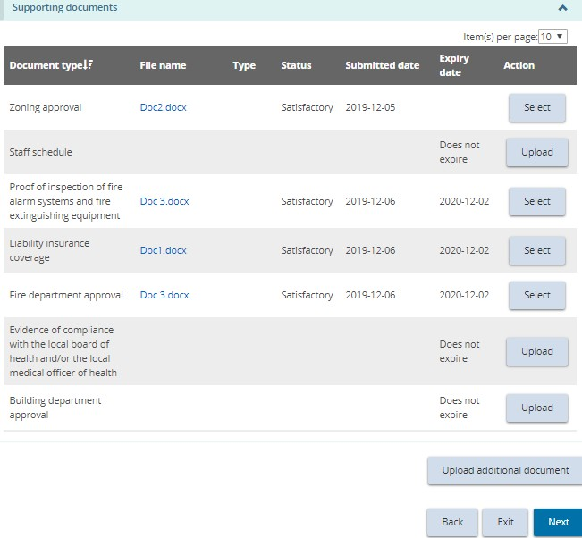
Your page may list different documents.
Note: The documents on this page refer to the licence documents, not the profile.
Note: Supporting documents can be uploaded after the renewal application is submitted.
- Upload supporting documents as required. Please refer to the working with supporting documents section, and uploading a document to multiple sites under one licence (staff model homes only) section for further details.
- Click .

Step 6: Review director’s approvals
- The Director’s Approvals page appears.
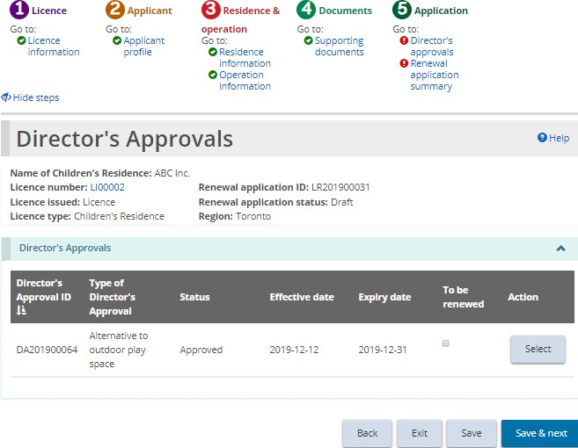
- Review any Director’s Approvals.
- If the Director’s Approval should be renewed along with your licence, click the “To be renewed” checkbox. Please see the If you renewed a Director’s Approval section below for further details.
- Click. The Renewal application summary page appears.
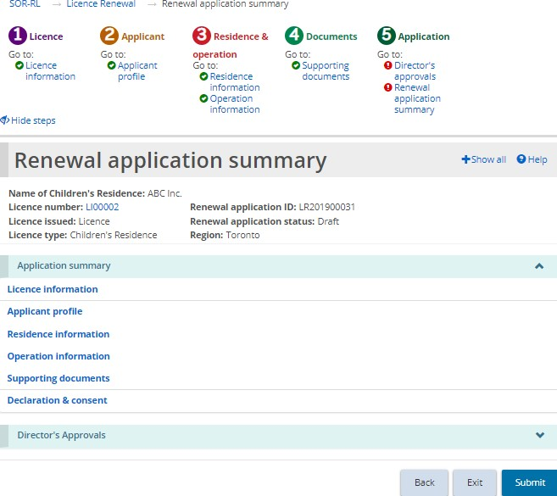
Children’s Residence example

Step 7: Submit the renewal
- Review the information. If changes are required, return to the section using the steps section at the top of the page.
- Click . The Declaration and consent page appears.
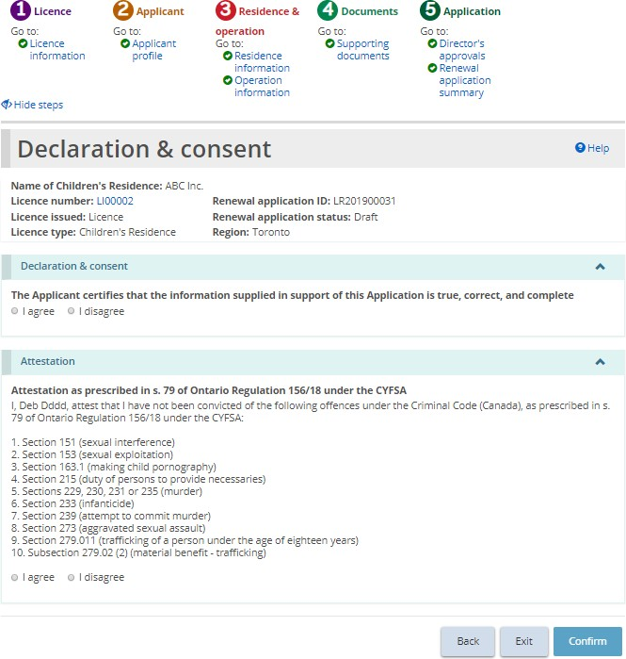
Children’s Residence example.
- Read the declaration and consent and answer the questions.
Note: An executive officer of the corporation who has authority to bind the corporation must complete the attestation. The declaration and consent must be signed by an officer of the agency that has the authority to legally bind the applicant, for example an executive director, The application can be completed by another individual with appropriate access in the system, however for the required individual to complete the consent and declaration they must first access the application and select the “assign to me” button at the bottom of the summary page. Please see the “Assign to Me” section for further details.
- Click . A Confirmation page appears.
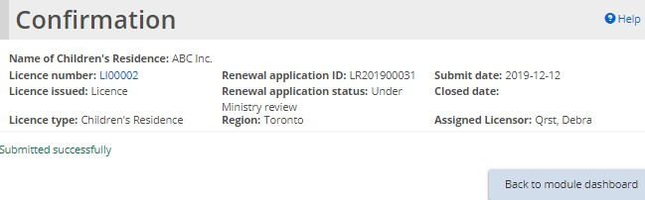
- Click . The renewal application can be found in the Submitted renewals section of your Licence renewals dashboard.
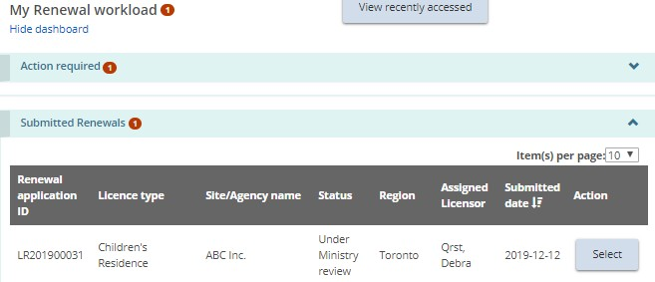

If you renewed a director’s approval
- Return to the SOR-RL home page.
- Click .
- Click See dashboard. The Action required section displays the draft Director’s Approval.
- Click . The Director’s Approval Summary page appears.
- Click . The Director’s Approval details page appears.
- Review/edit the details if required.
- Click . The Supporting documents page appears.
- Upload the supporting documents.
- Click . The Director’s Approval summary page appears.
- Click . The Declaration and consent page appears.
- Answer the questions and click . The Confirmation page appears.
- Click . The Director’s Approval is moved to the Submitted section of your dashboard.

Viewing a draft licence renewal
As you work on a renewal, it is saved in the Licence Renewal dashboard.
- Click. The Licence Renewal module appears.
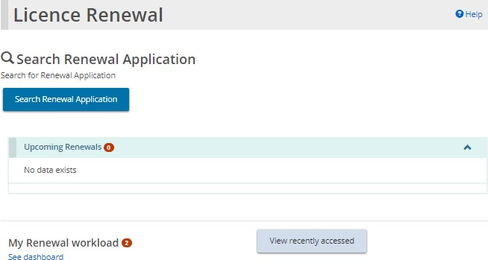
- Click See Dashboard. The draft renewal appears in the Action required section.
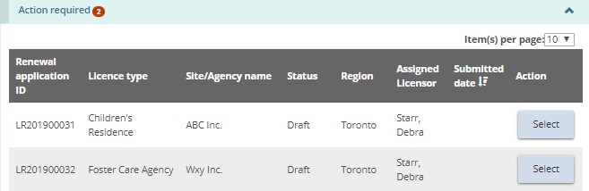
- To open the renewal, click .

Withdrawing a licence renewal
Renewal applications cannot be withdrawn.

Viewing serious occurrences
Only users with the SOR Initiator role can submit, access, update or revise Serious Occurrence Reports. Users with the Monthly Reporting User role can view Serious Occurrences. For more information on submitting a Serious Occurrence Report, see the SOR-RL Serious Occurrence Reporting User Guide for SOR Initiators and Probation Officers. You can find a copy of the Guide on the SOR-RL Training Portal.
- With the SOR Initiator user role selected, click . The Serious Occurrence module appears.
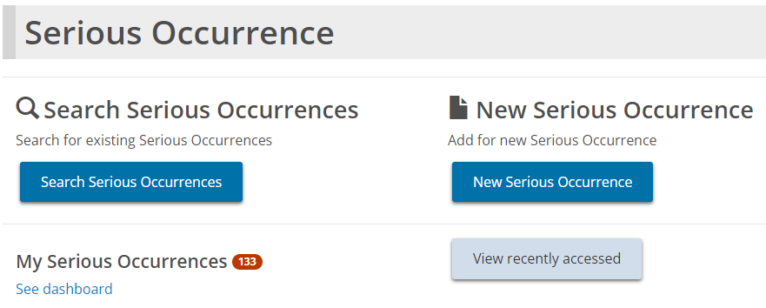
SOR Initiator view
SOR Initiators can search for Serious Occurrence Reports, submit new SORs, update or revise existing SORs, view recently accessed SORs, and view their SOR dashboard which categorizes SORs and highlights outstanding action to be taken.
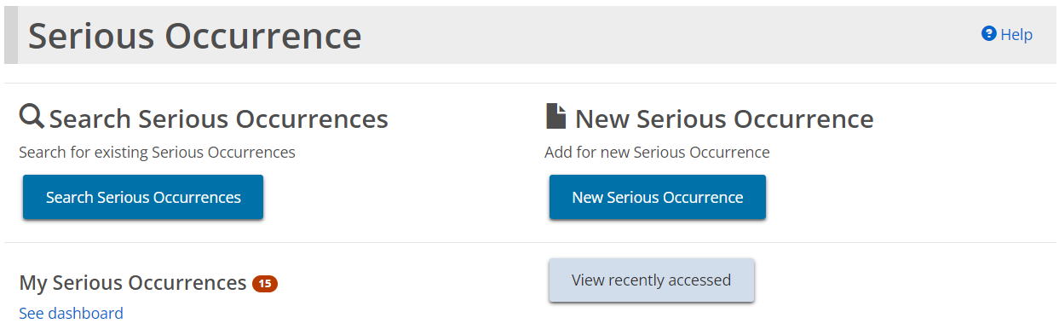
SOR Initiator view
Monthly Reporting Users can search for Serious Occurrence Reports.
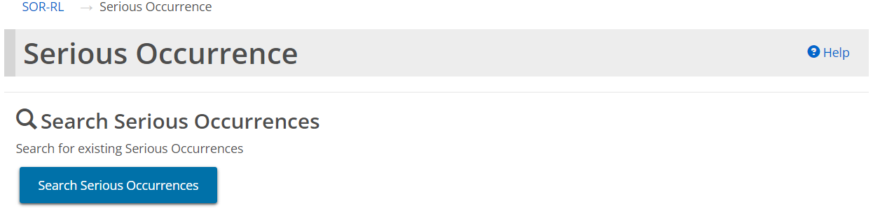
Monthly Reporting User view

Appendix A: Terms and acronyms

Term | Definition
Head office/lead office | Head office indicated in the profile (head office of the corporation). Head office may be located anywhere, however, corporation must record a “lead” office location in the region in which they wish to have a licence be issued and operate.
Ministry | Ministry of Children, Community and Social Services
SOR-RL | Serious Occurrence Reporting and Residential Licensing

Appendix B: System/functional roles
Refer to the SOR-RL User Role Matrix on the SOR-RL Training Portal, which lists all SOR-RL user roles, their responsibilities, assignments and functionality.

Appendix C: Statuses

Application statuses
The application status will change as it progresses through the approval process. An application includes a new application, renewal application, director’s approval application, change request application.
The following are the possible application statuses:

Draft:
- The item has not yet been submitted.
- The application can be updated, withdrawn or submitted.

Under Ministry Review
- The ministry is currently reviewing the application.
- Only some changes can be made by the applicant.

Incomplete:
- More information/revisions are required

Withdrawn:
- The item has been withdrawn by the applicant/licensee.

Approved

Not approved

Condition/occurrence statuses
The following is a list of statuses and what they mean. Note that both occurrences and the overall condition has a status.

Active:
- The original occurrence has not been submitted by the licensee

Overdue:
- The occurrence has not been submitted by the due date. Once an overdue item is in compliance, the word “Overdue” will appear in the submitted date column.

Under ministry review

In compliance:
- The submitted document or occurrence has been reviewed and is in compliance.
- When all occurrences are in compliance, the overall condition is “in compliance”

Incomplete:
- Additional information is required.

Removed:
- The licensor has removed the occurrence

Appendix D: Symbols and icons quick reference
Symbol | Description
 | Edit entry
 | Delete entry
 | Use calendar to select a date
 | Table column sorted in ascending order
 | Table sorted in descending order
 | Number of lines appearing on a page
 | Expand / collapse banner or section
 | A number indicates the number of items in that section
 | Information in the section is complete
 | Information is missing from the section
 | Mandatory field

